Summary of Research workshops  January 2021 | An appreciative inquiry into AMHP decision-making at the point of referral for a Mental Health Act assessment.  Matthew Simpson

An appreciative inquiry into AMHP decision-making at the point of referral for a Mental Health Act assessment.

Introduction:

Nine AMHPs from one AMHP service participated in a series of research workshops focussing on decision-making at the point of referral for a Mental Health Act assessment. An appreciative inquiry methodology was adopted to bring a strengths-based approach to practice development. This document brings together a summary of the work completed during the workshops, and includes a service implementation plan.

Affirmative topic choice:

Appreciative inquiries start with identifying the focus of study, named affirmative topics. The process is then cyclical, moving through phases of discovery, dream, design, and destiny. The destiny phase draws together an implementation plan, but the process can continue from there as practice grows and develops in new directions. What is detailed in this document is the completion of the first cycle of appreciative inquiry from discovery to destiny.
The beginning of affirmative topic choice in this study was the completion of mini-interviews to generate a narrative about the best of practice now. This then evolved through a process of thematic analysis from those interview on then to the development of the affirmative topics.
The first workshop started with participants forming pairs and conducting mini-interviews with each other, followed by small group then whole group discussions to form themes from which to build the affirmative topics. The mini-interview questions were designed to give participants an experience of using positive questions, with conversation being central, creating inspiring stories about best practice. The questions asked were:
- Tell me about a peak experience or high point in your professional life, a time when you felt really proud of your decision-making at the point of referral for a Mental Health Act assessment?
- Without being humble, what do you most value about
  - Yourself and the way you make decisions at the point of referral for a Mental Health Act assessment? What unique skills do you bring to this decision?
  - Your team and the way decisions are made at the point of referral for a Mental Health Act assessment.
  - AMHPs in general: what value do AMHPs bring to individuals and to society when making decisions about whether to proceed with a Mental Health Act assessment?
- What core factors give life to AMHP decision-making at the point of referral for a Mental Health Act assessment when it is at its best?
- If you had a magic wand and could have any three wishes granted to heighten the decision experience what would they be?

Following the mini-interviews the participants first completed a thematic analysis of those interviews before constructing the affirmative topics.

Themes:
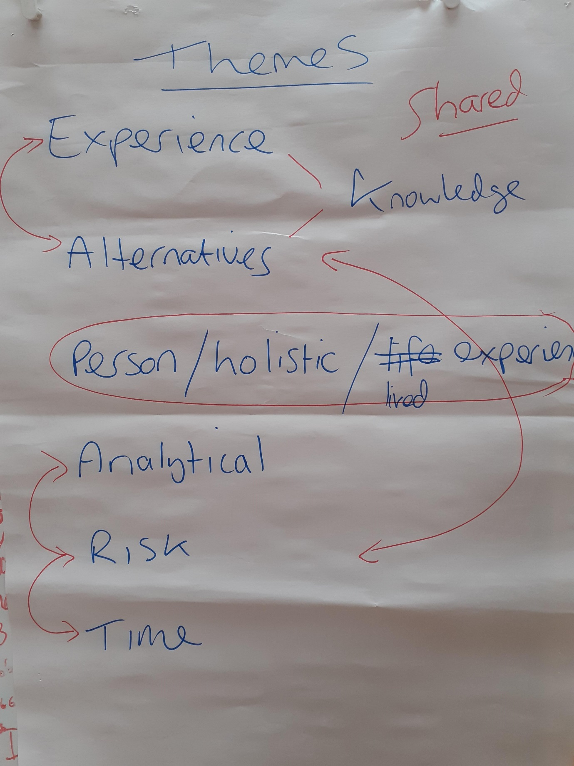

Summary of themes:
This list of themes emerged with the connections following afterwards. Centred around the person and a holistic understanding of their lived experience came the AMHP using their knowledge and experience of alternatives. The notion this is in some way shared with service users was incorporated here. Then being analytical and issues of risk and time emerged, these concepts relating back to the AMHP and their knowledge and experience. In this way what looked like six themes appeared to be grouped into three interconnected meta-themes. We did not name those meta-themes in the workshops, but considering them subsequently the person is in the middle between the AMHP and risk, the AMHP drawing on their experience and knowledge to analyse risk and try to ‘buy time’, a concept that evolved later in the study. There was much discussion about this concept of time, with participants seeking a way to express how they perhaps manipulate time in some way to create opportunity.
Following this thematic analysis participants developed the affirmative topics as follows:
- We use our experience, knowledge and the views of others to inform and support our decisions.
- Using a holistic and open-minded approach we keep the person at the centre of our decision.
- We selectively gather information and think analytically and creatively about possible options and alternatives to an assessment under the Mental Health Act.
- We balance risk and time in our decision-making to create opportunities.

Discovery:

For each affirmative topic a series of questions was developed by participants to form the appreciative interview protocol. Appreciative interviews were then completed in pairs between workshops one and two. Participants were given a choice to either just interview each other or to branch out and interview other AMHPs not involved in the study. There was a consensus that those involved in the study understood the practice development goals and the appreciative stance, and as such the data would be more coherent focussing only on those participants directly involved.

Shared Meanings from appreciative interviews:

In the second workshop participants started by highlighting key messages from their appreciative interviews, drawing out themes and then developing a set of shared meanings as follows:

Experience (professional, personal, expertise) leading to intuition and confidence.
Peer/team support as a resource.
Support from partner agencies.
Focus on essence and uniqueness (identity) of person.
Listening to person and others.
Transparency.
Focus on social perspectives.
Seeing people through different lenses.
Balanced view of outcomes.
Open to all possibilities.
Collaboration with services/family.
Shared understanding with the person.
Joint visit.
Documentation/opinion subject to verification.
Analysis of risk/protective factors.
Acceptance/tolerance of risk/positive risk taking.
Changing gears and buying time.

From these shared meanings the pinnacle of the discovery phase is the creation of a positive core map:

Positive Core Map:
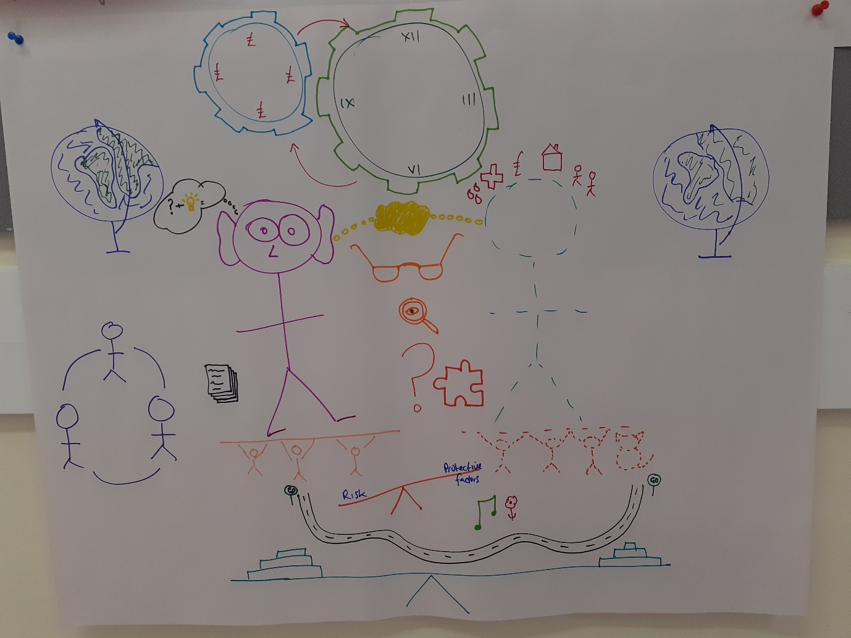
We started by drawing the AMHP and the service user at the centre of the picture, with the AMHP having big ears and eyes to represent them listening and gathering information. The service user was drawn in dotted lines to show they were not clear to the AMHP at this stage of the decision-making process. The bubble between them represented the shared understanding between the AMHP and service user and transparency, and the glasses represented the different lenses from which the AMHP views the service user. The question mark highlights being open to all possibilities. The jigsaw piece, magnifying glass, and the pages represent the analysis and scrutiny of information. The bubble with the lightbulb represents intuition.
Beneath the AMHP are their peer supports, and to the side their partnership working with others. The globe for both the AMHP and service user represents the essence and uniqueness of the person, a holistic representation. We initially added this to the service user but felt it also applied to the AMHP, reflecting their personal and professional experiences and acknowledging the human element to the decision. The people beneath the service user are their supports, including animals hence the image of a cat. Again, these are dotted because they are unclear to us. Around the service user’s head are a number of images representing different aspects of their life, reflecting the decision is holistic. These were not meant to be comprehensive, but just to acknowledge each person will have a range of issues that are important to them. We included housing, finances, social supports, distress, medical issues.
Above the AMHP and service user we drew some cogs in the form of clocks one with pound signs. This represented the AMHP trying to buy time and the notion of shifting gears. Beneath the service user and AMHP we drew scales balancing risk and protective factors. We included music and a flower for nature next to protective factors to represent some factors that could be protective but recognising these could be anything. The notion of accepting risk formed part of this aspect of the drawing. We added a road with “Go” signs at each end further representing the collaborative nature of the decision with the service user, and beneath it all the scales to represent how everything is then balanced to reach a decision.

Dream:

Participants were asked to quietly consider a focal question (below) before then discussing and agreeing a collective dream.
Focal question: It’s 20-years from today, legislation and resources remain largely the same but there have been changes that have improved the way services work with people with mental illness. What’s happening now when someone reaches a crisis point in their mental health? How are AMHPs approaching the decision about whether to proceed with an MHA assessment? What decisions and choices did AMHPs make to pave the way for these changes?

Collective dream from focal question:
- Services are holistic and person centred.
- Services work collaboratively with people.
- There is a graded pathway with earlier involvement of an AMHP, including directly with the person and a “blue light” meeting process.
- Extended calm café / psychiatric A&E with social worker/AMHP/psychiatrist input/nurses.
- Robust crisis plans that includes collaborative input from the person.
- Joint working.
- Joint resourcing.
- Education/understanding.
- Person-centred language.
- Culture – society and service. Acceptance, parity, a rights-based approach, capacity, shared and supported decision-making.

Creative enactment of a blue light/strategy meeting:
In order to bring life to the collective dream participants began workshop three with a creative enactment of what was termed a blue light or strategy meeting, something envisaged as part of the collective dream.
Scenario: Female in her late 30s, lives with her 14-year-old son in a village with her mother around the corner. Her brother has come to stay while she isn’t well to support her.
She believes her central heating boiler is poisoning her with carbon monoxide. The same is true of the boiler at her mother’s house. She keeps calling the fire brigade. She went to the village post office to escape poisoning.
She was detained under s136, assessed, agreed to home treatment and was discharged. Immediately on discharge she called an ambulance due to carbon monoxide poisoning. She also “tampered” with the boiler.
She is accepting 200mg quetiapine but largely because her brother is coercing her to take it. She doesn’t think she needs it and is concerned about having too much medication due to a previous experience.
Her brother can’t cope with her anymore and her mother feels the same. Home treatment team feel they can no longer home treat. That said they are seeing her daily.

Additional information gained: Her son has gone to stay with his father. Medication is prescribed by the GP. She has not been seen by a psychiatrist apart from at her s136 assessment. Her 200mg quetiapine comprises of eight 25mg tablets despite higher mg tablets being available. 200mg is not a therapeutic dose for psychosis, rather this would be a minimum of 400mg. Mother and brother can’t cope principally because they are all staying at mother’s house and she keeps waking mother and brother up to check they are still alive due to fear they have fallen prey to carbon monoxide poisoning. When she was detained in the place of safety, she felt safe from poisoning and was more relaxed for her assessment there. The tampering with the boiler consisted of her taking a screwdriver to the cover but being unable to remove it.

Plan developed:
Practical intervention – service the boiler.
Bring in an alternative support network for the person and their family.
Encourage the use of a calm café or psychiatric A&E – a safe place to explore concerns/issues. Could extend to the use of a crisis house.
Consider changes to treatment. Example was too many individual tablets.
Explore physical health issues either at home or at the calm café.
Clarify risks.
General support for earlier involvement of the AMHP service.

Themes regarding the collective dream:
Participants then used their experience of the creative enactment to develop themes from the collective dream, following which a mind map of the future was developed:
- Earlier involvement of AMHP service.
- Practical intervention.
- Alternative support network.
- Safe environment – calm café, crisis house.
- Multi-disciplinary home treatment team with support arm. Care co-ordinator central point for person. Includes treatment review and physical health.
- Clarify risks and consider ways to mitigate.
- Explore antecedent.

Mind map of the future:
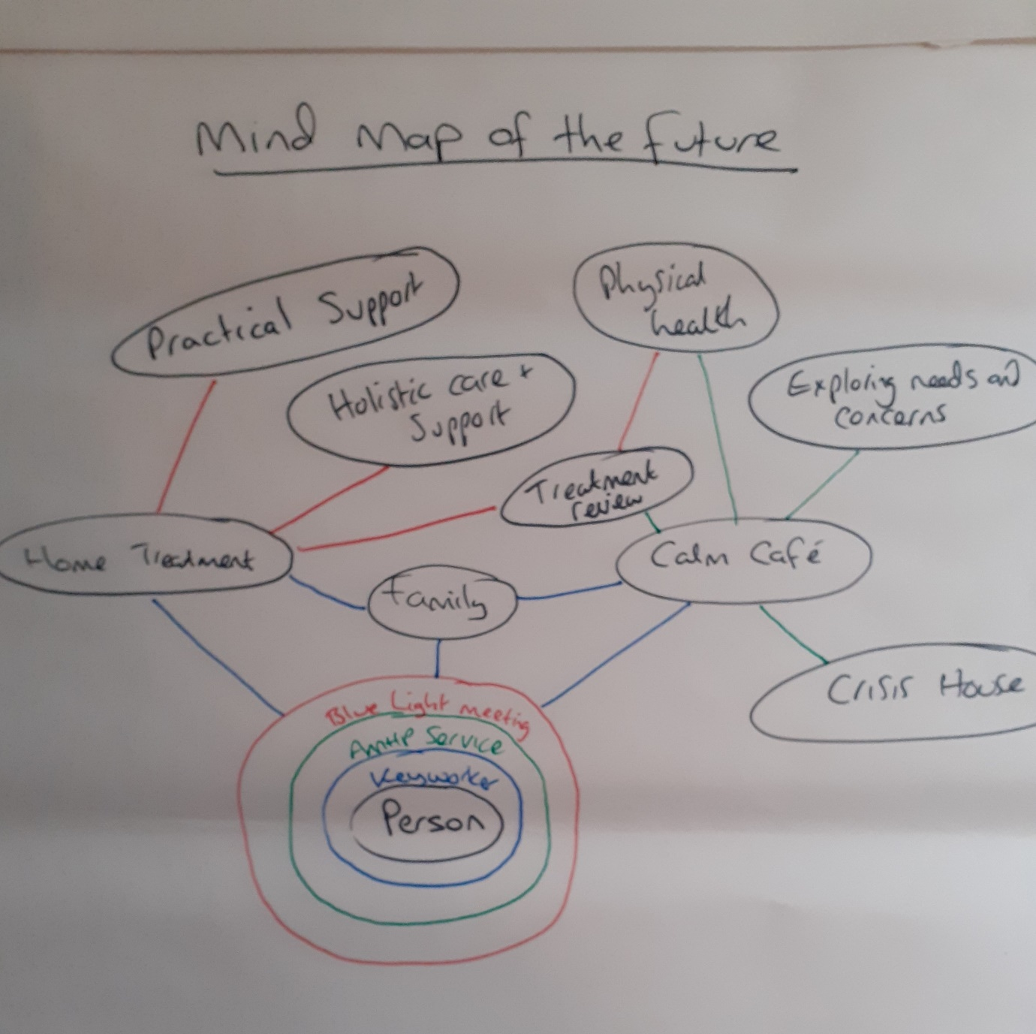

Design and Destiny:

The third workshop concluded with agreeing strategic design elements to achieve the desired future (what policies, procedures, practices need to change)? After these design elements were agreed a provocative proposition was developed for each one, an affirmative statement that reaches toward the desired goal.
The original study design concluded with workshop three, but a fourth workshop was added because the destiny phase remained incomplete. Workshop four completed the appreciative inquiry with an implementation plan for each provocative proposition.

Strategic design element one:
How we manage referrals and include the person and all relevant others.

Provocative proposition:
“The triage AMHP will listen to those involved, discuss the options with the person and relevant others to explore whether an AMHP will consider the persons case further”.
This proposition is designed to bring in elements of collaboration and partnership with the service user, their family, relevant others and partner agencies. It is analytical, holistic and person-centred. It promotes early involvement of an AMHP, and seeks to gain clarity about risks, where possible “buying time” for a more considered response. The bespoke nature of the triage AMHP role values this part of the process, allowing that AMHP to focus only on early intervention rather than fitting this aspect of the role around other commitments that often take precedence otherwise. The joint visit forms part of this role, connecting the AMHP with the person referred and the people and agencies involved. Shared understanding is promoted. Transparency is enhanced through open conversations with the person referred to enable them to contribute to a decision. Time is spent analysing/scrutinising information to gain a balanced perspective. Use of safe places may also come into this.

Implementation plan:
- Triage AMHP role
- Capture information from a variety of sources.
- Involving other services where appropriate.
- Active role in exploring alternatives to admission.
- Consider how to involve the person referred in the decision.
- Transparency with the person referred, and all others involved about concerns and outcomes.
- Peer consultation.
- The level of assessed risk will inform how quickly a decision is required or how much time can be spent exploring options.

Service design element two:
How we involve other services in the decision.

Provocative proposition:
“All involved professionals will be invited to contribute to a plan with clear agreed outcomes and actions”.
This proposition focusses on partnership work and builds in the notion of a graded pathway to assessment under the MHA, adopting a rights-based approach that views detention as a last resort. It also draws support for the decision from partner agencies. It enables the AMHP to view the situation from a range of perspectives, encouraging this openness in others also. The forum provides a space to balance and share risks, in this way promoting positive risk taking and considering ways to mitigate risk other than detention. Creative and practical solutions can be agreed and implemented, including considering alternative support systems.

Implementation plan:
- Identify who needs to be involved in the decision.
- Promote a dialogue with those involved, including the possibility of convening a meeting.
- Strive toward a shared understanding of outcomes, with clarity about risks and harm.
- Develop a realistic action plan with shared responsibilities and timescales, with agreed review points. Any resource requirements to be escalated to team managers.

Service design element three:
How we allocate work to enhance continuity.

Provocative proposition:
“Work is allocated following a principal of continuity, where the worker knows the person best, or they have relevant expertise with the issues faced by the person referred”.
This proposition recognises that knowledge of the person and a relationship with them enhances decision-making. It maximises a person-centred approach and enhances collaboration and transparency. It proposes maximising experience and expertise where knowledge of the person is absent.

Implementation plan:
- Identify who in the team, available within the appropriate timescale, knows the person best.
- Who in the team available has relevant experience, expertise or confidence.
- If it’s possible for one AMHP to follow a situation through this would be preferable, but where that AMHP is unavailable and needs to hand over to another AMHP they will ensure all relevant information is documented clearly to inform future decisions, notifying the person/team on the following day by phone and/or email.

Service design element four:
How we educate other services about our role.

Provocative proposition:
“We work positively with other services on an ongoing basis, so they understand our role”.
This proposition promotes understanding of the AMHP role. It encourages early intervention from the AMHP service and a partnership approach. It seeks to “buy time” by encouraging earlier involvement. In this way it promotes a rights-based approach and contributes to culture change. Enacting this proposition supports all the other provocative propositions.

Implementation plan:
- Day to day, communication with other teams is proactive, encourages earlier AMHP involvement, and builds understanding about the process toward an assessment.
- Develop regular AMHP interface meetings with relevant agencies invited to bring reflections about what’s working and what could work better between services.
- Involve other agencies in the monthly AMHP meetings.
- AMHPs will participate in all relevant strategic and case meetings where we are notified about them, and informal discussions.

