 | Male (N=162) | Female (N=217) | Total (N=379) | p value
IKEA_13_37 |  |  |  | 0.768¹
Mean (SD) | 3.2 (1.2) | 3.2 (1.2) | 3.2 (1.2)
Range | 1.0 - 5.0 | 1.0 - 5.0 | 1.0 - 5.0
IKEA_17_49 |  |  |  | 0.239¹
Mean (SD) | 3.0 (1.3) | 2.9 (1.3) | 2.9 (1.3)
Range | 1.0 - 5.0 | 1.0 - 5.0 | 1.0 - 5.0
IKEA_20_58 |  |  |  | 0.992¹
Mean (SD) | 3.0 (1.3) | 3.1 (1.3) | 3.1 (1.3)
Range | 1.0 - 5.0 | 1.0 - 5.0 | 1.0 - 5.0
IKEA_26_76 |  |  |  | 0.307¹
Mean (SD) | 3.3 (1.2) | 3.2 (1.2) | 3.2 (1.2)
Range | 1.0 - 5.0 | 1.0 - 5.0 | 1.0 - 5.0
LIKE_13_39 |  |  |  | 0.632¹
Mean (SD) | 3.7 (1.0) | 3.7 (1.1) | 3.7 (1.0)
Range | 1.0 - 5.0 | 1.0 - 5.0 | 1.0 - 5.0
LIKE_17_51 |  |  |  | 0.876¹
Mean (SD) | 3.6 (1.2) | 3.6 (1.2) | 3.6 (1.2)
Range | 1.0 - 5.0 | 1.0 - 5.0 | 1.0 - 5.0
LIKE_20_60 |  |  |  | 0.381¹
Mean (SD) | 3.7 (1.1) | 3.6 (1.2) | 3.7 (1.2)
Range | 1.0 - 5.0 | 1.0 - 5.0 | 1.0 - 5.0
LIKE_26_78 |  |  |  | 0.786¹
Mean (SD) | 3.5 (1.1) | 3.6 (1.1) | 3.6 (1.1)
Range | 1.0 - 5.0 | 1.0 - 5.0 | 1.0 - 5.0
ISLG_13_38 |  |  |  | 0.042¹
Mean (SD) | 3.5 (1.1) | 3.7 (1.1) | 3.6 (1.1)
Range | 1.0 - 5.0 | 1.0 - 5.0 | 1.0 - 5.0
ISLG_17_50 |  |  |  | 0.003¹
Mean (SD) | 3.6 (1.1) | 4.0 (1.0) | 3.8 (1.1)
Range | 1.0 - 5.0 | 1.0 - 5.0 | 1.0 - 5.0
ISLG_20_59 |  |  |  | 0.953¹
Mean (SD) | 4.0 (0.9) | 4.0 (1.0) | 4.0 (1.0)
Range | 1.0 - 5.0 | 1.0 - 5.0 | 1.0 - 5.0
ISLG_26_77 |  |  |  | 0.005¹
Mean (SD) | 3.5 (1.1) | 3.8 (1.0) | 3.6 (1.1)
Range | 1.0 - 5.0 | 1.0 - 5.0 | 1.0 - 5.0

- Linear Model ANOVA

 | Less than 29 (N=155) | 30 - 39 (N=112) | 40 - 49 (N=76) | ≥ 50 (N=36) | Total (N=379) | p value
IKEA_13_37 |  |  |  |  |  | 0.263¹
Mean (SD) | 3.1 (1.2) | 3.4 (1.1) | 3.1 (1.3) | 3.2 (0.9) | 3.2 (1.2)
Range | 1.0 - 5.0 | 1.0 - 5.0 | 1.0 - 5.0 | 1.0 - 5.0 | 1.0 - 5.0
IKEA_17_49 |  |  |  |  |  | 0.673¹
Mean (SD) | 2.9 (1.3) | 3.0 (1.4) | 2.8 (1.3) | 2.8 (1.1) | 2.9 (1.3)
Range | 1.0 - 5.0 | 1.0 - 5.0 | 1.0 - 5.0 | 1.0 - 5.0 | 1.0 - 5.0
IKEA_20_58 |  |  |  |  |  | 0.028¹
Mean (SD) | 3.2 (1.3) | 3.1 (1.3) | 2.9 (1.3) | 2.6 (1.0) | 3.1 (1.3)
Range | 1.0 - 5.0 | 1.0 - 5.0 | 1.0 - 5.0 | 1.0 - 5.0 | 1.0 - 5.0
IKEA_26_76 |  |  |  |  |  | 0.173¹
Mean (SD) | 3.3 (1.2) | 3.2 (1.2) | 3.2 (1.3) | 2.8 (0.8) | 3.2 (1.2)
Range | 1.0 - 5.0 | 1.0 - 5.0 | 1.0 - 5.0 | 1.0 - 4.0 | 1.0 - 5.0
LIKE_13_39 |  |  |  |  |  | 0.036¹
Mean (SD) | 3.6 (1.1) | 3.6 (1.1) | 3.9 (0.9) | 4.1 (0.8) | 3.7 (1.0)
Range | 1.0 - 5.0 | 1.0 - 5.0 | 1.0 - 5.0 | 3.0 - 5.0 | 1.0 - 5.0
LIKE_17_51 |  |  |  |  |  | 0.021¹
Mean (SD) | 3.5 (1.2) | 3.5 (1.3) | 3.9 (1.1) | 4.1 (1.0) | 3.6 (1.2)
Range | 1.0 - 5.0 | 1.0 - 5.0 | 1.0 - 5.0 | 1.0 - 5.0 | 1.0 - 5.0
LIKE_20_60 |  |  |  |  |  | 0.020¹
Mean (SD) | 3.7 (1.2) | 3.4 (1.2) | 3.8 (1.1) | 4.1 (1.0) | 3.7 (1.2)
Range | 1.0 - 5.0 | 1.0 - 5.0 | 1.0 - 5.0 | 1.0 - 5.0 | 1.0 - 5.0
LIKE_26_78 |  |  |  |  |  | 0.038¹
Mean (SD) | 3.5 (1.2) | 3.4 (1.2) | 3.8 (0.9) | 3.9 (0.9) | 3.6 (1.1)
Range | 1.0 - 5.0 | 1.0 - 5.0 | 1.0 - 5.0 | 2.0 - 5.0 | 1.0 - 5.0
ISLG_13_38 |  |  |  |  |  | 0.158¹
Mean (SD) | 3.5 (1.1) | 3.6 (1.0) | 3.6 (1.2) | 4.0 (0.8) | 3.6 (1.1)
Range | 1.0 - 5.0 | 1.0 - 5.0 | 1.0 - 5.0 | 2.0 - 5.0 | 1.0 - 5.0
ISLG_17_50 |  |  |  |  |  | 0.130¹
Mean (SD) | 3.7 (1.1) | 3.8 (1.0) | 3.8 (1.2) | 4.2 (0.7) | 3.8 (1.1)
Range | 1.0 - 5.0 | 1.0 - 5.0 | 1.0 - 5.0 | 2.0 - 5.0 | 1.0 - 5.0
ISLG_20_59 |  |  |  |  |  | 0.251¹
Mean (SD) | 4.0 (1.0) | 4.0 (1.0) | 4.2 (1.0) | 4.2 (0.9) | 4.0 (1.0)
Range | 1.0 - 5.0 | 1.0 - 5.0 | 1.0 - 5.0 | 1.0 - 5.0 | 1.0 - 5.0
ISLG_26_77 |  |  |  |  |  | 0.075¹
Mean (SD) | 3.6 (1.1) | 3.5 (1.1) | 3.7 (1.0) | 4.0 (0.9) | 3.6 (1.1)
Range | 1.0 - 5.0 | 1.0 - 5.0 | 1.0 - 5.0 | 2.0 - 5.0 | 1.0 - 5.0

- Linear Model ANOVA

 | Capital (N=141) | Hawalli (N=94) | Farwania (N=50) | Ahmadi (N=46) | Jahra (N=14) | Mubarak Al-Kabeer (N=34) | Total (N=379) | p value
IKEA_13_37 |  |  |  |  |  |  |  | 0.031¹
Mean (SD) | 3.0 (1.1) | 3.2 (1.1) | 3.4 (1.2) | 3.6 (1.2) | 3.4 (1.3) | 3.4 (1.1) | 3.2 (1.2)
Range | 1.0 - 5.0 | 1.0 - 5.0 | 1.0 - 5.0 | 1.0 - 5.0 | 1.0 - 5.0 | 1.0 - 5.0 | 1.0 - 5.0
IKEA_17_49 |  |  |  |  |  |  |  | < 0.001¹
Mean (SD) | 2.5 (1.2) | 3.2 (1.2) | 3.2 (1.4) | 3.3 (1.3) | 2.8 (1.3) | 2.9 (1.3) | 2.9 (1.3)
Range | 1.0 - 5.0 | 1.0 - 5.0 | 1.0 - 5.0 | 1.0 - 5.0 | 1.0 - 5.0 | 1.0 - 5.0 | 1.0 - 5.0
IKEA_20_58 |  |  |  |  |  |  |  | < 0.001¹
Mean (SD) | 2.6 (1.2) | 3.4 (1.2) | 3.2 (1.5) | 3.5 (1.3) | 2.9 (1.3) | 2.9 (1.4) | 3.1 (1.3)
Range | 1.0 - 5.0 | 1.0 - 5.0 | 1.0 - 5.0 | 1.0 - 5.0 | 1.0 - 5.0 | 1.0 - 5.0 | 1.0 - 5.0
IKEA_26_76 |  |  |  |  |  |  |  | 0.086¹
Mean (SD) | 3.0 (1.2) | 3.4 (1.1) | 3.3 (1.4) | 3.5 (1.3) | 3.3 (1.4) | 3.2 (1.0) | 3.2 (1.2)
Range | 1.0 - 5.0 | 1.0 - 5.0 | 1.0 - 5.0 | 1.0 - 5.0 | 1.0 - 5.0 | 1.0 - 5.0 | 1.0 - 5.0
LIKE_13_39 |  |  |  |  |  |  |  | 0.561¹
Mean (SD) | 3.8 (0.9) | 3.5 (1.1) | 3.7 (1.0) | 3.8 (1.1) | 3.7 (1.3) | 3.8 (1.0) | 3.7 (1.0)
Range | 1.0 - 5.0 | 1.0 - 5.0 | 1.0 - 5.0 | 1.0 - 5.0 | 1.0 - 5.0 | 1.0 - 5.0 | 1.0 - 5.0
LIKE_17_51 |  |  |  |  |  |  |  | 0.747¹
Mean (SD) | 3.6 (1.1) | 3.7 (1.1) | 3.6 (1.3) | 3.8 (1.3) | 3.4 (1.3) | 3.7 (1.2) | 3.6 (1.2)
Range | 1.0 - 5.0 | 1.0 - 5.0 | 1.0 - 5.0 | 1.0 - 5.0 | 1.0 - 5.0 | 1.0 - 5.0 | 1.0 - 5.0
LIKE_20_60 |  |  |  |  |  |  |  | 0.710¹
Mean (SD) | 3.7 (1.1) | 3.7 (1.1) | 3.6 (1.3) | 3.7 (1.3) | 3.3 (1.4) | 3.6 (1.1) | 3.7 (1.2)
Range | 1.0 - 5.0 | 1.0 - 5.0 | 1.0 - 5.0 | 1.0 - 5.0 | 1.0 - 5.0 | 1.0 - 5.0 | 1.0 - 5.0
LIKE_26_78 |  |  |  |  |  |  |  | 0.129¹
Mean (SD) | 3.7 (1.1) | 3.5 (1.1) | 3.4 (1.2) | 3.8 (1.1) | 3.0 (1.5) | 3.5 (0.9) | 3.6 (1.1)
Range | 1.0 - 5.0 | 1.0 - 5.0 | 1.0 - 5.0 | 1.0 - 5.0 | 1.0 - 5.0 | 1.0 - 5.0 | 1.0 - 5.0
ISLG_13_38 |  |  |  |  |  |  |  | 0.011¹
Mean (SD) | 3.7 (1.0) | 3.6 (1.0) | 3.3 (1.3) | 3.9 (0.9) | 2.9 (1.3) | 3.5 (1.0) | 3.6 (1.1)
Range | 1.0 - 5.0 | 1.0 - 5.0 | 1.0 - 5.0 | 2.0 - 5.0 | 1.0 - 4.0 | 1.0 - 5.0 | 1.0 - 5.0
ISLG_17_50 |  |  |  |  |  |  |  | 0.011¹
Mean (SD) | 4.0 (1.0) | 3.7 (1.1) | 3.5 (1.3) | 4.1 (0.8) | 3.5 (0.9) | 3.7 (0.9) | 3.8 (1.1)
Range | 1.0 - 5.0 | 1.0 - 5.0 | 1.0 - 5.0 | 2.0 - 5.0 | 1.0 - 5.0 | 1.0 - 5.0 | 1.0 - 5.0
ISLG_20_59 |  |  |  |  |  |  |  | 0.003¹
Mean (SD) | 4.2 (0.9) | 4.0 (1.0) | 3.6 (1.2) | 4.0 (0.9) | 3.7 (1.3) | 4.2 (0.7) | 4.0 (1.0)
Range | 1.0 - 5.0 | 1.0 - 5.0 | 1.0 - 5.0 | 2.0 - 5.0 | 1.0 - 5.0 | 3.0 - 5.0 | 1.0 - 5.0
ISLG_26_77 |  |  |  |  |  |  |  | 0.814¹
Mean (SD) | 3.7 (1.1) | 3.7 (1.1) | 3.5 (1.0) | 3.7 (1.0) | 3.7 (1.3) | 3.5 (1.1) | 3.6 (1.1)
Range | 1.0 - 5.0 | 1.0 - 5.0 | 1.0 - 5.0 | 1.0 - 5.0 | 1.0 - 5.0 | 1.0 - 5.0 | 1.0 - 5.0

- Linear Model ANOVA

 | Arabian (N=265) | Non-Arabian (N=114) | Total (N=379) | p value
IKEA_13_37 |  |  |  | 0.031¹
Mean (SD) | 3.1 (1.2) | 3.4 (1.2) | 3.2 (1.2)
Range | 1.0 - 5.0 | 1.0 - 5.0 | 1.0 - 5.0
IKEA_17_49 |  |  |  | < 0.001¹
Mean (SD) | 2.7 (1.2) | 3.4 (1.3) | 2.9 (1.3)
Range | 1.0 - 5.0 | 1.0 - 5.0 | 1.0 - 5.0
IKEA_20_58 |  |  |  | < 0.001¹
Mean (SD) | 2.8 (1.3) | 3.6 (1.2) | 3.1 (1.3)
Range | 1.0 - 5.0 | 1.0 - 5.0 | 1.0 - 5.0
IKEA_26_76 |  |  |  | 0.002¹
Mean (SD) | 3.1 (1.2) | 3.5 (1.2) | 3.2 (1.2)
Range | 1.0 - 5.0 | 1.0 - 5.0 | 1.0 - 5.0
LIKE_13_39 |  |  |  | 0.487¹
Mean (SD) | 3.7 (1.0) | 3.6 (1.1) | 3.7 (1.0)
Range | 1.0 - 5.0 | 1.0 - 5.0 | 1.0 - 5.0
LIKE_17_51 |  |  |  | 0.298¹
Mean (SD) | 3.6 (1.2) | 3.7 (1.2) | 3.6 (1.2)
Range | 1.0 - 5.0 | 1.0 - 5.0 | 1.0 - 5.0
LIKE_20_60 |  |  |  | 0.487¹
Mean (SD) | 3.7 (1.1) | 3.7 (1.2) | 3.7 (1.2)
Range | 1.0 - 5.0 | 1.0 - 5.0 | 1.0 - 5.0
LIKE_26_78 |  |  |  | 0.394¹
Mean (SD) | 3.6 (1.1) | 3.5 (1.2) | 3.6 (1.1)
Range | 1.0 - 5.0 | 1.0 - 5.0 | 1.0 - 5.0
ISLG_13_38 |  |  |  | 0.502¹
Mean (SD) | 3.6 (1.1) | 3.5 (1.1) | 3.6 (1.1)
Range | 1.0 - 5.0 | 1.0 - 5.0 | 1.0 - 5.0
ISLG_17_50 |  |  |  | 0.049¹
Mean (SD) | 3.9 (1.0) | 3.6 (1.1) | 3.8 (1.1)
Range | 1.0 - 5.0 | 1.0 - 5.0 | 1.0 - 5.0
ISLG_20_59 |  |  |  | 0.001¹
Mean (SD) | 4.1 (0.9) | 3.8 (1.1) | 4.0 (1.0)
Range | 1.0 - 5.0 | 1.0 - 5.0 | 1.0 - 5.0
ISLG_26_77 |  |  |  | 0.464¹
Mean (SD) | 3.7 (1.1) | 3.6 (1.0) | 3.6 (1.1)
Range | 1.0 - 5.0 | 1.0 - 5.0 | 1.0 - 5.0

- Linear Model ANOVA

 | Muslim (N=357) | Non-Muslim (N=22) | Total (N=379) | p value
IKEA_13_37 |  |  |  | 0.383¹
Mean (SD) | 3.2 (1.2) | 3.4 (1.0) | 3.2 (1.2)
Range | 1.0 - 5.0 | 2.0 - 5.0 | 1.0 - 5.0
IKEA_17_49 |  |  |  | 0.141¹
Mean (SD) | 2.9 (1.3) | 3.3 (1.2) | 2.9 (1.3)
Range | 1.0 - 5.0 | 1.0 - 5.0 | 1.0 - 5.0
IKEA_20_58 |  |  |  | 0.004¹
Mean (SD) | 3.0 (1.3) | 3.8 (1.3) | 3.1 (1.3)
Range | 1.0 - 5.0 | 2.0 - 5.0 | 1.0 - 5.0
IKEA_26_76 |  |  |  | 0.026¹
Mean (SD) | 3.2 (1.2) | 3.8 (1.0) | 3.2 (1.2)
Range | 1.0 - 5.0 | 1.0 - 5.0 | 1.0 - 5.0
LIKE_13_39 |  |  |  | 0.876¹
Mean (SD) | 3.7 (1.1) | 3.7 (0.7) | 3.7 (1.0)
Range | 1.0 - 5.0 | 2.0 - 5.0 | 1.0 - 5.0
LIKE_17_51 |  |  |  | 0.653¹
Mean (SD) | 3.6 (1.2) | 3.5 (1.2) | 3.6 (1.2)
Range | 1.0 - 5.0 | 1.0 - 5.0 | 1.0 - 5.0
LIKE_20_60 |  |  |  | 0.819¹
Mean (SD) | 3.7 (1.2) | 3.6 (1.1) | 3.7 (1.2)
Range | 1.0 - 5.0 | 1.0 - 5.0 | 1.0 - 5.0
LIKE_26_78 |  |  |  | 0.901¹
Mean (SD) | 3.6 (1.1) | 3.6 (1.2) | 3.6 (1.1)
Range | 1.0 - 5.0 | 1.0 - 5.0 | 1.0 - 5.0
ISLG_13_38 |  |  |  | 0.679¹
Mean (SD) | 3.6 (1.1) | 3.5 (1.1) | 3.6 (1.1)
Range | 1.0 - 5.0 | 1.0 - 5.0 | 1.0 - 5.0
ISLG_17_50 |  |  |  | 0.553¹
Mean (SD) | 3.8 (1.1) | 3.7 (1.1) | 3.8 (1.1)
Range | 1.0 - 5.0 | 2.0 - 5.0 | 1.0 - 5.0
ISLG_20_59 |  |  |  | 0.400¹
Mean (SD) | 4.0 (1.0) | 3.9 (1.1) | 4.0 (1.0)
Range | 1.0 - 5.0 | 2.0 - 5.0 | 1.0 - 5.0
ISLG_26_77 |  |  |  | 0.549¹
Mean (SD) | 3.6 (1.0) | 3.5 (1.2) | 3.6 (1.1)
Range | 1.0 - 5.0 | 1.0 - 5.0 | 1.0 - 5.0

- Linear Model ANOVA

 | Below High School (N=9) | High School (N=64) | Diploma (N=74) | Bachelor (N=176) | Higher Education (N=56) | Total (N=379) | p value
IKEA_13_37 |  |  |  |  |  |  | 0.849¹
Mean (SD) | 3.1 (1.4) | 3.1 (1.3) | 3.3 (1.2) | 3.2 (1.1) | 3.2 (1.3) | 3.2 (1.2)
Range | 1.0 - 5.0 | 1.0 - 5.0 | 1.0 - 5.0 | 1.0 - 5.0 | 1.0 - 5.0 | 1.0 - 5.0
IKEA_17_49 |  |  |  |  |  |  | 0.031¹
Mean (SD) | 2.7 (1.7) | 2.9 (1.4) | 3.3 (1.4) | 2.8 (1.2) | 2.9 (1.3) | 2.9 (1.3)
Range | 1.0 - 5.0 | 1.0 - 5.0 | 1.0 - 5.0 | 1.0 - 5.0 | 1.0 - 5.0 | 1.0 - 5.0
IKEA_20_58 |  |  |  |  |  |  | 0.026¹
Mean (SD) | 2.9 (1.2) | 3.4 (1.3) | 3.1 (1.4) | 2.8 (1.2) | 3.3 (1.4) | 3.1 (1.3)
Range | 1.0 - 5.0 | 1.0 - 5.0 | 1.0 - 5.0 | 1.0 - 5.0 | 1.0 - 5.0 | 1.0 - 5.0
IKEA_26_76 |  |  |  |  |  |  | 0.123¹
Mean (SD) | 3.2 (1.4) | 3.4 (1.3) | 3.4 (1.2) | 3.0 (1.2) | 3.4 (1.2) | 3.2 (1.2)
Range | 1.0 - 5.0 | 1.0 - 5.0 | 1.0 - 5.0 | 1.0 - 5.0 | 1.0 - 5.0 | 1.0 - 5.0
LIKE_13_39 |  |  |  |  |  |  | 0.599¹
Mean (SD) | 3.7 (1.6) | 3.5 (1.2) | 3.6 (1.0) | 3.8 (1.0) | 3.8 (0.9) | 3.7 (1.0)
Range | 1.0 - 5.0 | 1.0 - 5.0 | 1.0 - 5.0 | 1.0 - 5.0 | 1.0 - 5.0 | 1.0 - 5.0
LIKE_17_51 |  |  |  |  |  |  | 0.887¹
Mean (SD) | 3.9 (1.3) | 3.7 (1.2) | 3.6 (1.2) | 3.6 (1.2) | 3.7 (1.1) | 3.6 (1.2)
Range | 1.0 - 5.0 | 1.0 - 5.0 | 1.0 - 5.0 | 1.0 - 5.0 | 1.0 - 5.0 | 1.0 - 5.0
LIKE_20_60 |  |  |  |  |  |  | 0.852¹
Mean (SD) | 3.8 (1.6) | 3.8 (1.0) | 3.6 (1.2) | 3.6 (1.1) | 3.6 (1.3) | 3.7 (1.2)
Range | 1.0 - 5.0 | 1.0 - 5.0 | 1.0 - 5.0 | 1.0 - 5.0 | 1.0 - 5.0 | 1.0 - 5.0
LIKE_26_78 |  |  |  |  |  |  | 0.452¹
Mean (SD) | 3.2 (1.4) | 3.6 (1.3) | 3.5 (1.1) | 3.5 (1.1) | 3.8 (1.1) | 3.6 (1.1)
Range | 1.0 - 5.0 | 1.0 - 5.0 | 1.0 - 5.0 | 1.0 - 5.0 | 1.0 - 5.0 | 1.0 - 5.0
ISLG_13_38 |  |  |  |  |  |  | 0.691¹
Mean (SD) | 3.1 (1.3) | 3.6 (1.0) | 3.6 (0.9) | 3.6 (1.1) | 3.6 (1.1) | 3.6 (1.1)
Range | 2.0 - 5.0 | 1.0 - 5.0 | 1.0 - 5.0 | 1.0 - 5.0 | 1.0 - 5.0 | 1.0 - 5.0
ISLG_17_50 |  |  |  |  |  |  | 0.871¹
Mean (SD) | 3.6 (1.4) | 3.7 (1.2) | 3.9 (0.9) | 3.8 (1.1) | 3.9 (1.0) | 3.8 (1.1)
Range | 1.0 - 5.0 | 1.0 - 5.0 | 1.0 - 5.0 | 1.0 - 5.0 | 1.0 - 5.0 | 1.0 - 5.0
ISLG_20_59 |  |  |  |  |  |  | 0.369¹
Mean (SD) | 3.4 (1.2) | 4.0 (0.9) | 4.0 (1.0) | 4.1 (0.9) | 4.0 (1.0) | 4.0 (1.0)
Range | 2.0 - 5.0 | 2.0 - 5.0 | 1.0 - 5.0 | 1.0 - 5.0 | 1.0 - 5.0 | 1.0 - 5.0
ISLG_26_77 |  |  |  |  |  |  | 0.812¹
Mean (SD) | 3.6 (0.5) | 3.7 (1.1) | 3.7 (1.0) | 3.6 (1.1) | 3.7 (1.1) | 3.6 (1.1)
Range | 3.0 - 4.0 | 1.0 - 5.0 | 1.0 - 5.0 | 1.0 - 5.0 | 1.0 - 5.0 | 1.0 - 5.0

- Linear Model ANOVA

 | Student (N=103) | Employ (N=213) | Retired (N=32) | Other (N=31) | Total (N=379) | p value
IKEA_13_37 |  |  |  |  |  | 0.536¹
Mean (SD) | 3.1 (1.2) | 3.2 (1.2) | 3.3 (0.9) | 3.5 (1.4) | 3.2 (1.2)
Range | 1.0 - 5.0 | 1.0 - 5.0 | 1.0 - 5.0 | 1.0 - 5.0 | 1.0 - 5.0
IKEA_17_49 |  |  |  |  |  | 0.406¹
Mean (SD) | 2.8 (1.3) | 3.0 (1.3) | 2.8 (1.0) | 3.2 (1.4) | 2.9 (1.3)
Range | 1.0 - 5.0 | 1.0 - 5.0 | 1.0 - 5.0 | 1.0 - 5.0 | 1.0 - 5.0
IKEA_20_58 |  |  |  |  |  | 0.011¹
Mean (SD) | 3.3 (1.3) | 2.9 (1.3) | 2.7 (1.1) | 3.5 (1.4) | 3.1 (1.3)
Range | 1.0 - 5.0 | 1.0 - 5.0 | 1.0 - 5.0 | 1.0 - 5.0 | 1.0 - 5.0
IKEA_26_76 |  |  |  |  |  | 0.491¹
Mean (SD) | 3.3 (1.3) | 3.2 (1.2) | 3.0 (1.1) | 3.2 (1.4) | 3.2 (1.2)
Range | 1.0 - 5.0 | 1.0 - 5.0 | 1.0 - 5.0 | 1.0 - 5.0 | 1.0 - 5.0
LIKE_13_39 |  |  |  |  |  | 0.133¹
Mean (SD) | 3.6 (1.1) | 3.6 (1.0) | 4.0 (0.9) | 3.9 (1.1) | 3.7 (1.0)
Range | 1.0 - 5.0 | 1.0 - 5.0 | 2.0 - 5.0 | 1.0 - 5.0 | 1.0 - 5.0
LIKE_17_51 |  |  |  |  |  | 0.386¹
Mean (SD) | 3.5 (1.2) | 3.6 (1.2) | 3.9 (1.0) | 3.8 (1.2) | 3.6 (1.2)
Range | 1.0 - 5.0 | 1.0 - 5.0 | 1.0 - 5.0 | 1.0 - 5.0 | 1.0 - 5.0
LIKE_20_60 |  |  |  |  |  | 0.150¹
Mean (SD) | 3.8 (1.0) | 3.6 (1.2) | 4.0 (1.0) | 3.5 (1.3) | 3.7 (1.2)
Range | 1.0 - 5.0 | 1.0 - 5.0 | 1.0 - 5.0 | 1.0 - 5.0 | 1.0 - 5.0
LIKE_26_78 |  |  |  |  |  | 0.555¹
Mean (SD) | 3.6 (1.2) | 3.5 (1.2) | 3.8 (1.0) | 3.6 (1.0) | 3.6 (1.1)
Range | 1.0 - 5.0 | 1.0 - 5.0 | 2.0 - 5.0 | 1.0 - 5.0 | 1.0 - 5.0
ISLG_13_38 |  |  |  |  |  | 0.067¹
Mean (SD) | 3.5 (1.1) | 3.5 (1.0) | 4.0 (0.9) | 3.8 (1.0) | 3.6 (1.1)
Range | 1.0 - 5.0 | 1.0 - 5.0 | 2.0 - 5.0 | 1.0 - 5.0 | 1.0 - 5.0
ISLG_17_50 |  |  |  |  |  | 0.208¹
Mean (SD) | 3.7 (1.1) | 3.8 (1.1) | 4.2 (0.8) | 3.9 (0.8) | 3.8 (1.1)
Range | 1.0 - 5.0 | 1.0 - 5.0 | 2.0 - 5.0 | 2.0 - 5.0 | 1.0 - 5.0
ISLG_20_59 |  |  |  |  |  | 0.635¹
Mean (SD) | 4.0 (0.9) | 4.0 (1.0) | 4.2 (0.9) | 3.9 (0.9) | 4.0 (1.0)
Range | 2.0 - 5.0 | 1.0 - 5.0 | 1.0 - 5.0 | 1.0 - 5.0 | 1.0 - 5.0
ISLG_26_77 |  |  |  |  |  | 0.270¹
Mean (SD) | 3.7 (1.0) | 3.5 (1.1) | 3.8 (1.0) | 3.8 (0.9) | 3.6 (1.1)
Range | 1.0 - 5.0 | 1.0 - 5.0 | 2.0 - 5.0 | 2.0 - 5.0 | 1.0 - 5.0

- Linear Model ANOVA

 | Public Sector (gov) (N=162) | Private Secor (N=87) | Other (N=57) | Not Applicable (N=73) | Total (N=379) | p value
IKEA_13_37 |  |  |  |  |  | 0.352¹
Mean (SD) | 3.2 (1.1) | 3.2 (1.2) | 3.4 (1.1) | 3.0 (1.2) | 3.2 (1.2)
Range | 1.0 - 5.0 | 1.0 - 5.0 | 1.0 - 5.0 | 1.0 - 5.0 | 1.0 - 5.0
IKEA_17_49 |  |  |  |  |  | < 0.001¹
Mean (SD) | 2.8 (1.2) | 3.2 (1.3) | 3.4 (1.4) | 2.5 (1.3) | 2.9 (1.3)
Range | 1.0 - 5.0 | 1.0 - 5.0 | 1.0 - 5.0 | 1.0 - 5.0 | 1.0 - 5.0
IKEA_20_58 |  |  |  |  |  | 0.007¹
Mean (SD) | 2.8 (1.2) | 3.1 (1.3) | 3.5 (1.4) | 3.2 (1.3) | 3.1 (1.3)
Range | 1.0 - 5.0 | 1.0 - 5.0 | 1.0 - 5.0 | 1.0 - 5.0 | 1.0 - 5.0
IKEA_26_76 |  |  |  |  |  | 0.476¹
Mean (SD) | 3.1 (1.1) | 3.3 (1.2) | 3.4 (1.3) | 3.2 (1.3) | 3.2 (1.2)
Range | 1.0 - 5.0 | 1.0 - 5.0 | 1.0 - 5.0 | 1.0 - 5.0 | 1.0 - 5.0
LIKE_13_39 |  |  |  |  |  | 0.221¹
Mean (SD) | 3.8 (1.0) | 3.5 (1.1) | 3.8 (1.0) | 3.6 (1.2) | 3.7 (1.0)
Range | 1.0 - 5.0 | 1.0 - 5.0 | 1.0 - 5.0 | 1.0 - 5.0 | 1.0 - 5.0
LIKE_17_51 |  |  |  |  |  | 0.584¹
Mean (SD) | 3.7 (1.2) | 3.6 (1.2) | 3.6 (1.2) | 3.5 (1.2) | 3.6 (1.2)
Range | 1.0 - 5.0 | 1.0 - 5.0 | 1.0 - 5.0 | 1.0 - 5.0 | 1.0 - 5.0
LIKE_20_60 |  |  |  |  |  | 0.497¹
Mean (SD) | 3.8 (1.1) | 3.6 (1.3) | 3.6 (1.2) | 3.7 (1.1) | 3.7 (1.2)
Range | 1.0 - 5.0 | 1.0 - 5.0 | 1.0 - 5.0 | 1.0 - 5.0 | 1.0 - 5.0
LIKE_26_78 |  |  |  |  |  | 0.513¹
Mean (SD) | 3.6 (1.1) | 3.4 (1.1) | 3.6 (1.2) | 3.6 (1.2) | 3.6 (1.1)
Range | 1.0 - 5.0 | 1.0 - 5.0 | 1.0 - 5.0 | 1.0 - 5.0 | 1.0 - 5.0
ISLG_13_38 |  |  |  |  |  | 0.184¹
Mean (SD) | 3.7 (1.0) | 3.4 (1.0) | 3.5 (1.0) | 3.6 (1.1) | 3.6 (1.1)
Range | 1.0 - 5.0 | 1.0 - 5.0 | 1.0 - 5.0 | 1.0 - 5.0 | 1.0 - 5.0
ISLG_17_50 |  |  |  |  |  | 0.462¹
Mean (SD) | 3.9 (1.1) | 3.8 (1.1) | 3.7 (0.9) | 3.7 (1.2) | 3.8 (1.1)
Range | 1.0 - 5.0 | 1.0 - 5.0 | 2.0 - 5.0 | 1.0 - 5.0 | 1.0 - 5.0
ISLG_20_59 |  |  |  |  |  | 0.349¹
Mean (SD) | 4.1 (0.9) | 4.0 (1.1) | 3.9 (0.8) | 4.0 (1.0) | 4.0 (1.0)
Range | 1.0 - 5.0 | 1.0 - 5.0 | 1.0 - 5.0 | 2.0 - 5.0 | 1.0 - 5.0
ISLG_26_77 |  |  |  |  |  | 0.704¹
Mean (SD) | 3.7 (1.1) | 3.5 (1.1) | 3.7 (0.9) | 3.6 (1.1) | 3.6 (1.1)
Range | 1.0 - 5.0 | 1.0 - 5.0 | 1.0 - 5.0 | 1.0 - 5.0 | 1.0 - 5.0

- Linear Model ANOVA

Survey Plots
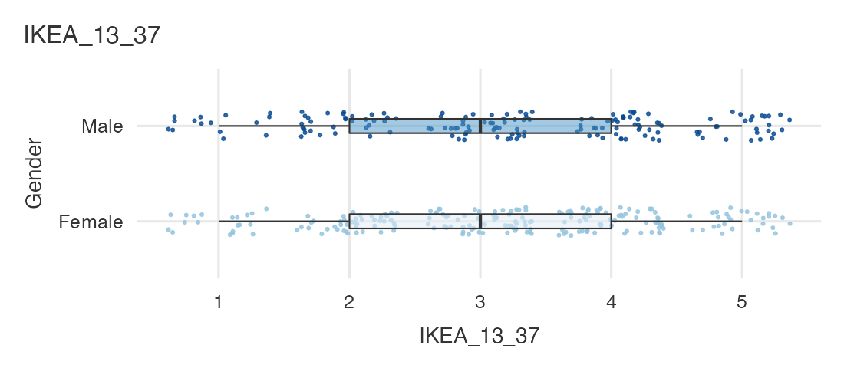
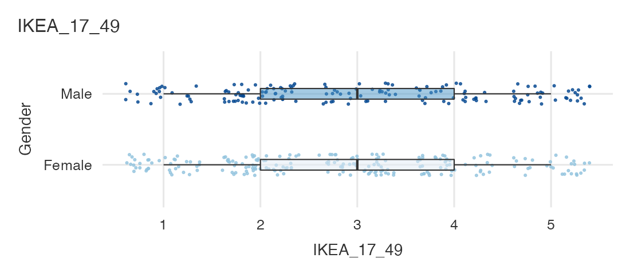
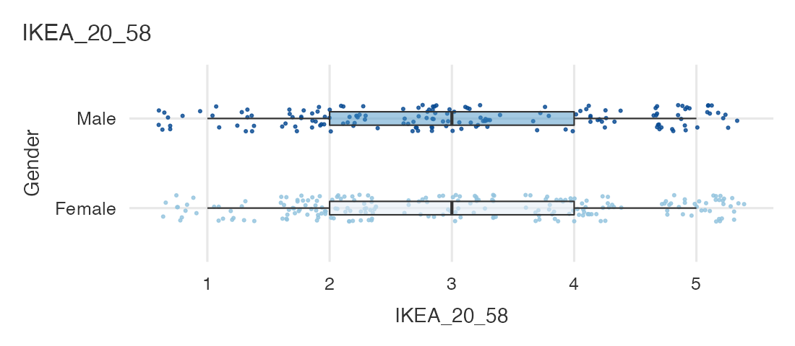
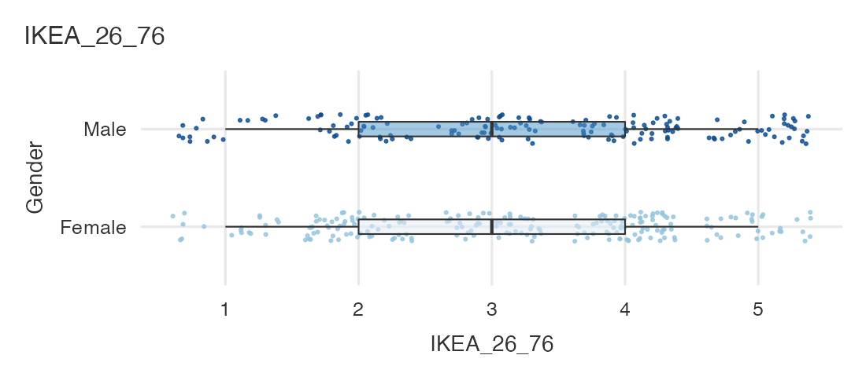
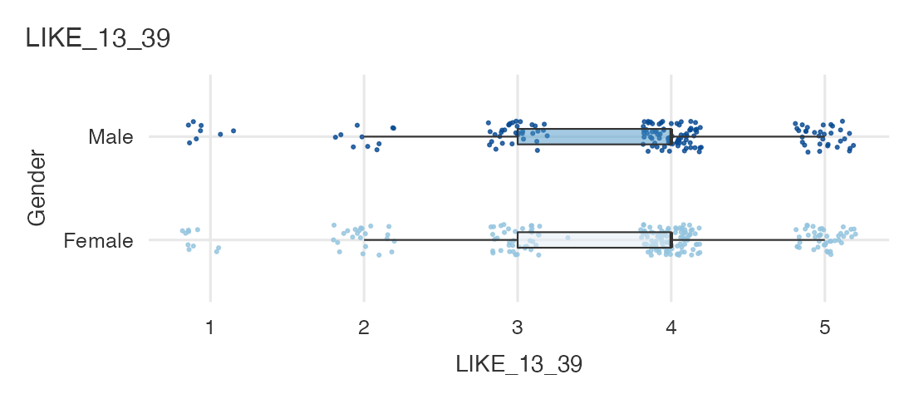
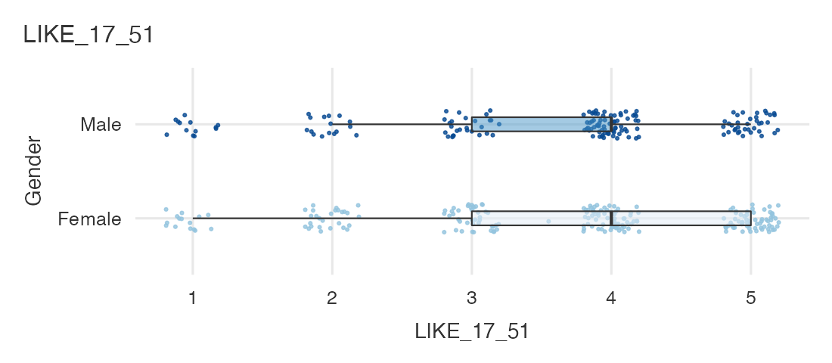
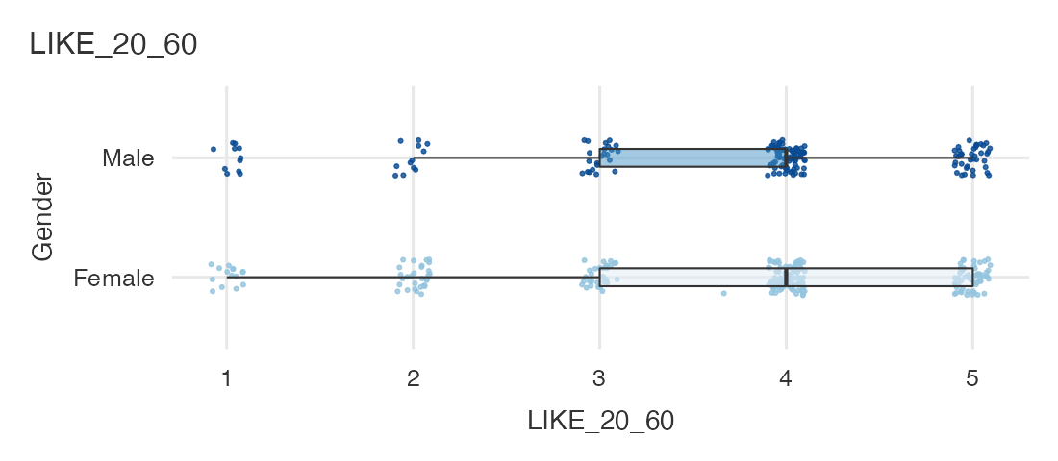
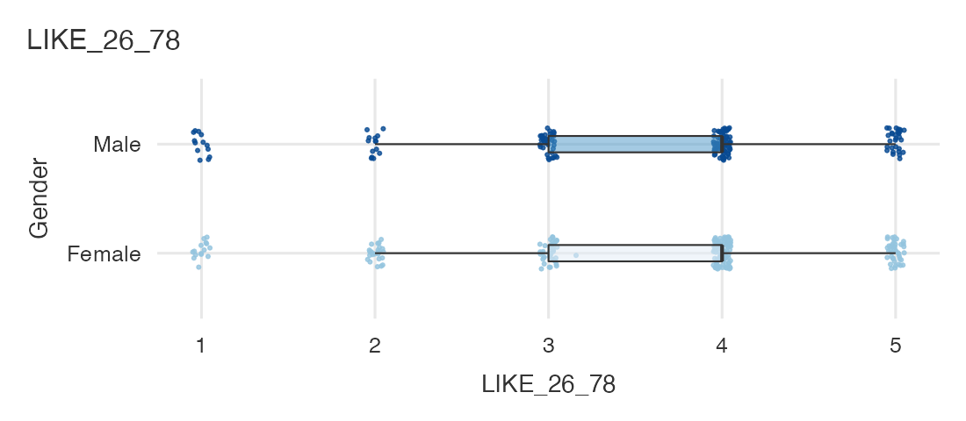
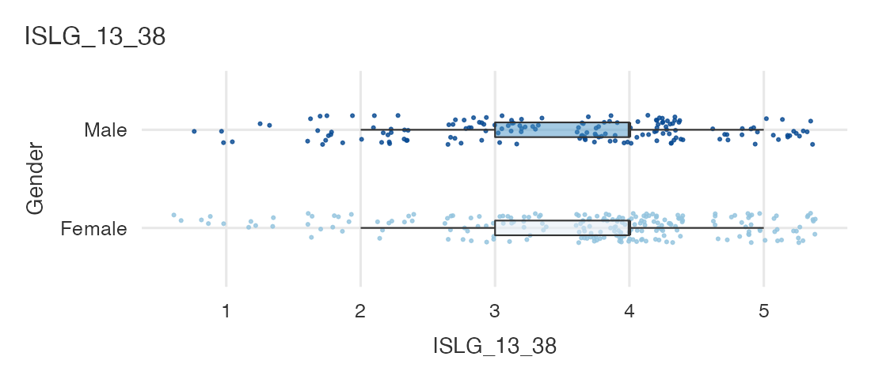
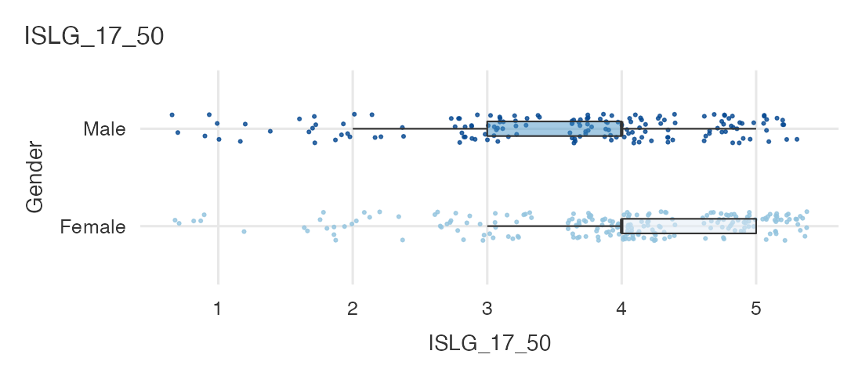
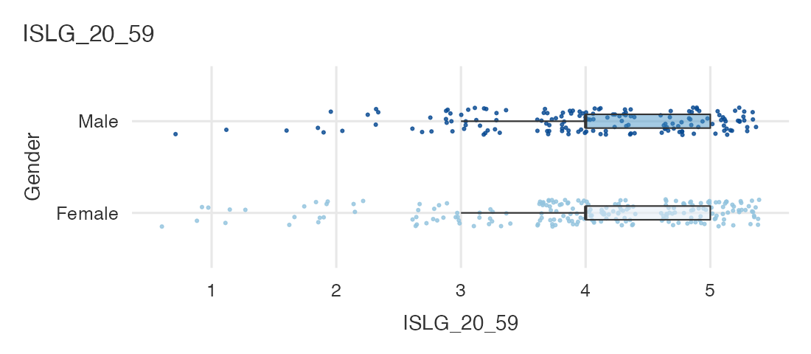
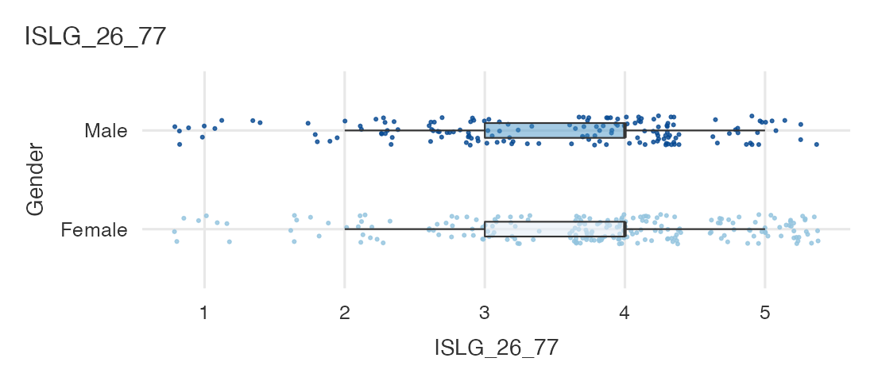

Survey Plots
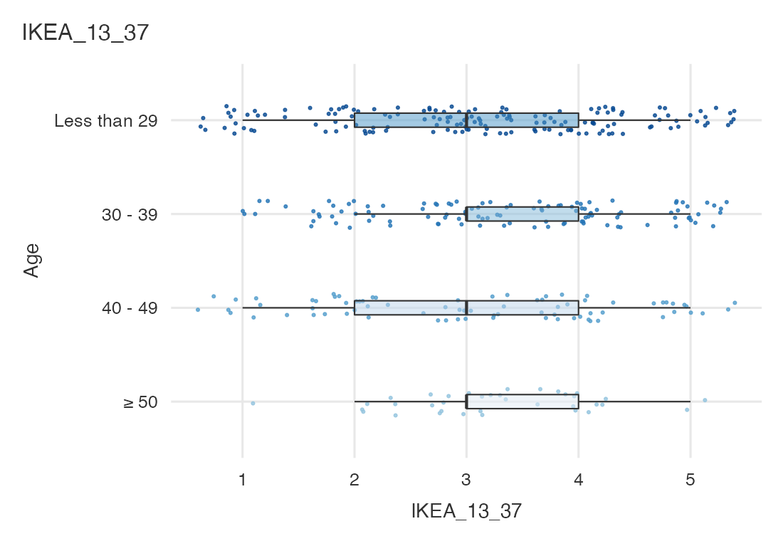
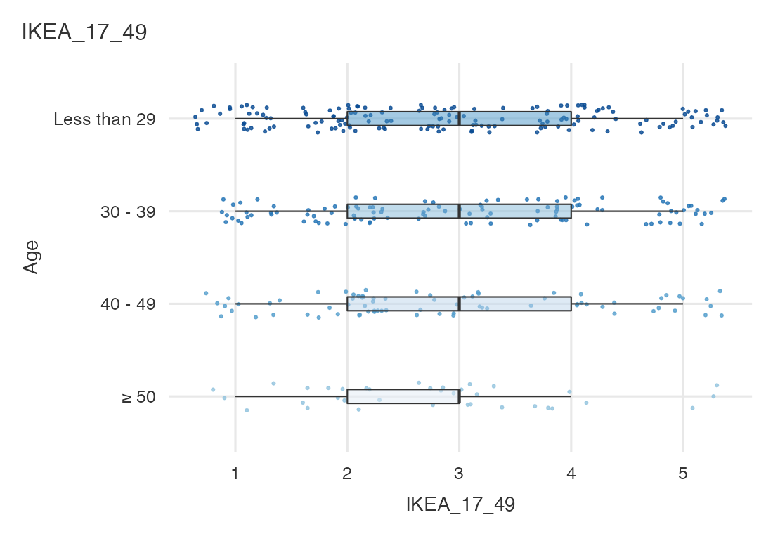
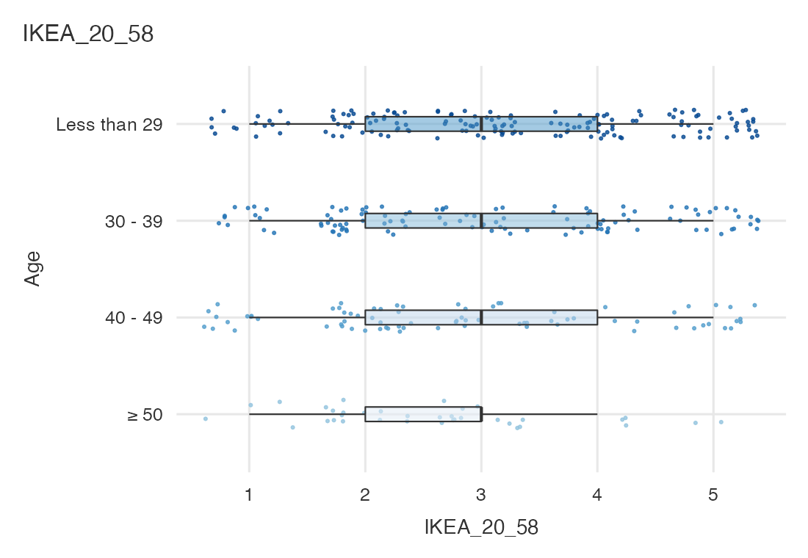
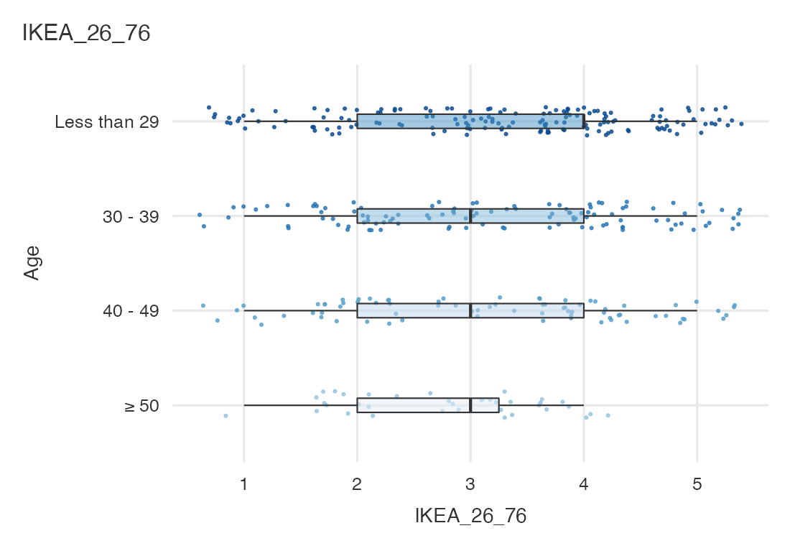
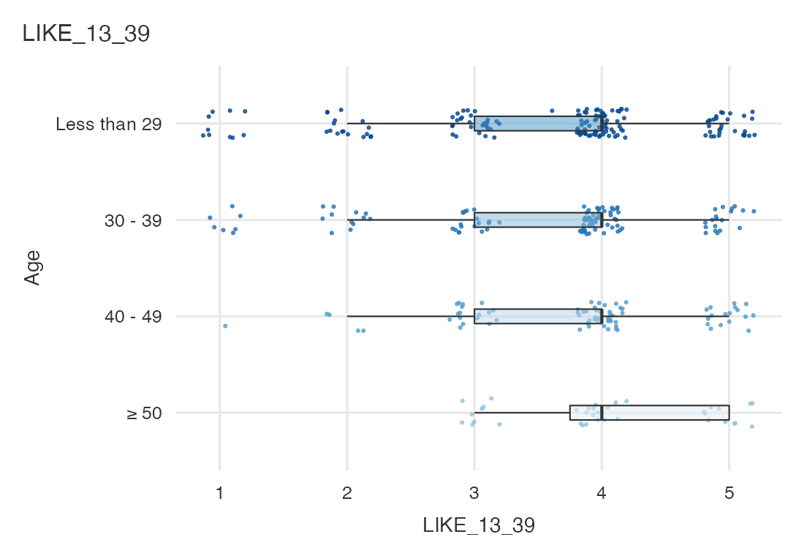
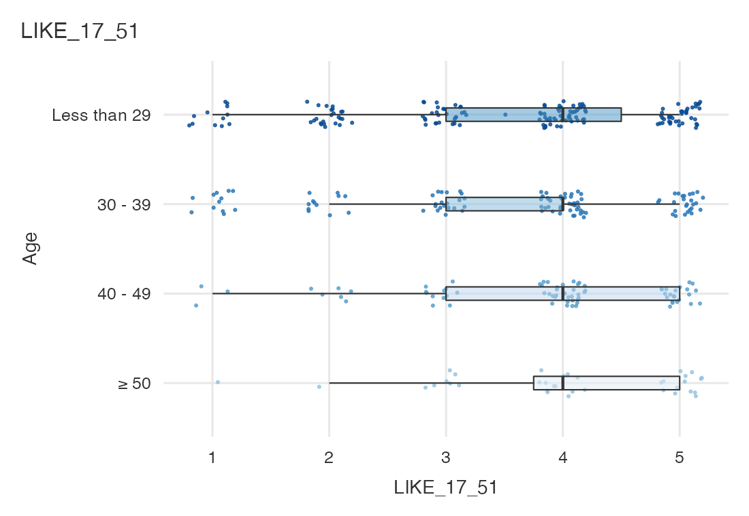
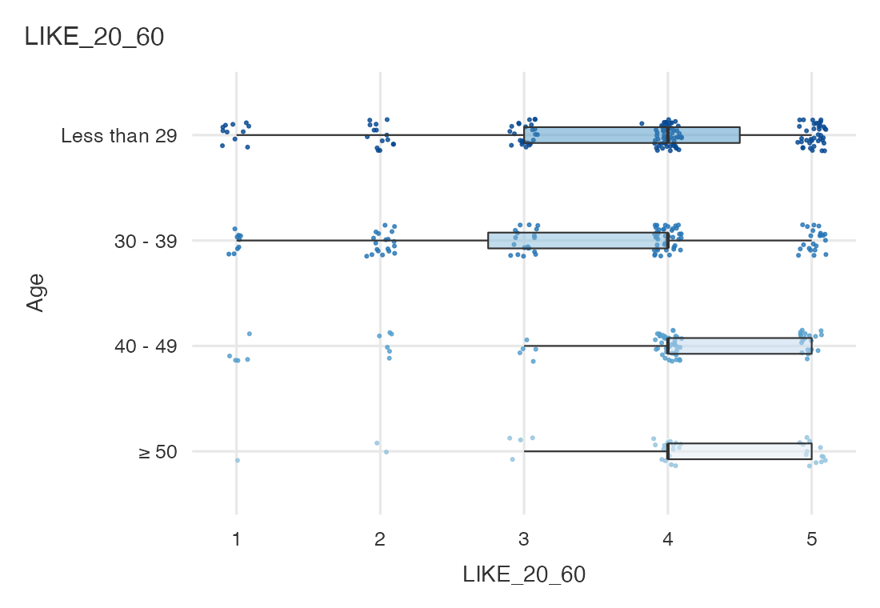
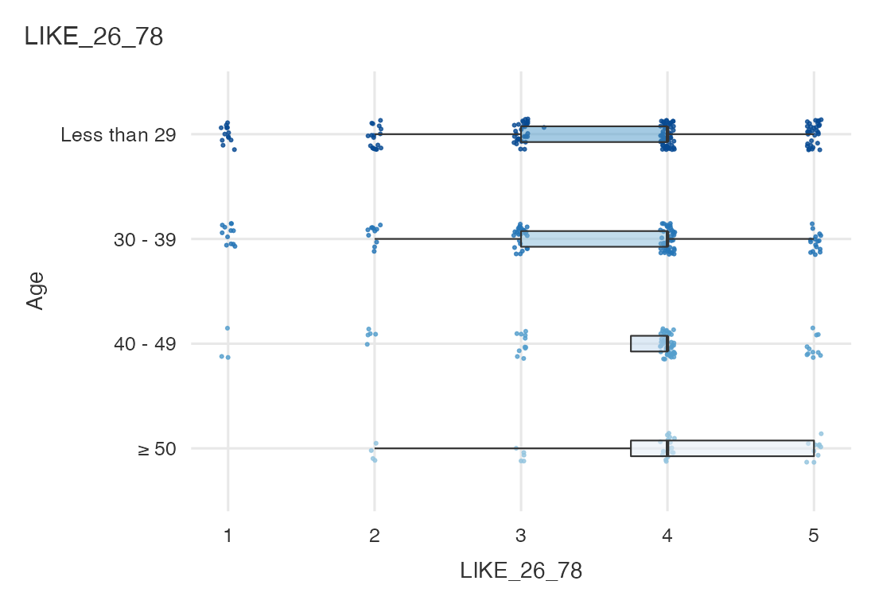
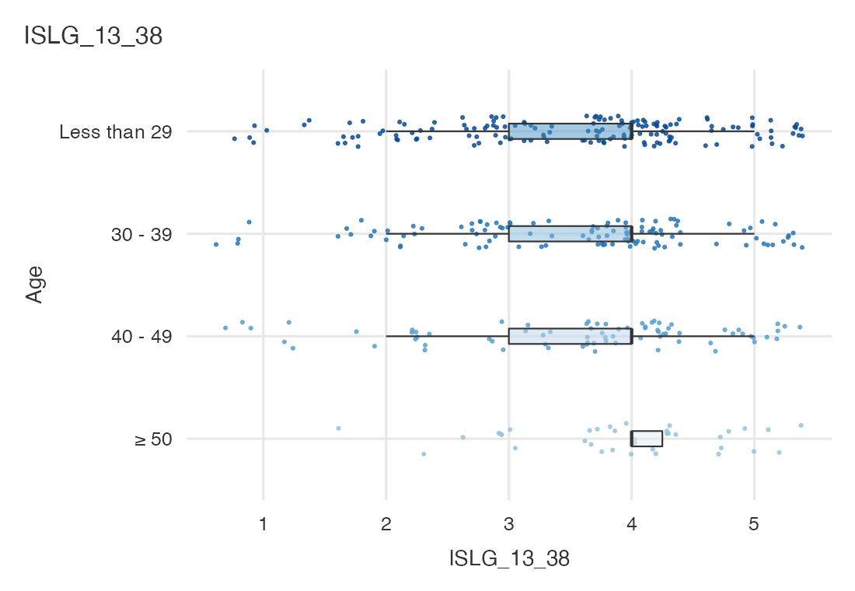
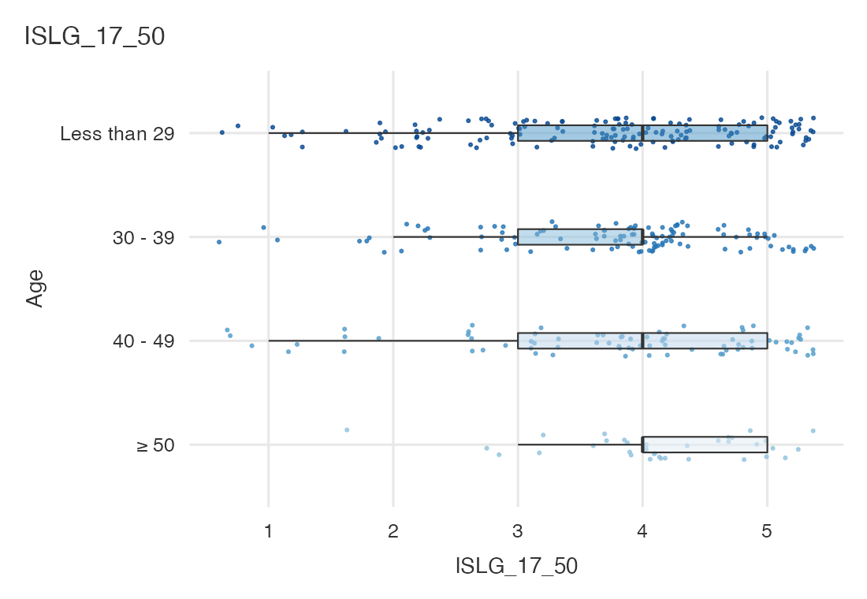
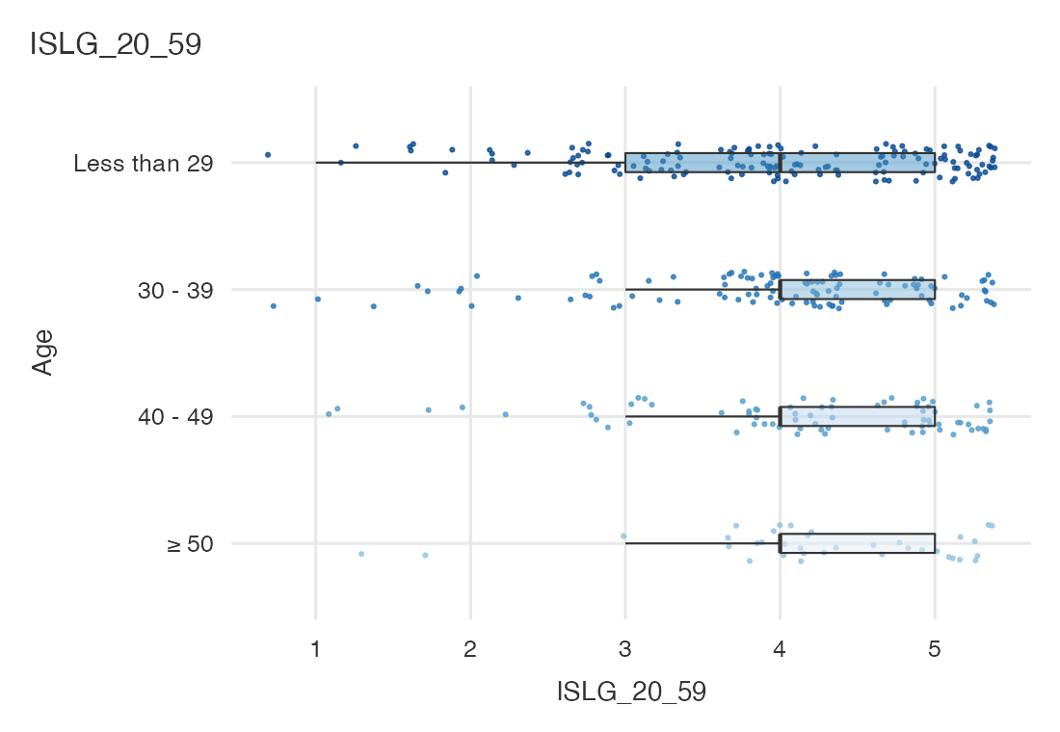
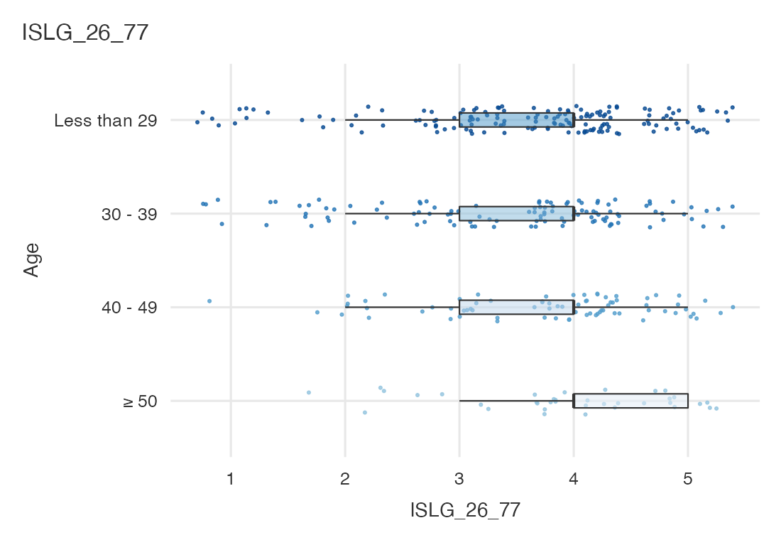

Survey Plots
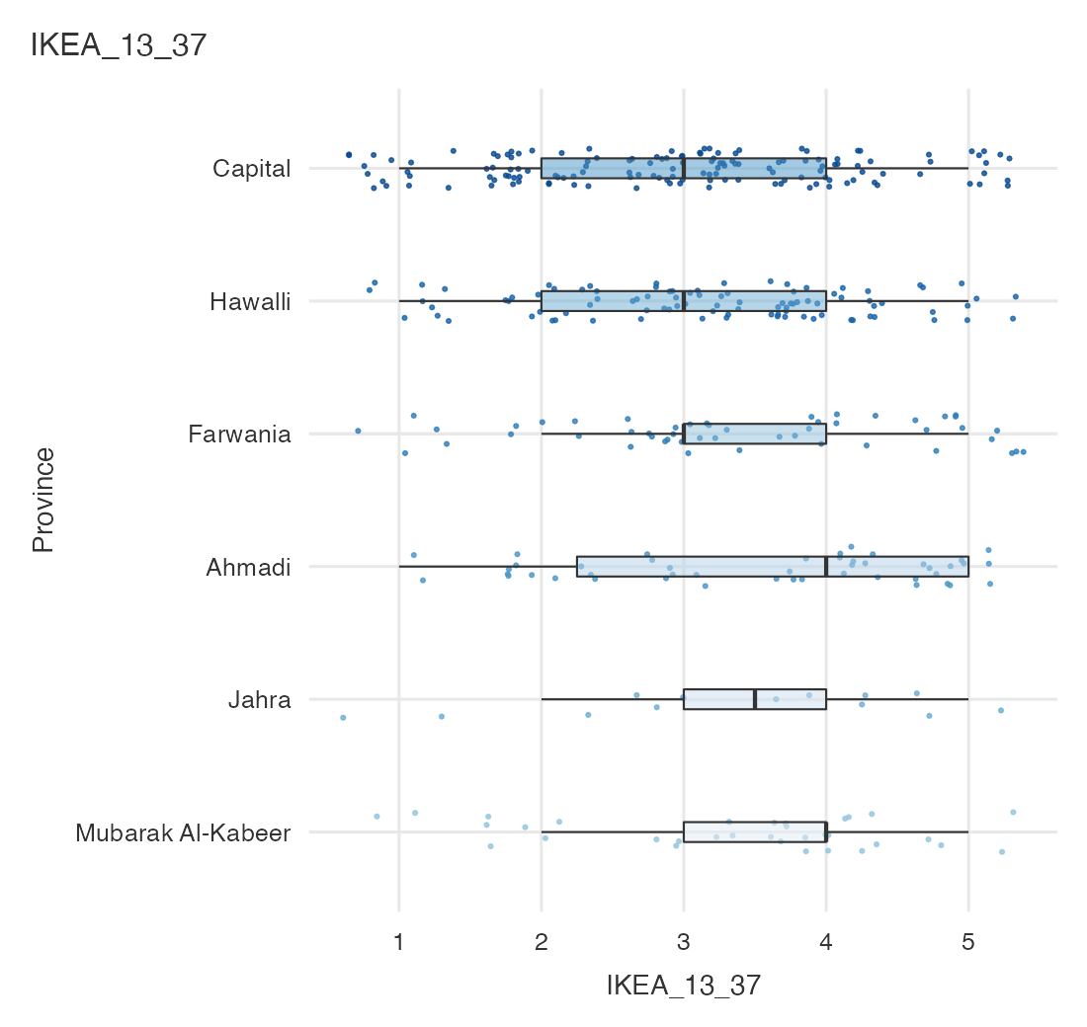
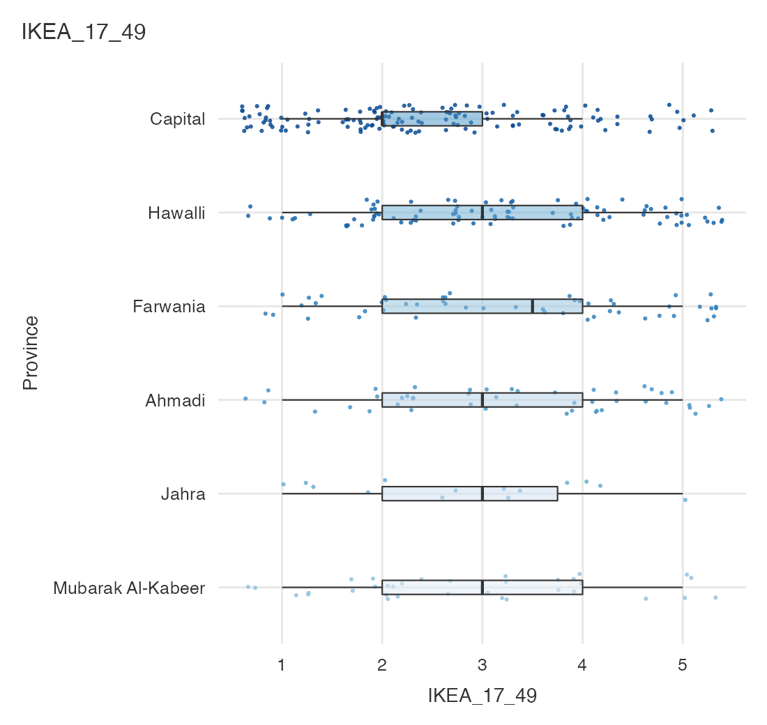
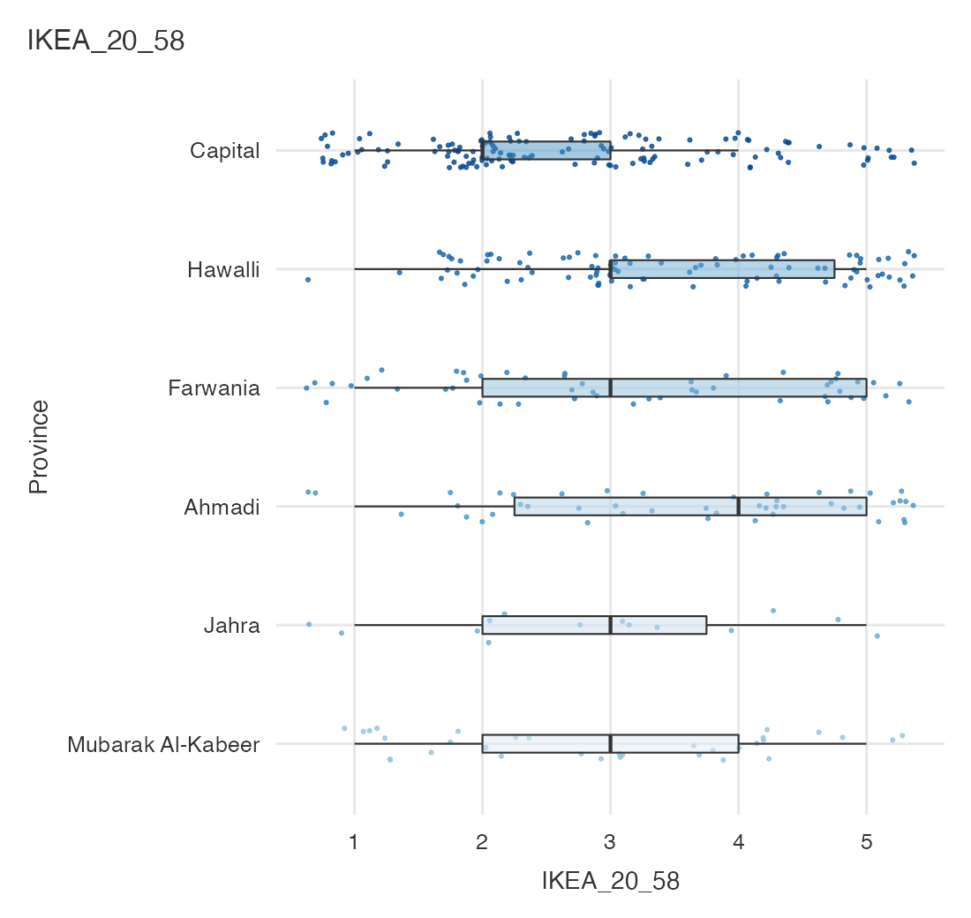
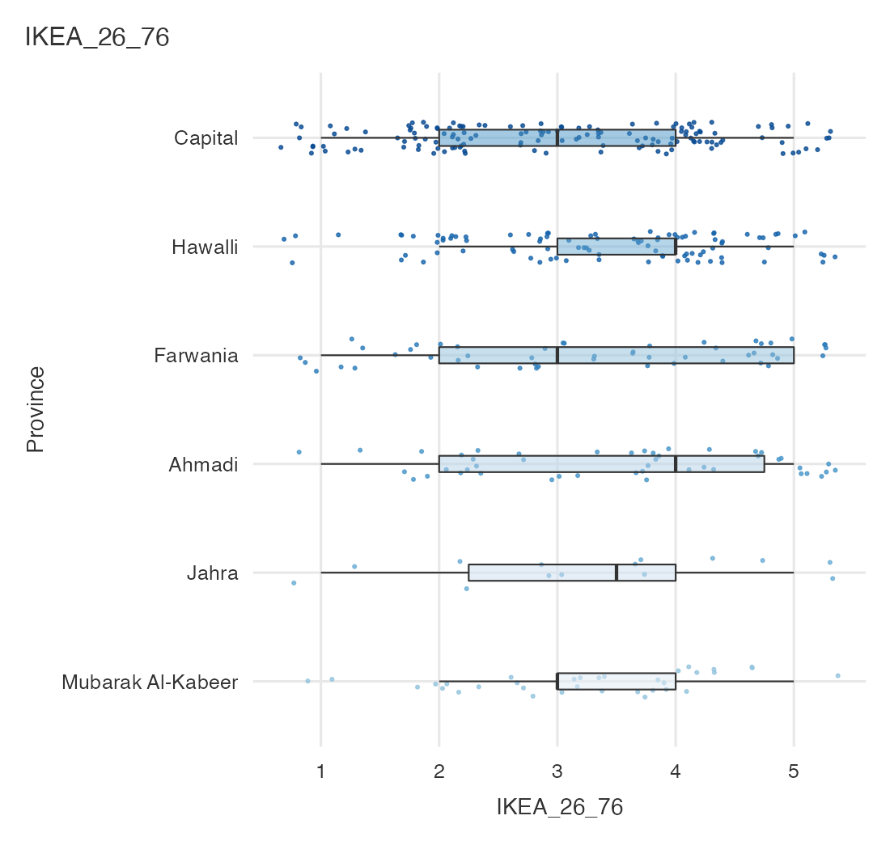
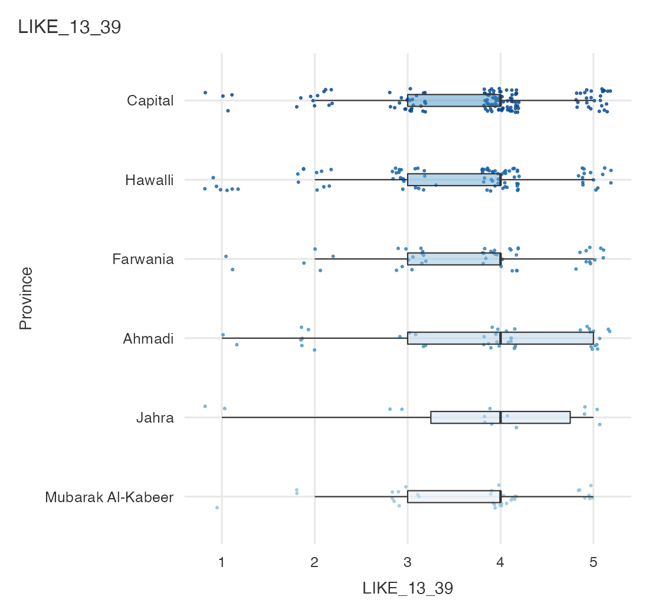
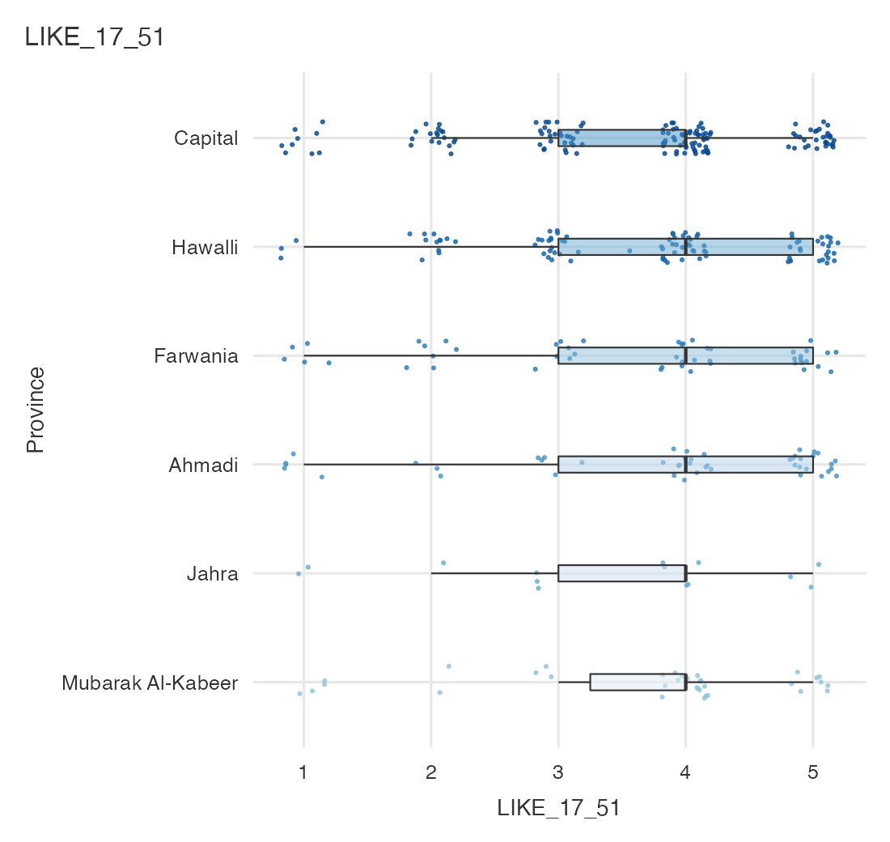
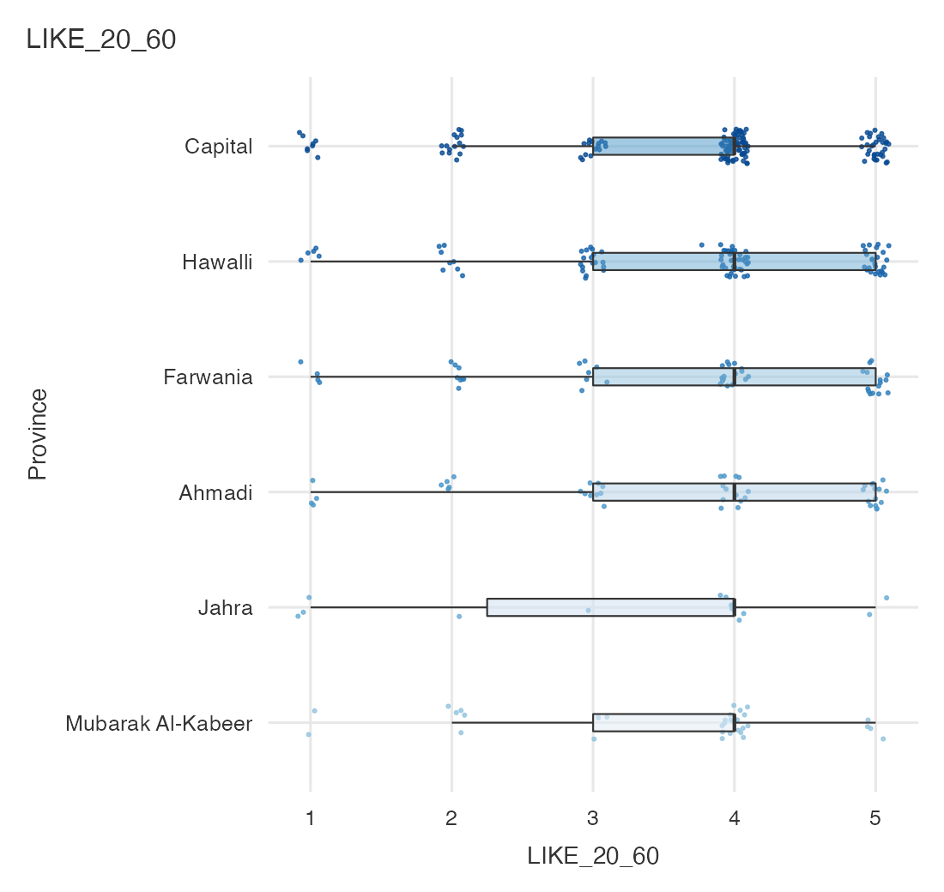
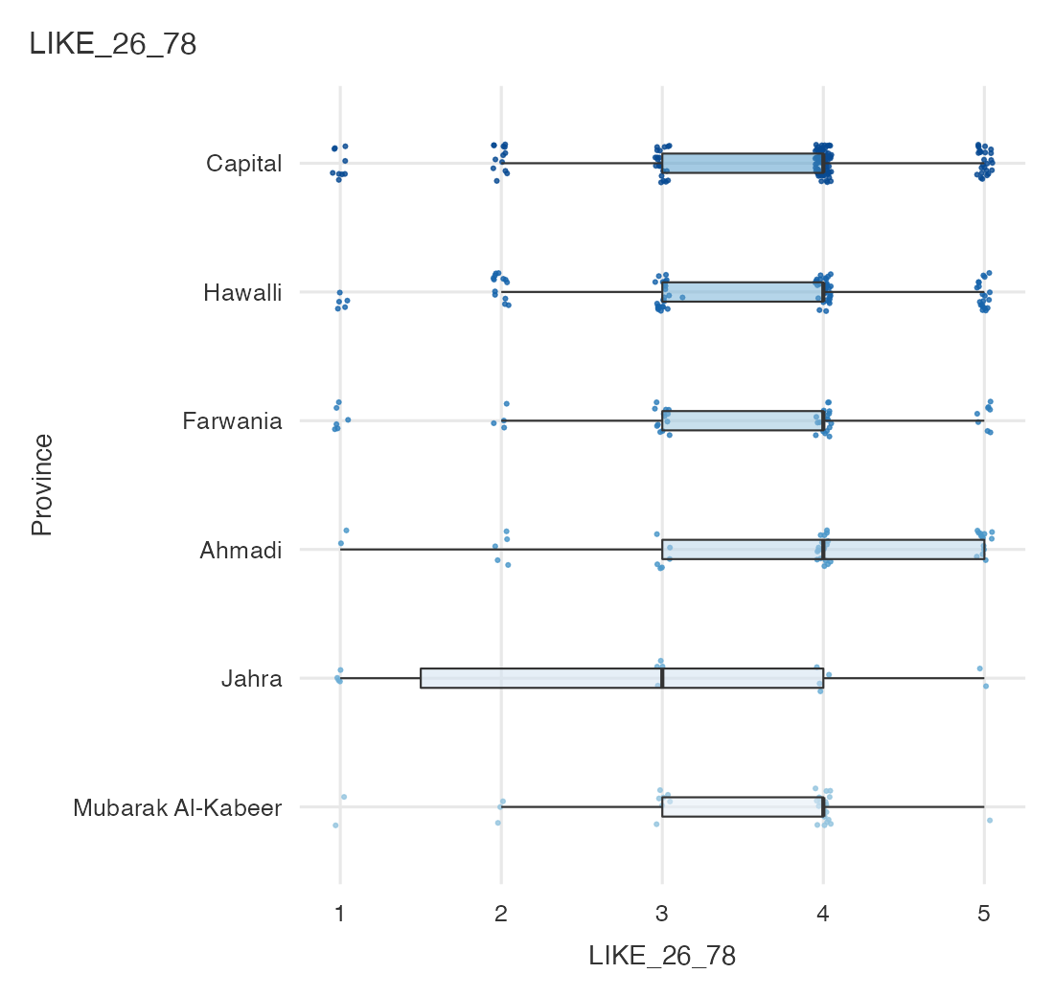
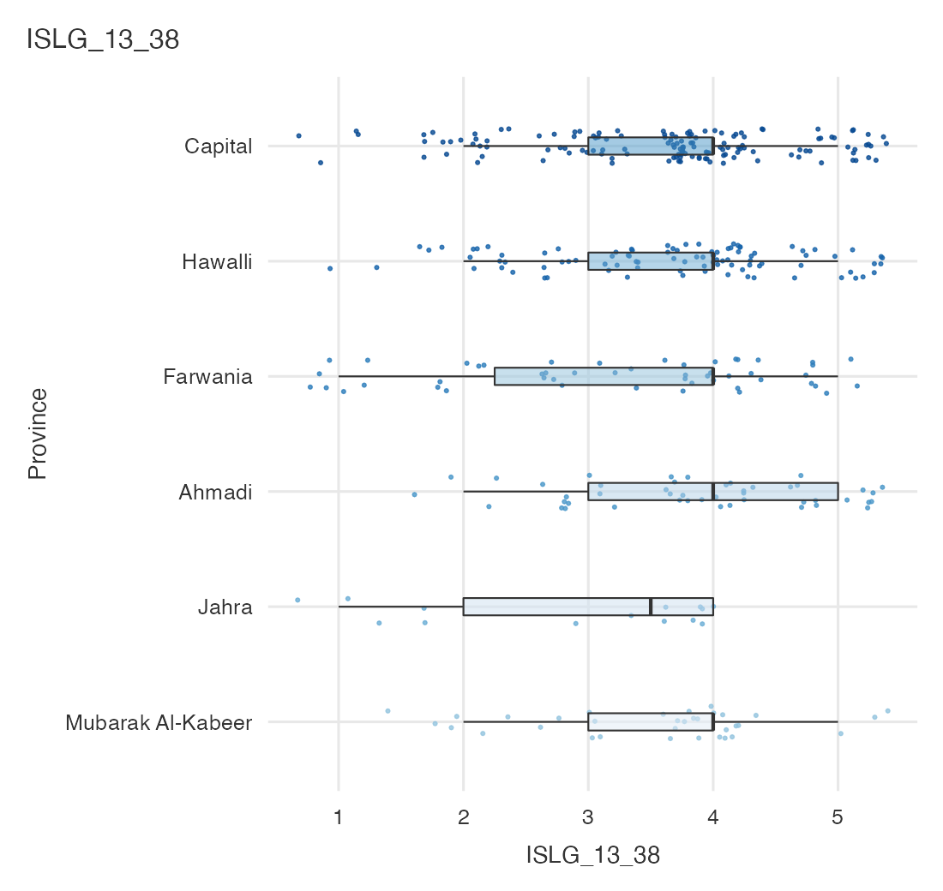
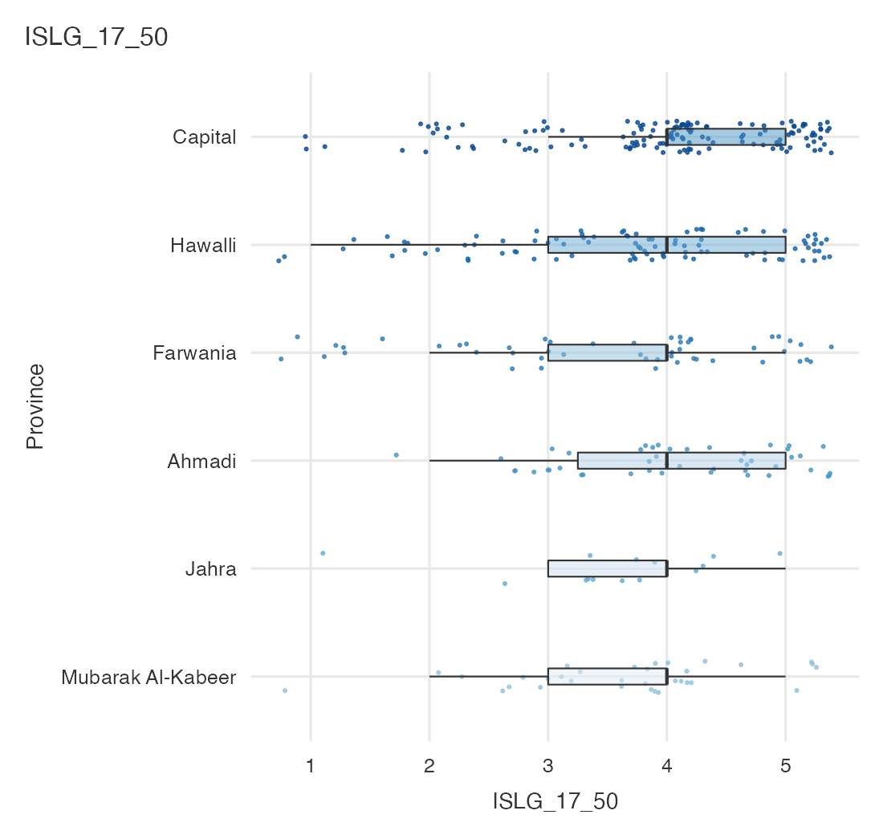
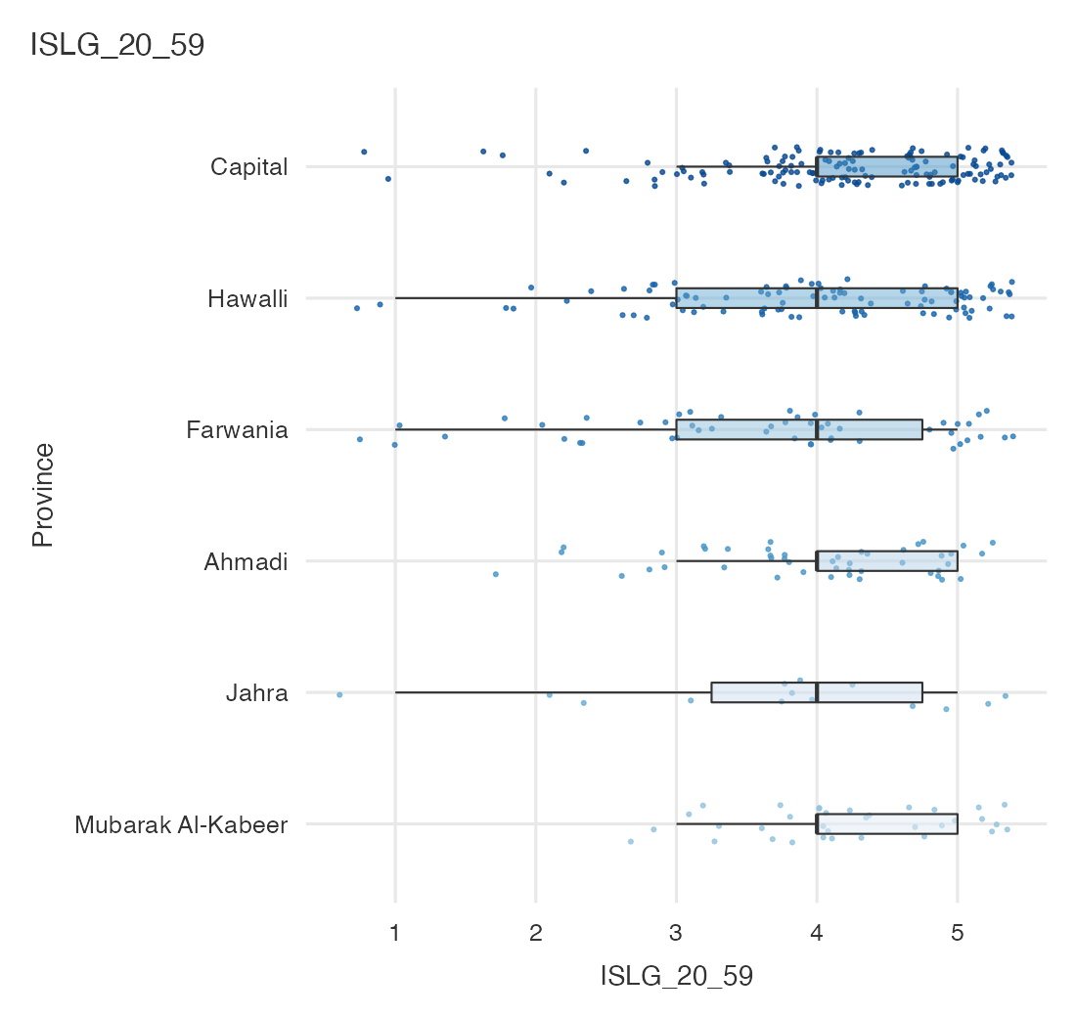
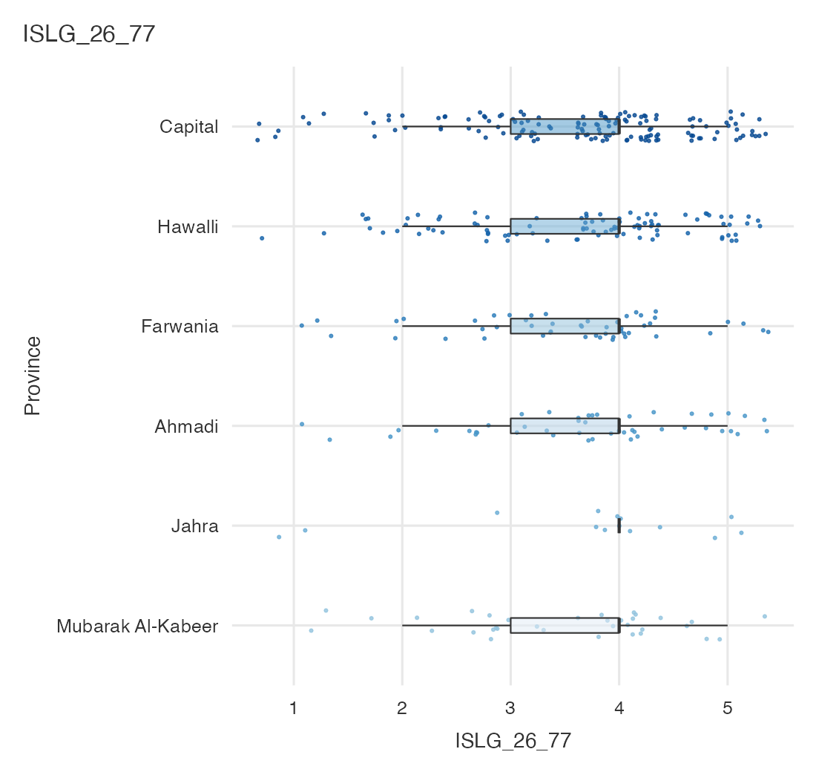

Survey Plots
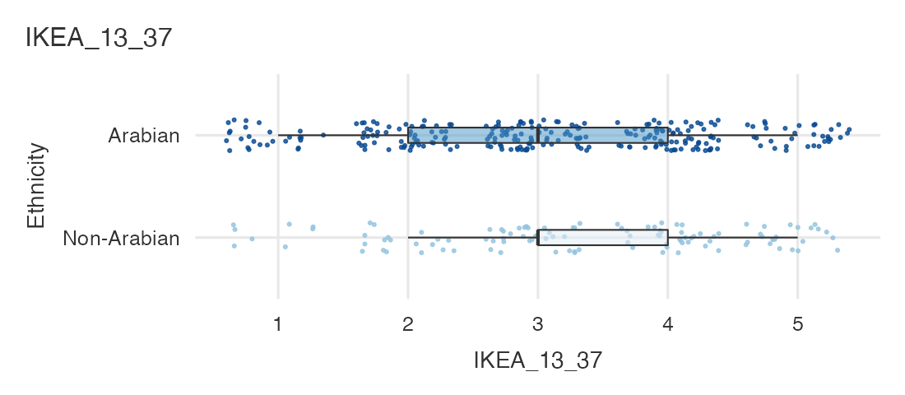
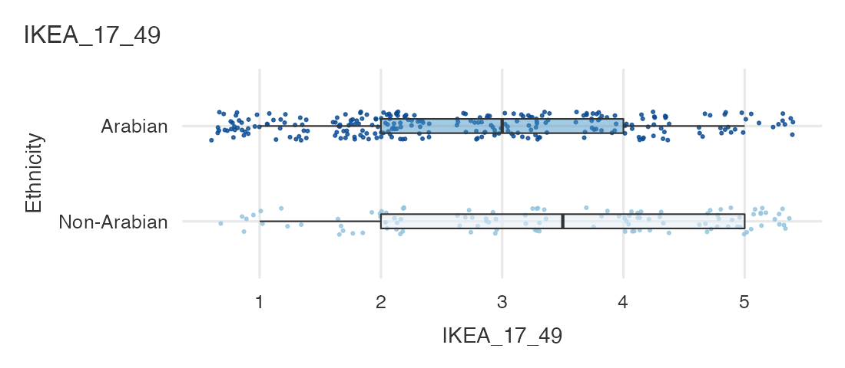
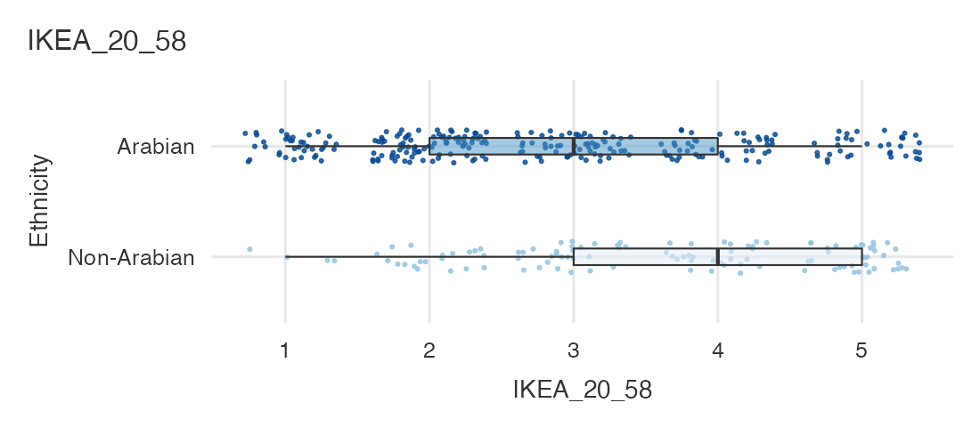
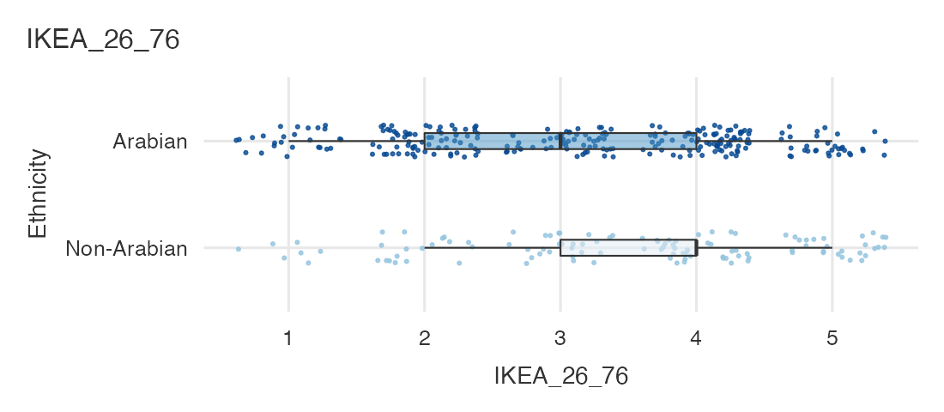
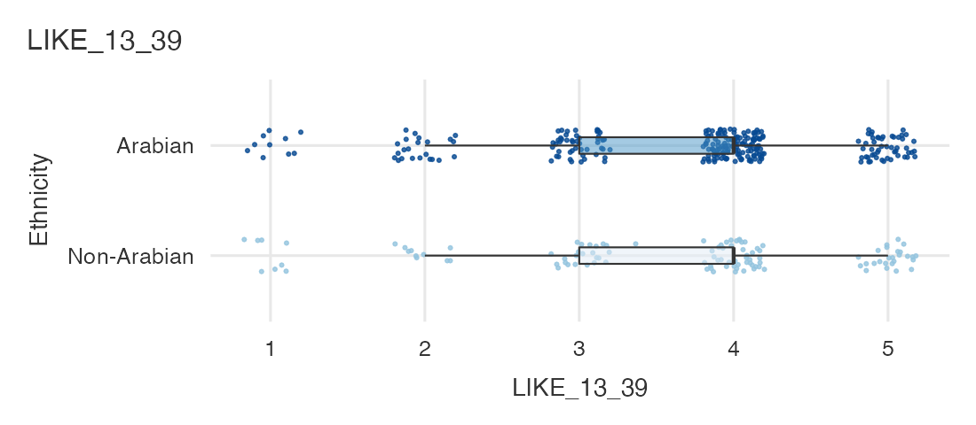
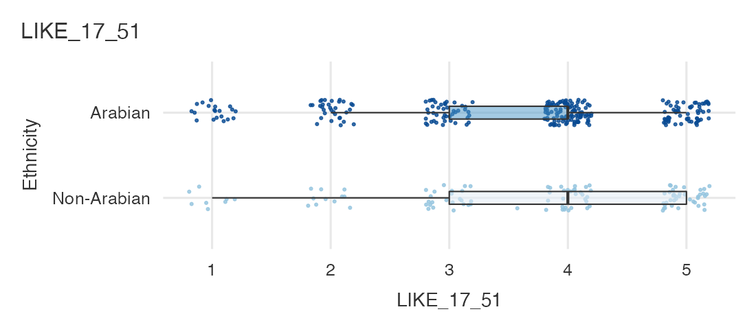
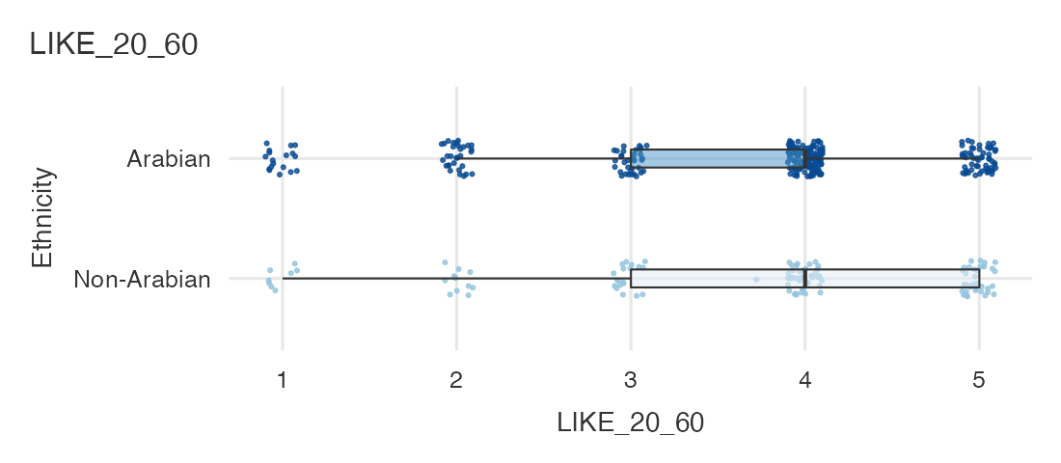
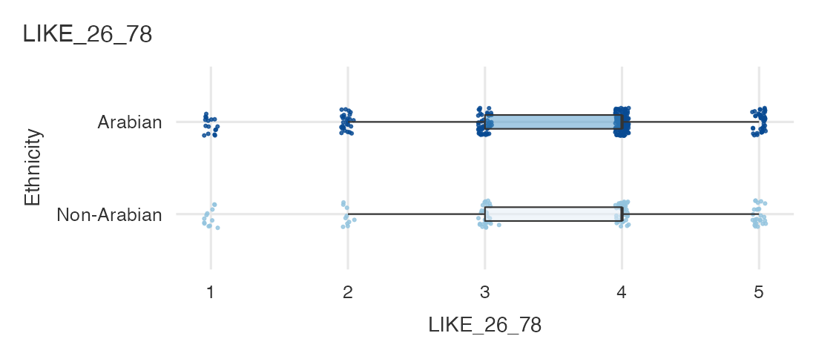
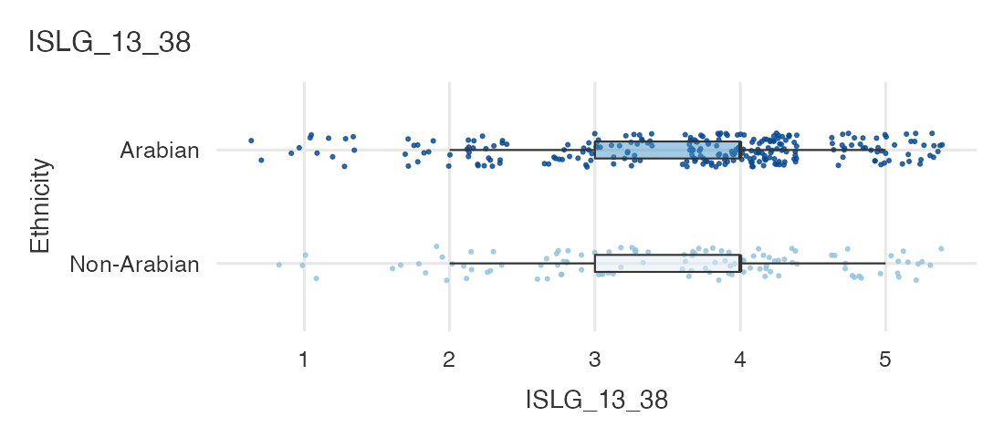
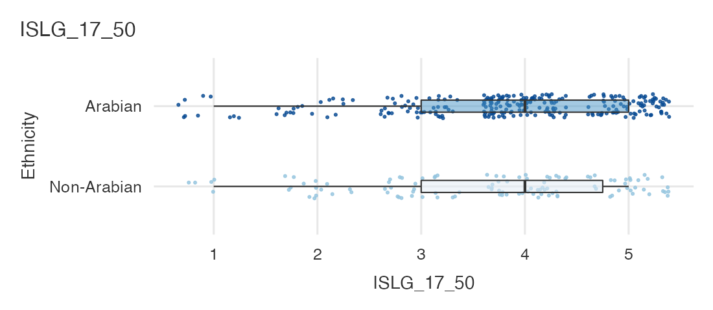
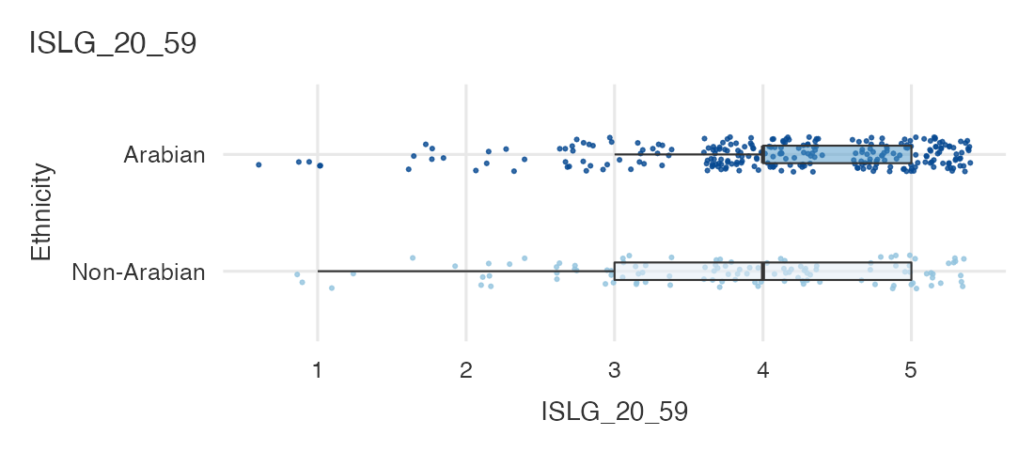
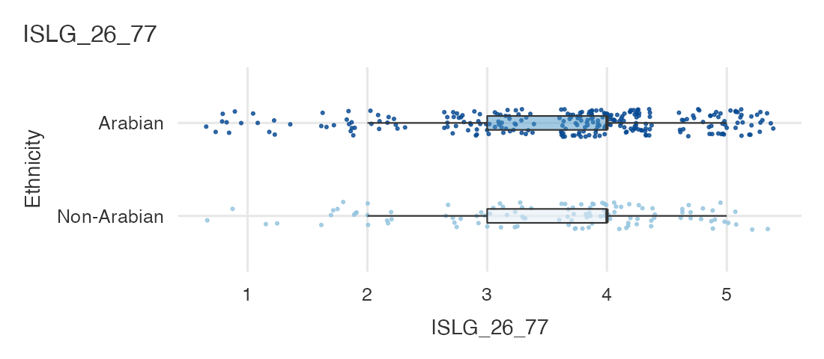

Survey Plots
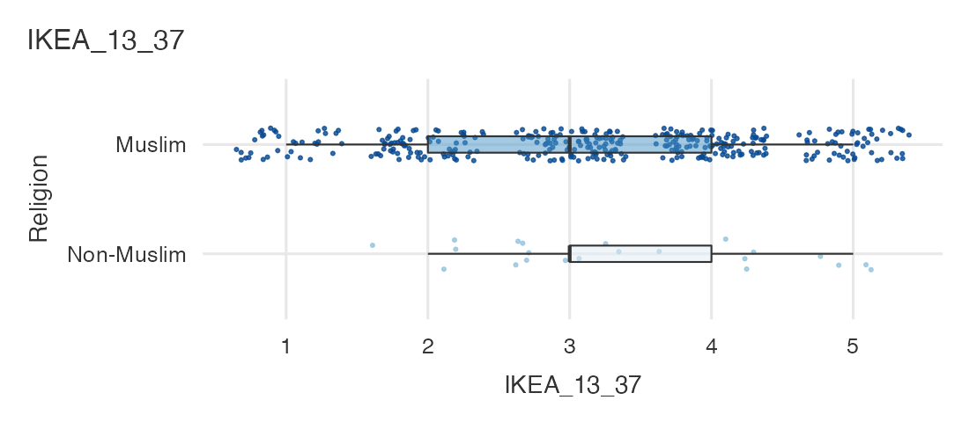
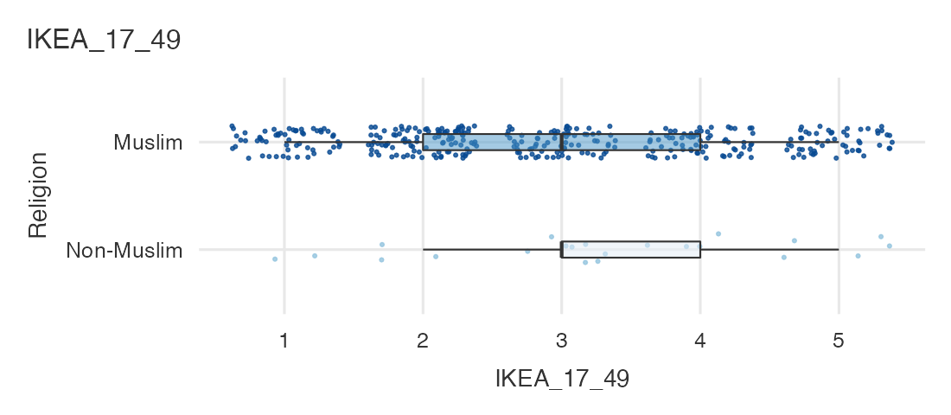
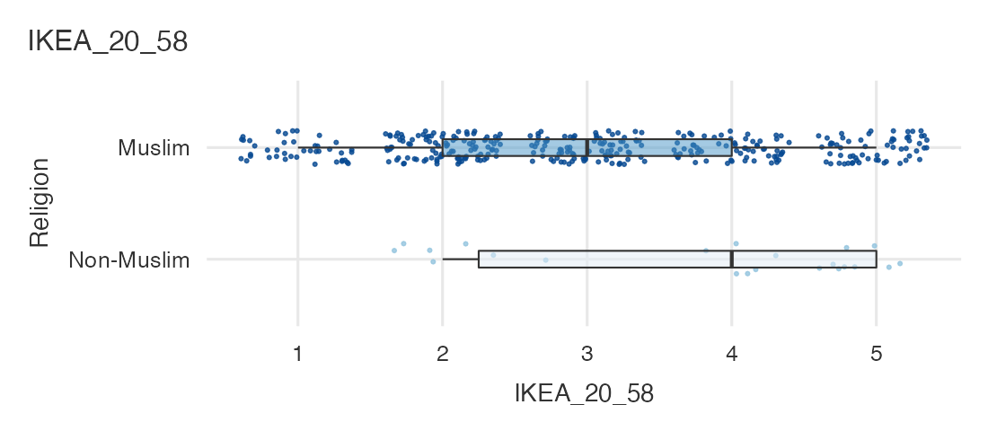
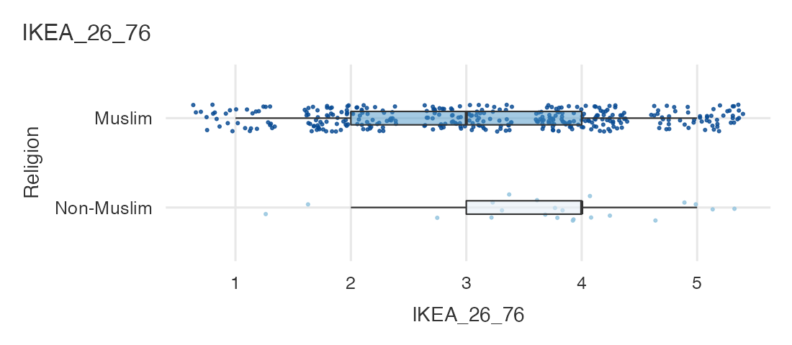
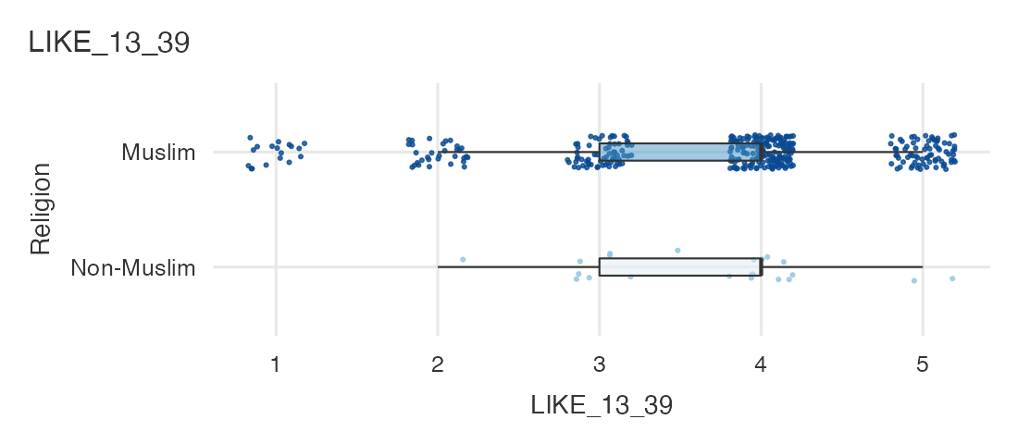
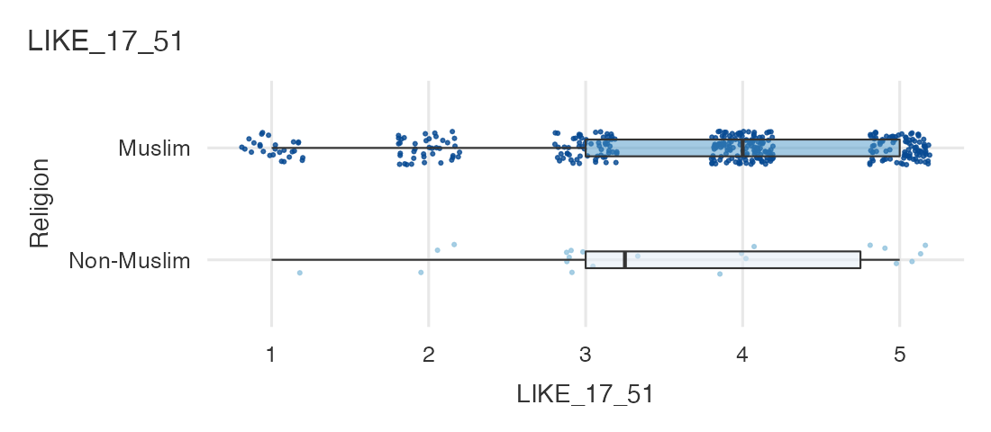
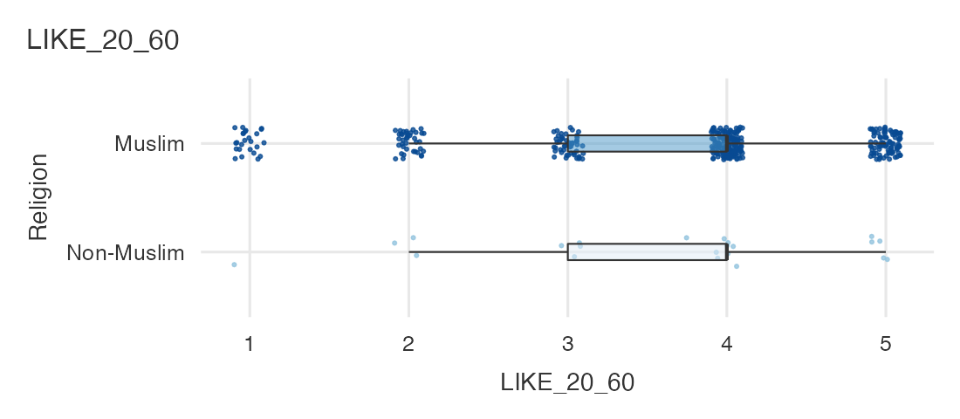
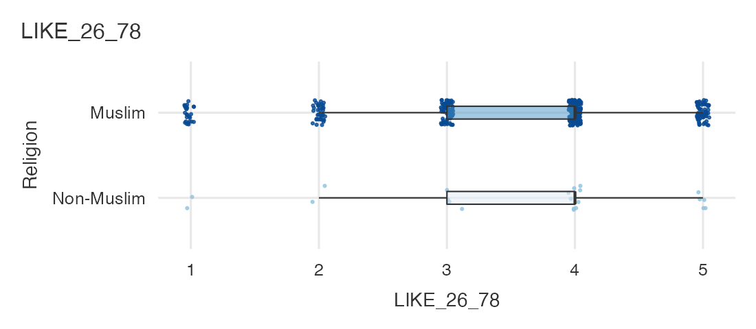
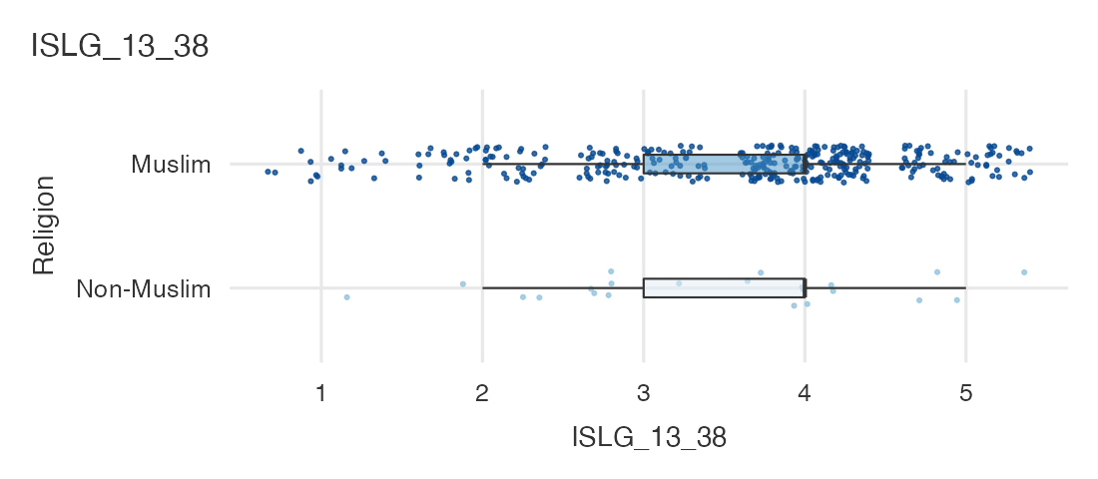
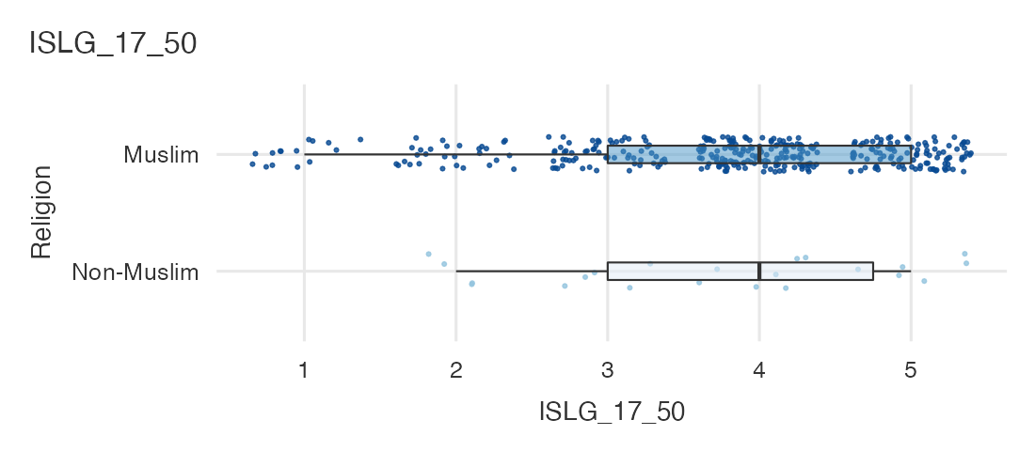
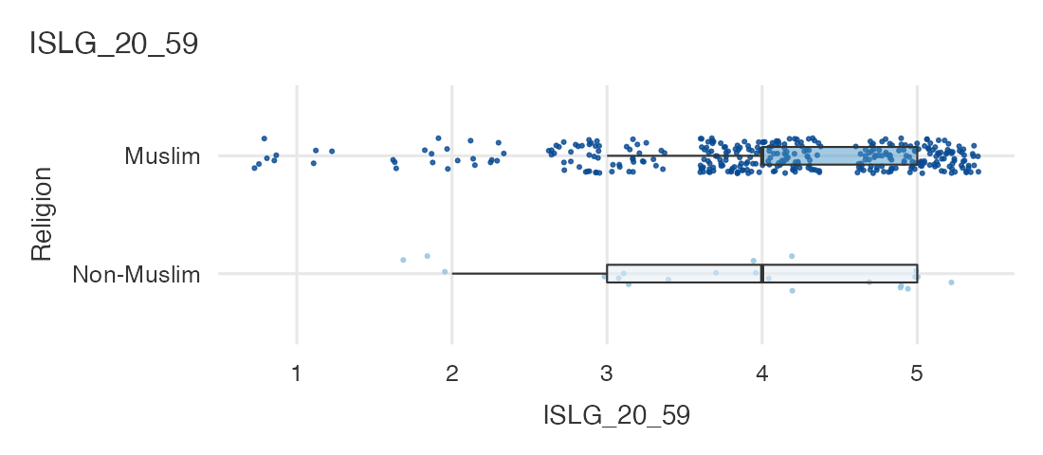
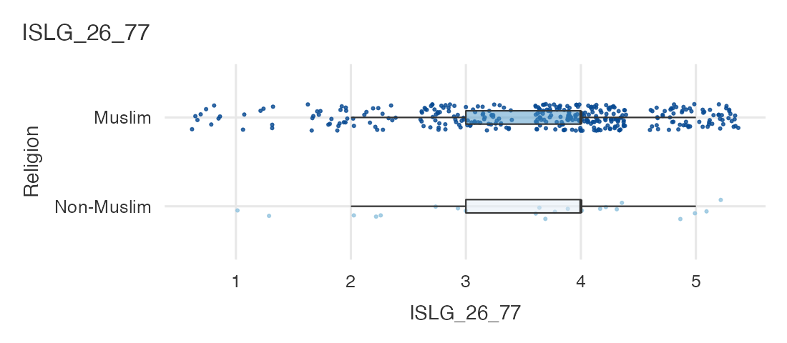

Survey Plots
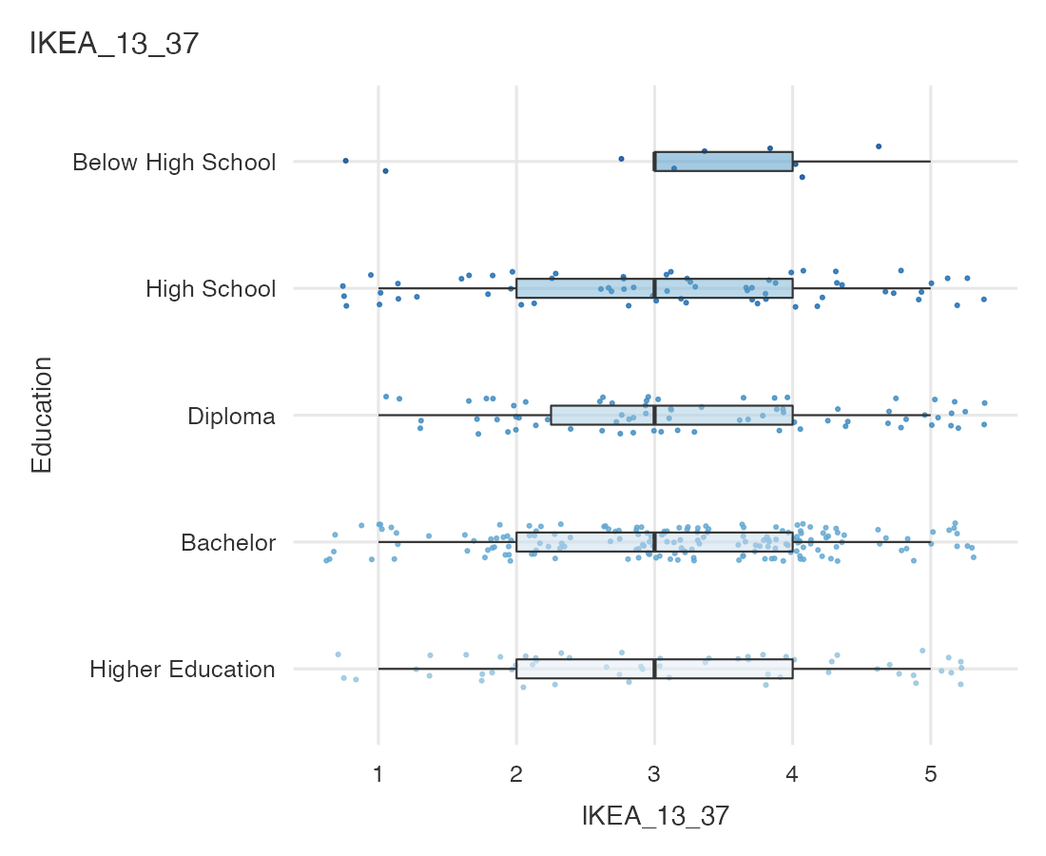
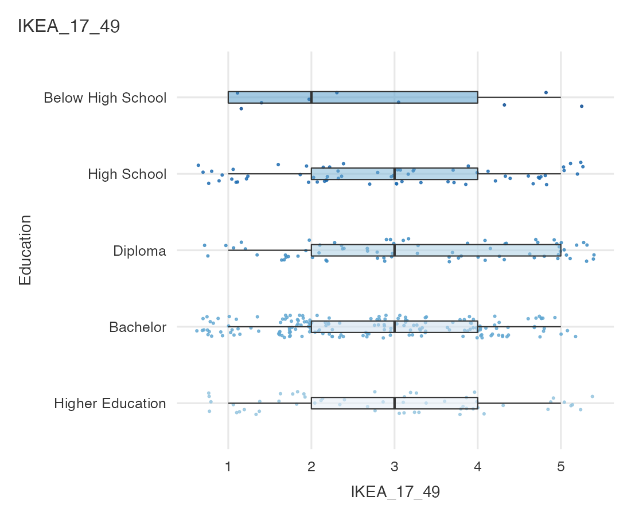
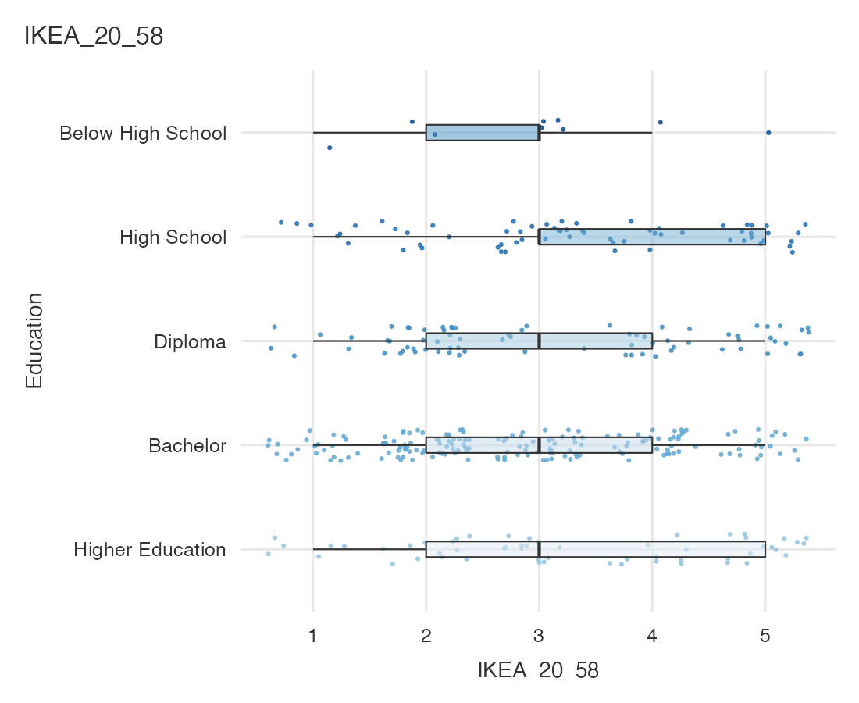
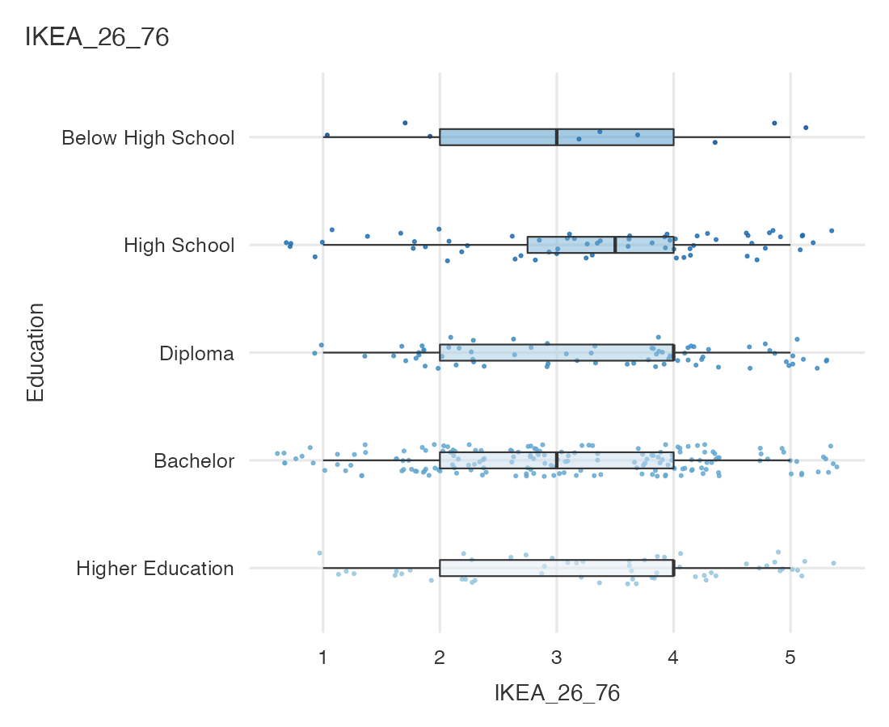
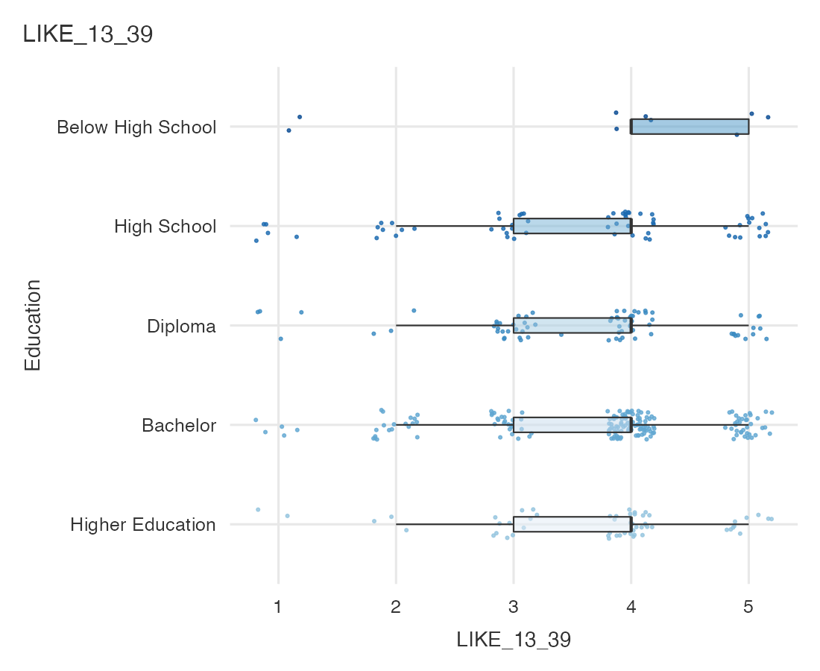
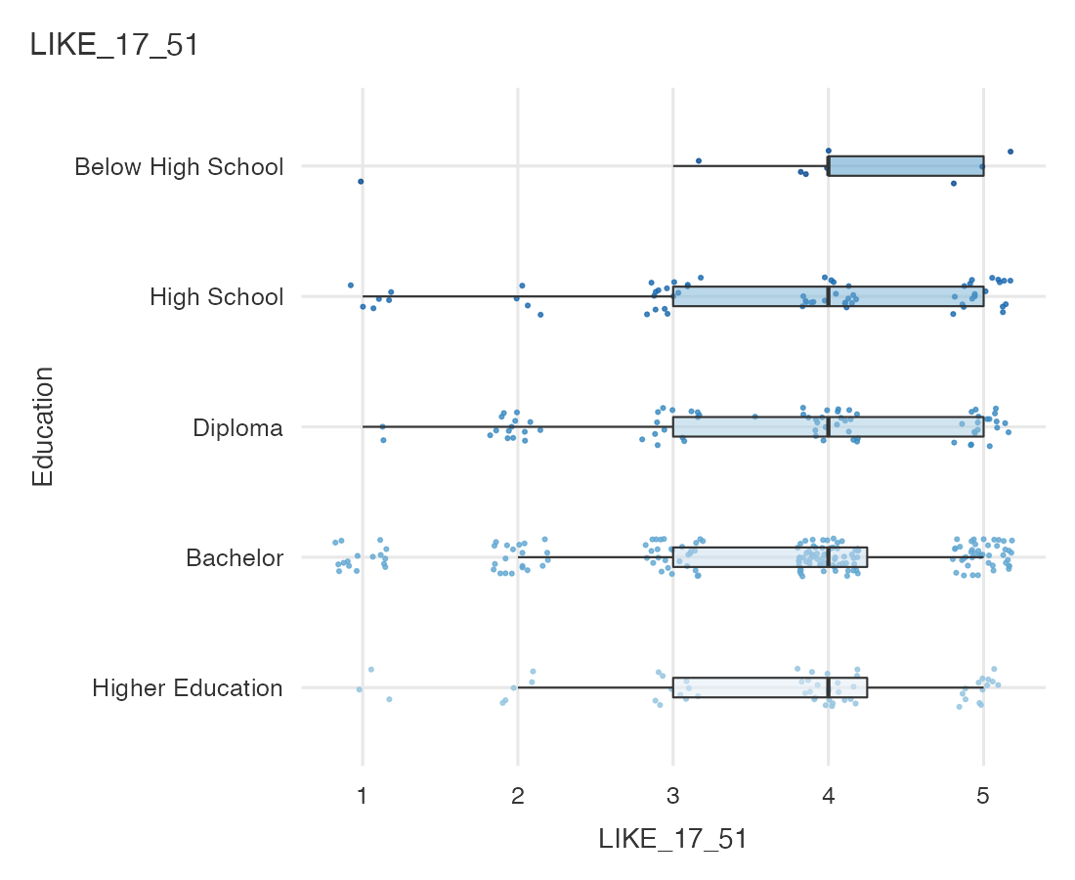
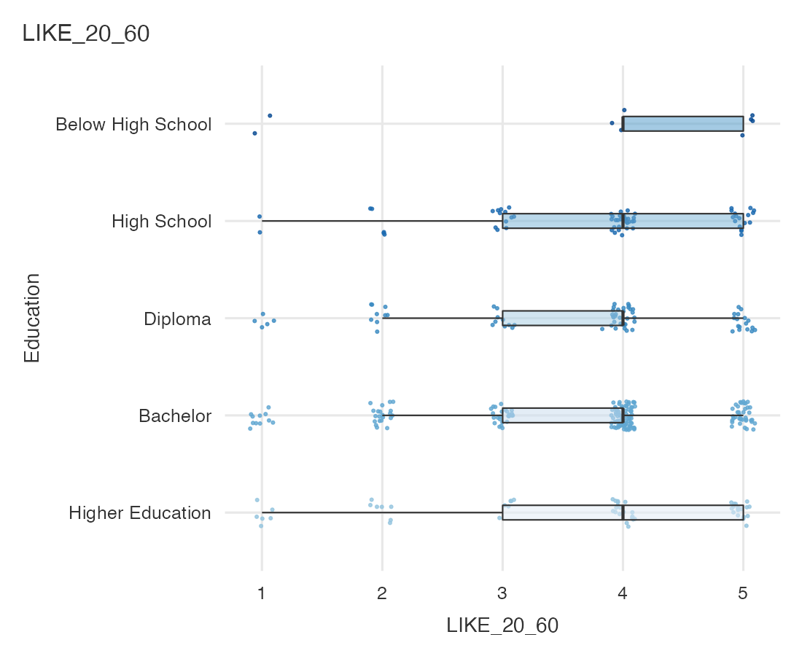
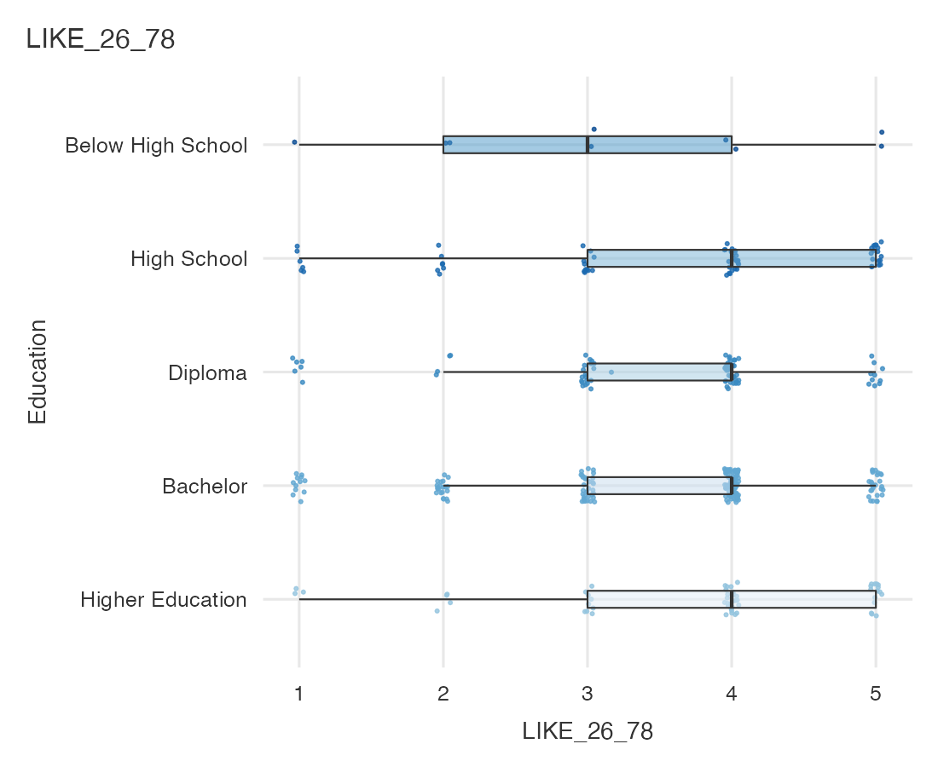
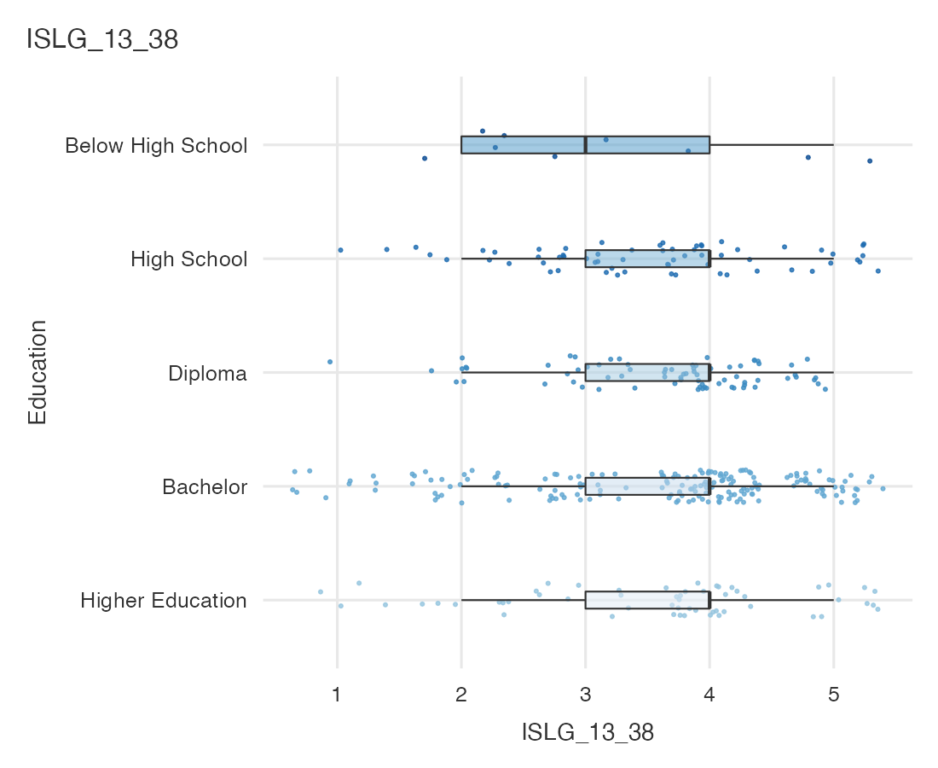
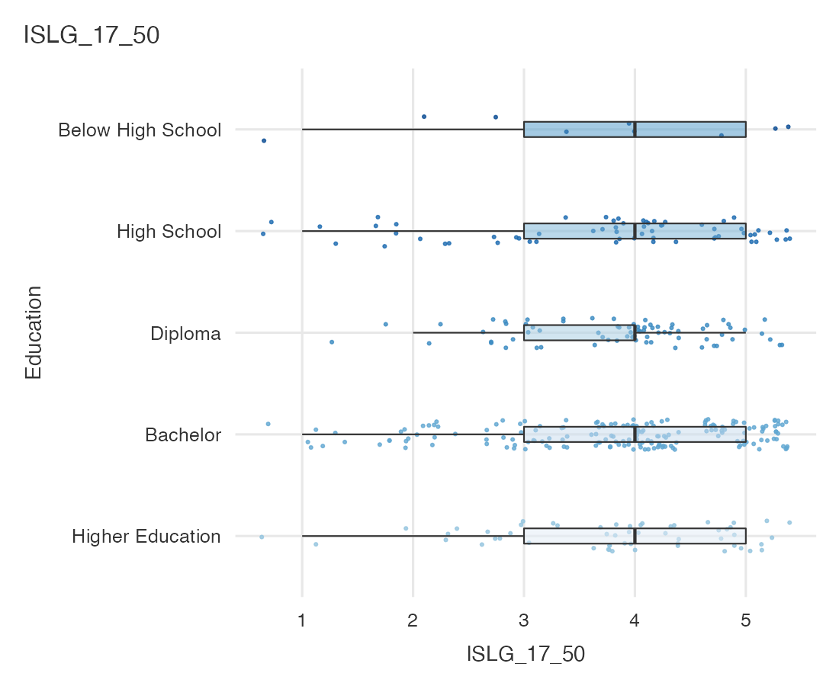
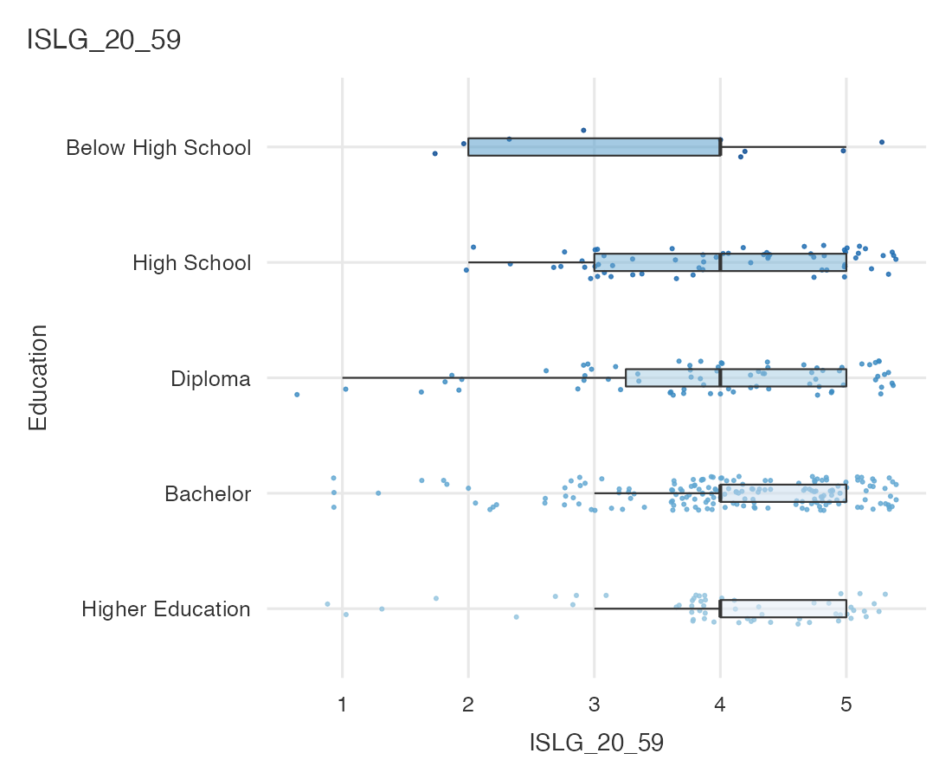
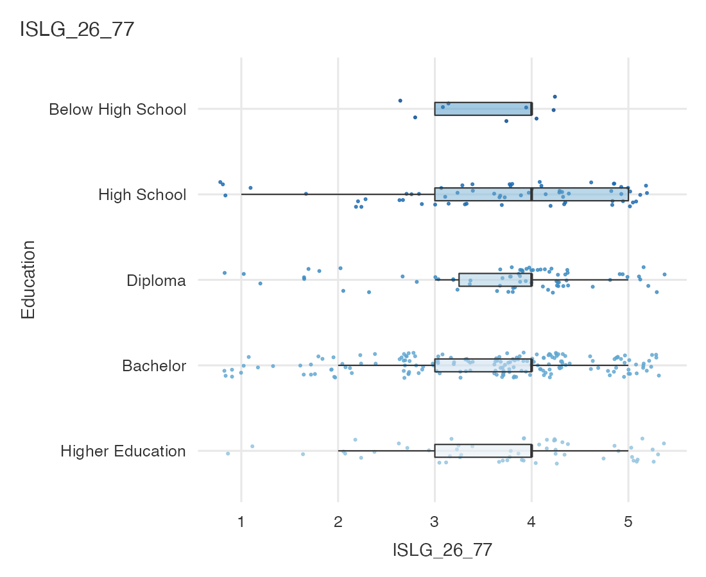

Survey Plots
