IKEA-IG Shape Grammar PD Formations and Outcomes – Initial Shape Octagon.

Through shape-rule applications, Initial Shape Octagon is used as an example to undergo shape grammar transformations developing Pattern Design (PD) creations. The final IKEA-IG PD framed illustration outcome is also presented:

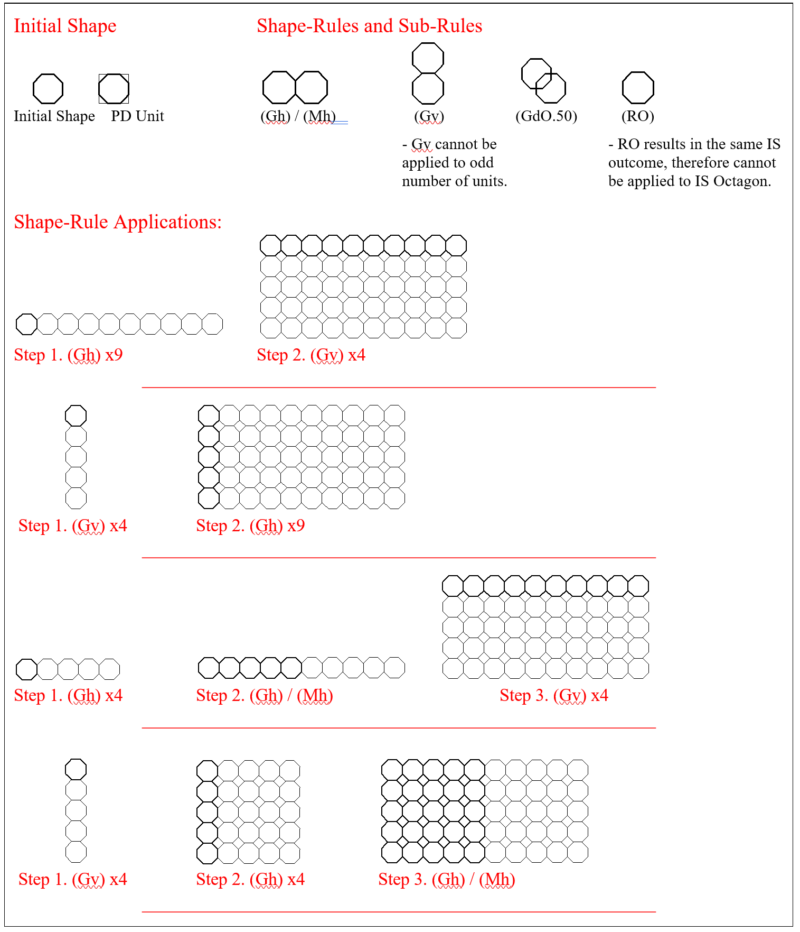
(Set #1) -

(Set #3) -
