Table 1
Two-Tailed Independent Samples t-Test for IKEA_5_13 by Group
 | KWT |  | UK
Variable | M | SD | M | SD | t | p | d
IKEA_5_13 | 2.00 | 1.25 | 2.57 | 0.94 | -2.02 | .048 | 0.51
Note. N = 63. Degrees of Freedom for the t-statistic = 61. d represents Cohen's d.
Figure 1
The mean of IKEA_5_13 by levels of Group
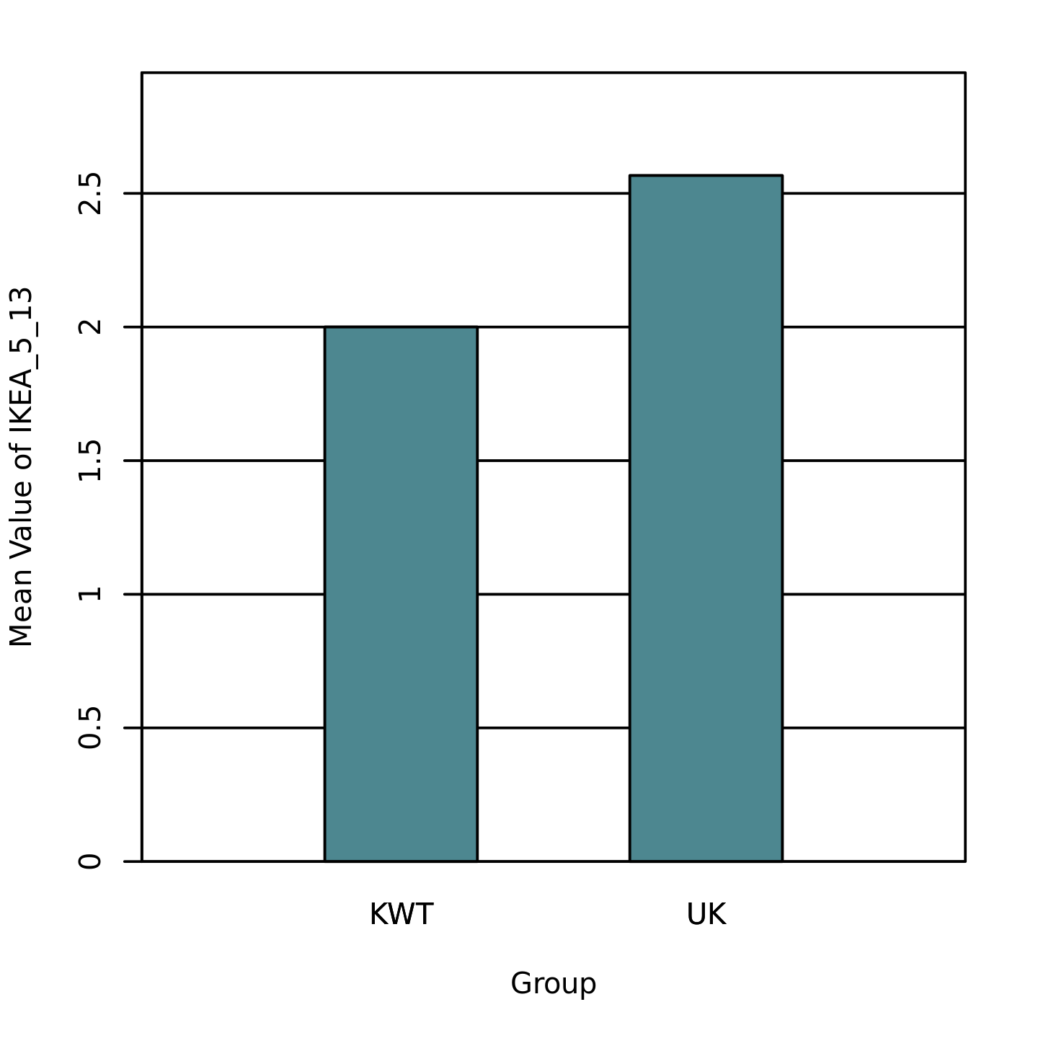

Table 2
Two-Tailed Independent Samples t-Test for ISLG_3_8 by Group
 | KWT |  | UK
Variable | M | SD | M | SD | t | p | d
ISLG_3_8 | 4.58 | 0.61 | 4.20 | 0.61 | 2.43 | .018 | 0.61
Note. N = 63. Degrees of Freedom for the t-statistic = 61. d represents Cohen's d.

Figure 2
The mean of ISLG_3_8 by levels of Group
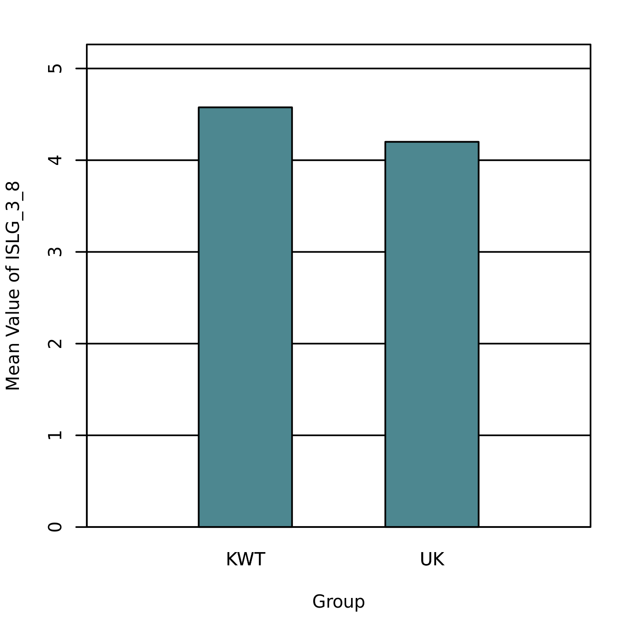

Table 3
Two-Tailed Independent Samples t-Test for ISLG_5_14 by Group
 | KWT |  | UK
Variable | M | SD | M | SD | t | p | d
ISLG_5_14 | 4.55 | 0.56 | 3.83 | 0.95 | 3.66 | < .001 | 0.91
Note. N = 63. Degrees of Freedom for the t-statistic = 61. d represents Cohen's d.

Figure 3
The mean of ISLG_5_14 by levels of Group
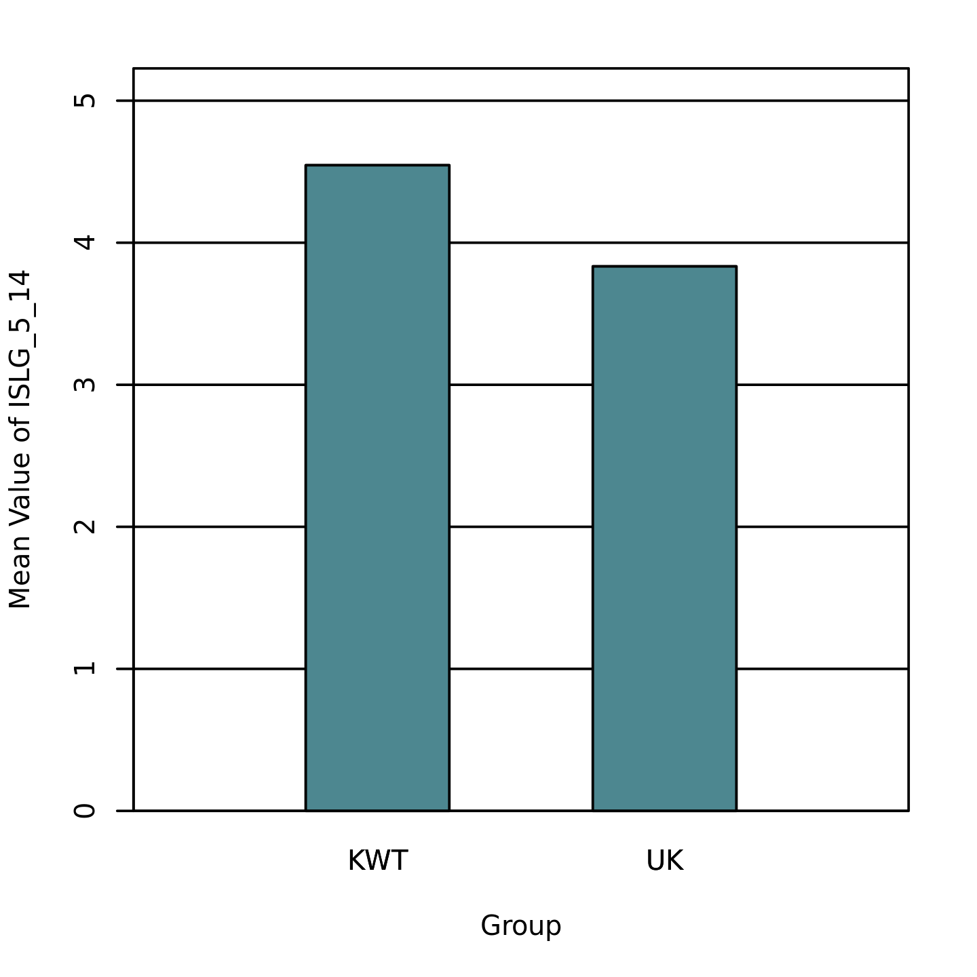
Table 4
Two-Tailed Independent Samples t-Test for ISLG_6_17 by Group
 | KWT |  | UK
Variable | M | SD | M | SD | t | p | d
ISLG_6_17 | 4.52 | 0.67 | 4.00 | 0.74 | 2.90 | .005 | 0.73
Note. N = 63. Degrees of Freedom for the t-statistic = 61. d represents Cohen's d.

Figure 4
The mean of ISLG_6_17 by levels of Group
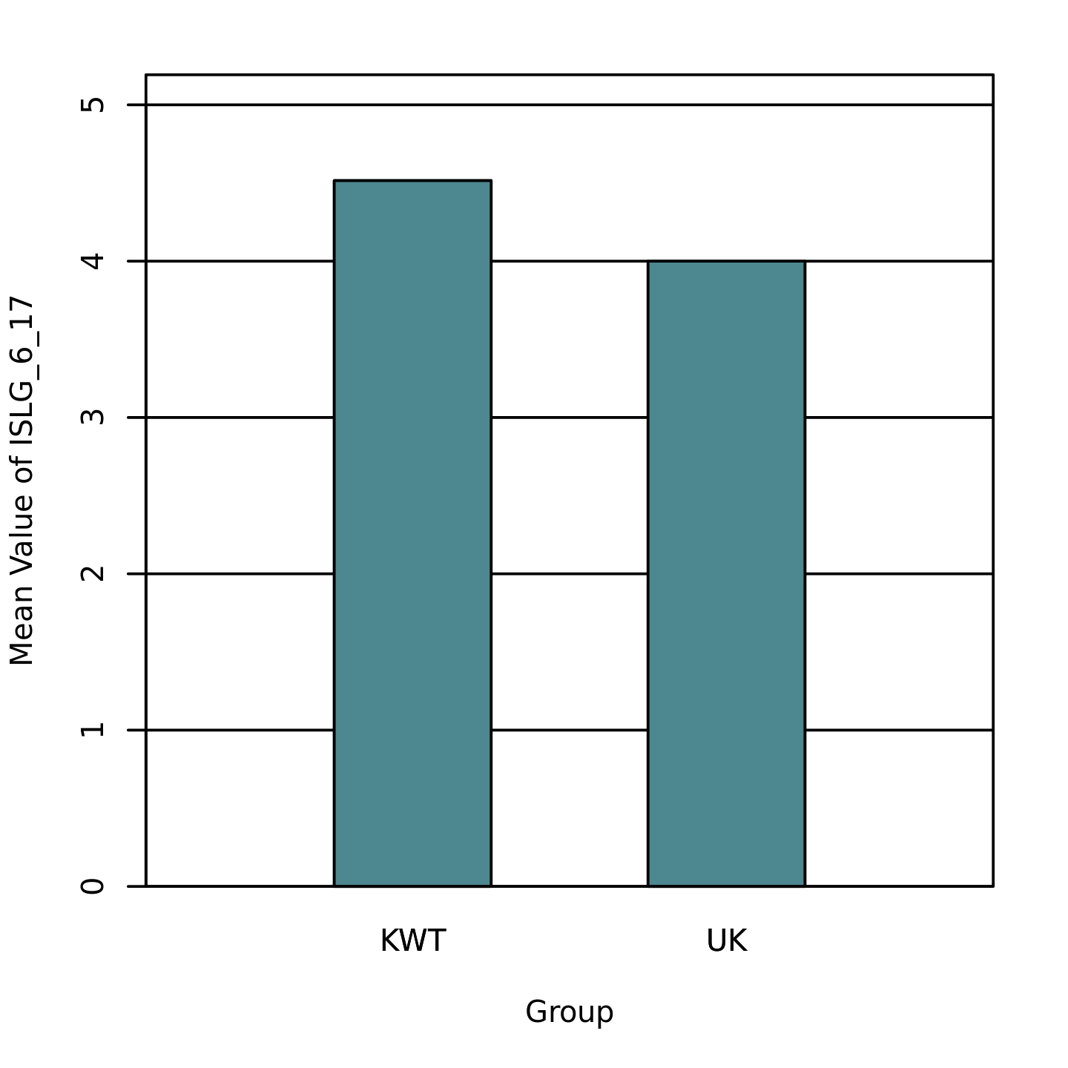

Table 5
Two-Tailed Independent Samples t-Test for ISLG_8_23 by Group
 | KWT |  | UK
Variable | M | SD | M | SD | t | p | d
ISLG_8_23 | 4.55 | 0.67 | 3.97 | 0.67 | 3.44 | .001 | 0.87
Note. N = 63. Degrees of Freedom for the t-statistic = 61. d represents Cohen's d.

Figure 5
The mean of ISLG_8_23 by levels of Group
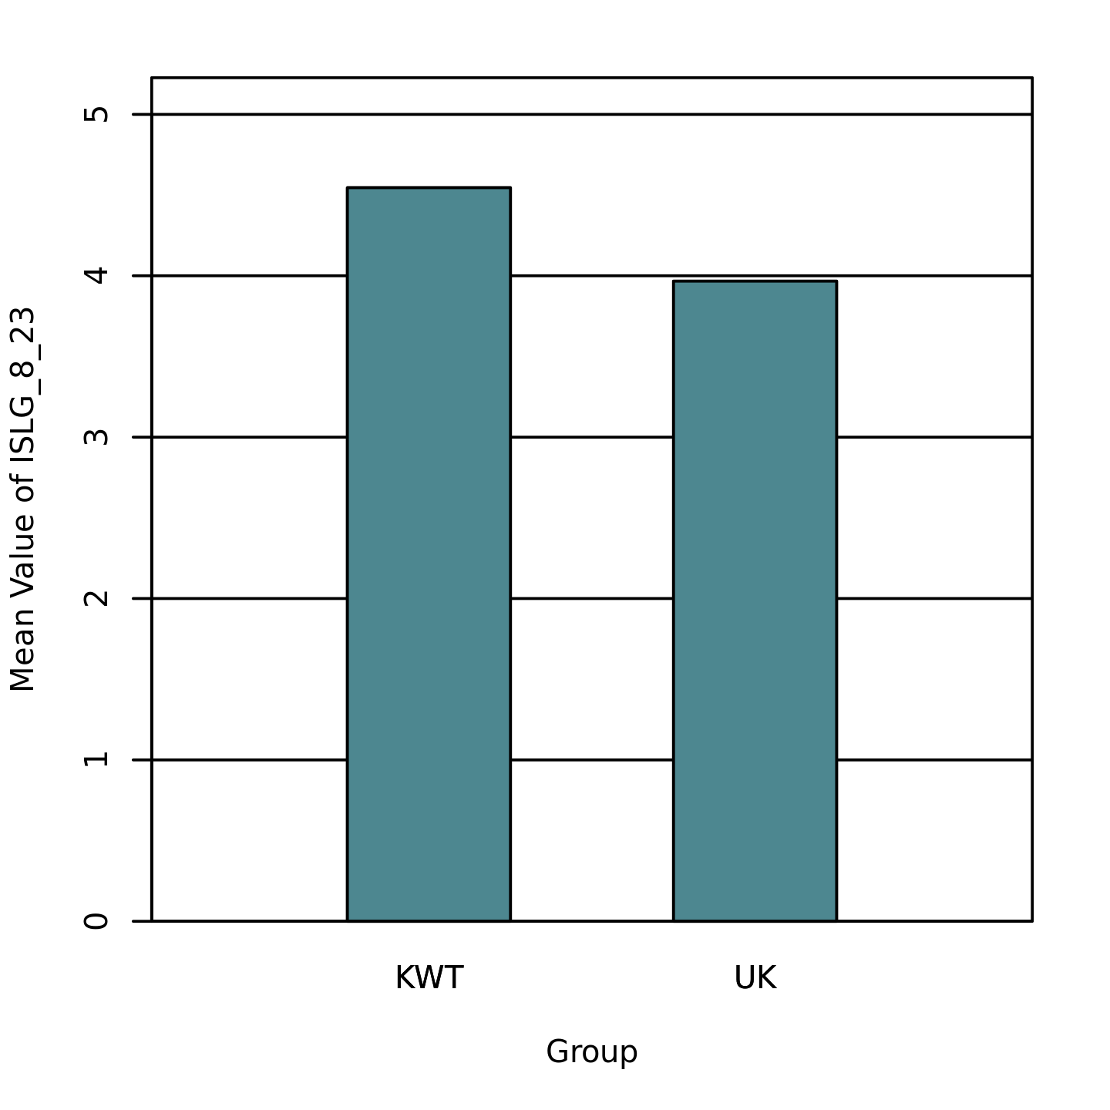

Table 6
Two-Tailed Independent Samples t-Test for ISLG_9_26 by Group
 | KWT |  | UK
Variable | M | SD | M | SD | t | p | d
ISLG_9_26 | 4.58 | 0.61 | 3.80 | 0.71 | 4.63 | < .001 | 1.16
Note. N = 63. Degrees of Freedom for the t-statistic = 61. d represents Cohen's d.

Figure 6
The mean of ISLG_9_26 by levels of Group
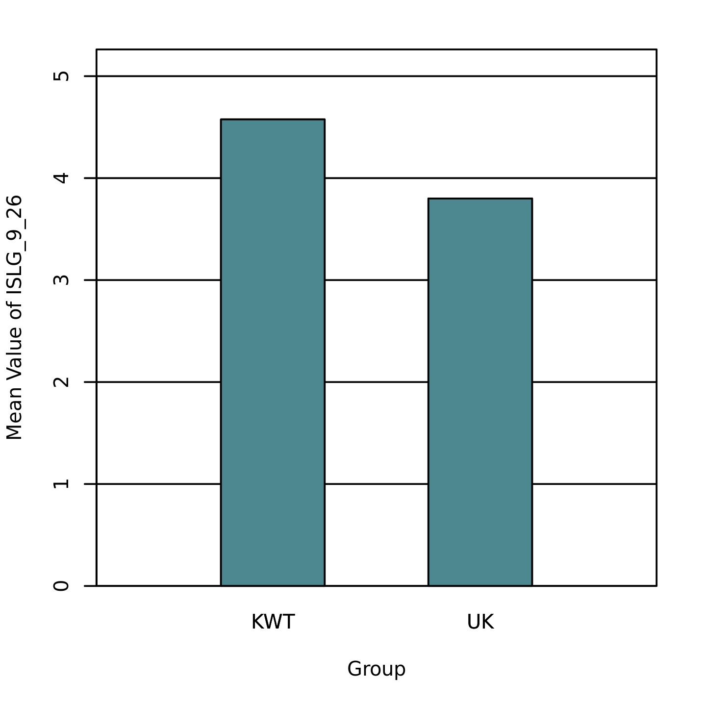

Table 7
Two-Tailed Independent Samples t-Test for ISLG_10_29 by Group
 | KWT |  | UK
Variable | M | SD | M | SD | t | p | d
ISLG_10_29 | 3.64 | 0.96 | 3.17 | 0.79 | 2.10 | .040 | 0.53
Note. N = 63. Degrees of Freedom for the t-statistic = 61. d represents Cohen's d.

Figure 7
The mean of ISLG_10_29 by levels of Group
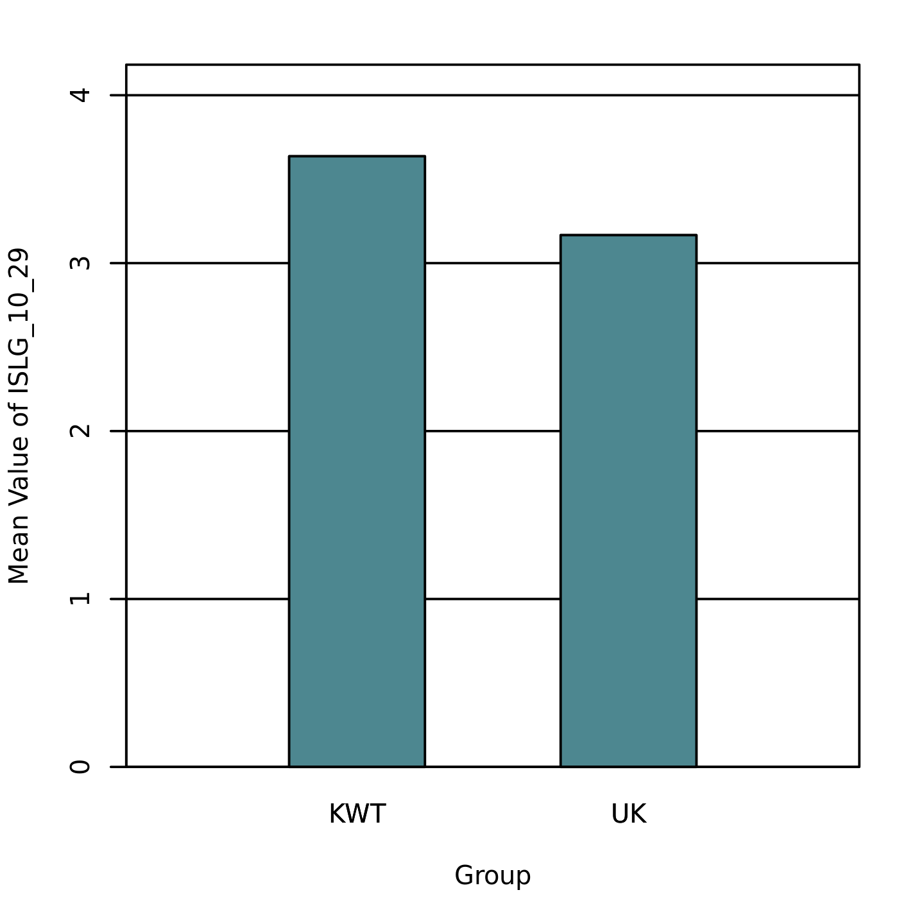

Table 8
Two-Tailed Independent Samples t-Test for LIKE_1_3 by Group
 | KWT |  | UK
Variable | M | SD | M | SD | t | p | d
LIKE_1_3 | 3.97 | 0.64 | 3.43 | 0.94 | 2.68 | .009 | 0.67
Note. N = 63. Degrees of Freedom for the t-statistic = 61. d represents Cohen's d.

Figure 8
The mean of LIKE_1_3 by levels of Group
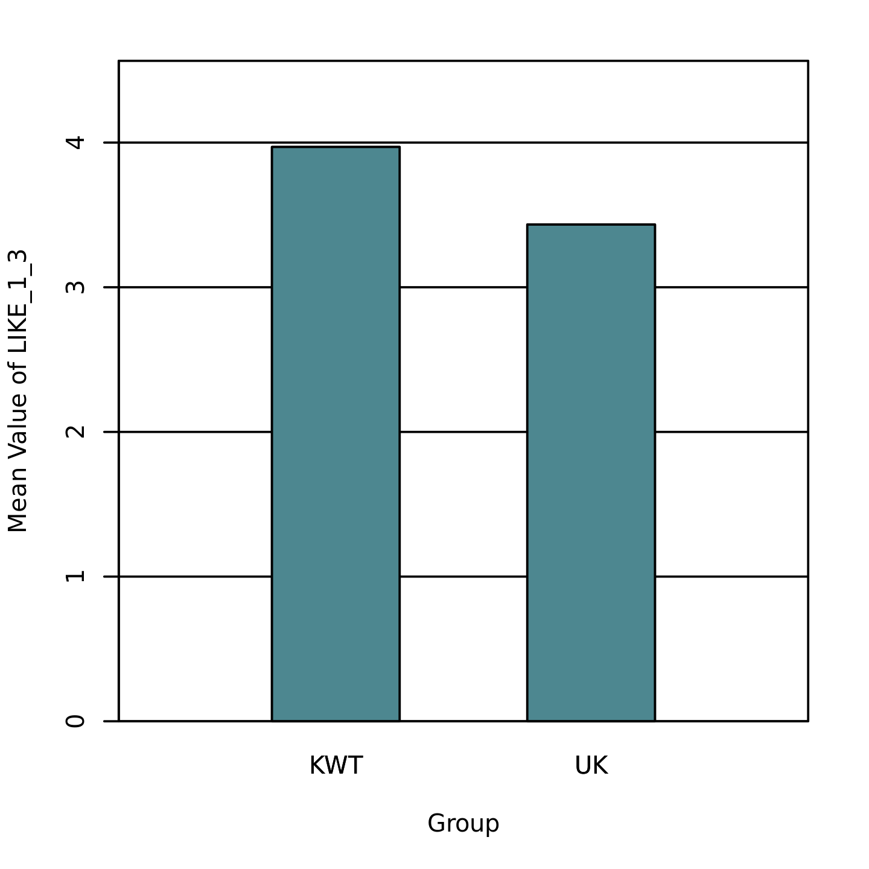

Table 9
Two-Tailed Independent Samples t-Test for LIKE_8_24 by Group
 | KWT |  | UK
Variable | M | SD | M | SD | t | p | d
LIKE_8_24 | 4.33 | 0.96 | 3.67 | 1.03 | 2.66 | .010 | 0.67
Note. N = 63. Degrees of Freedom for the t-statistic = 61. d represents Cohen's d.

Figure 9
The mean of LIKE_8_24 by levels of Group
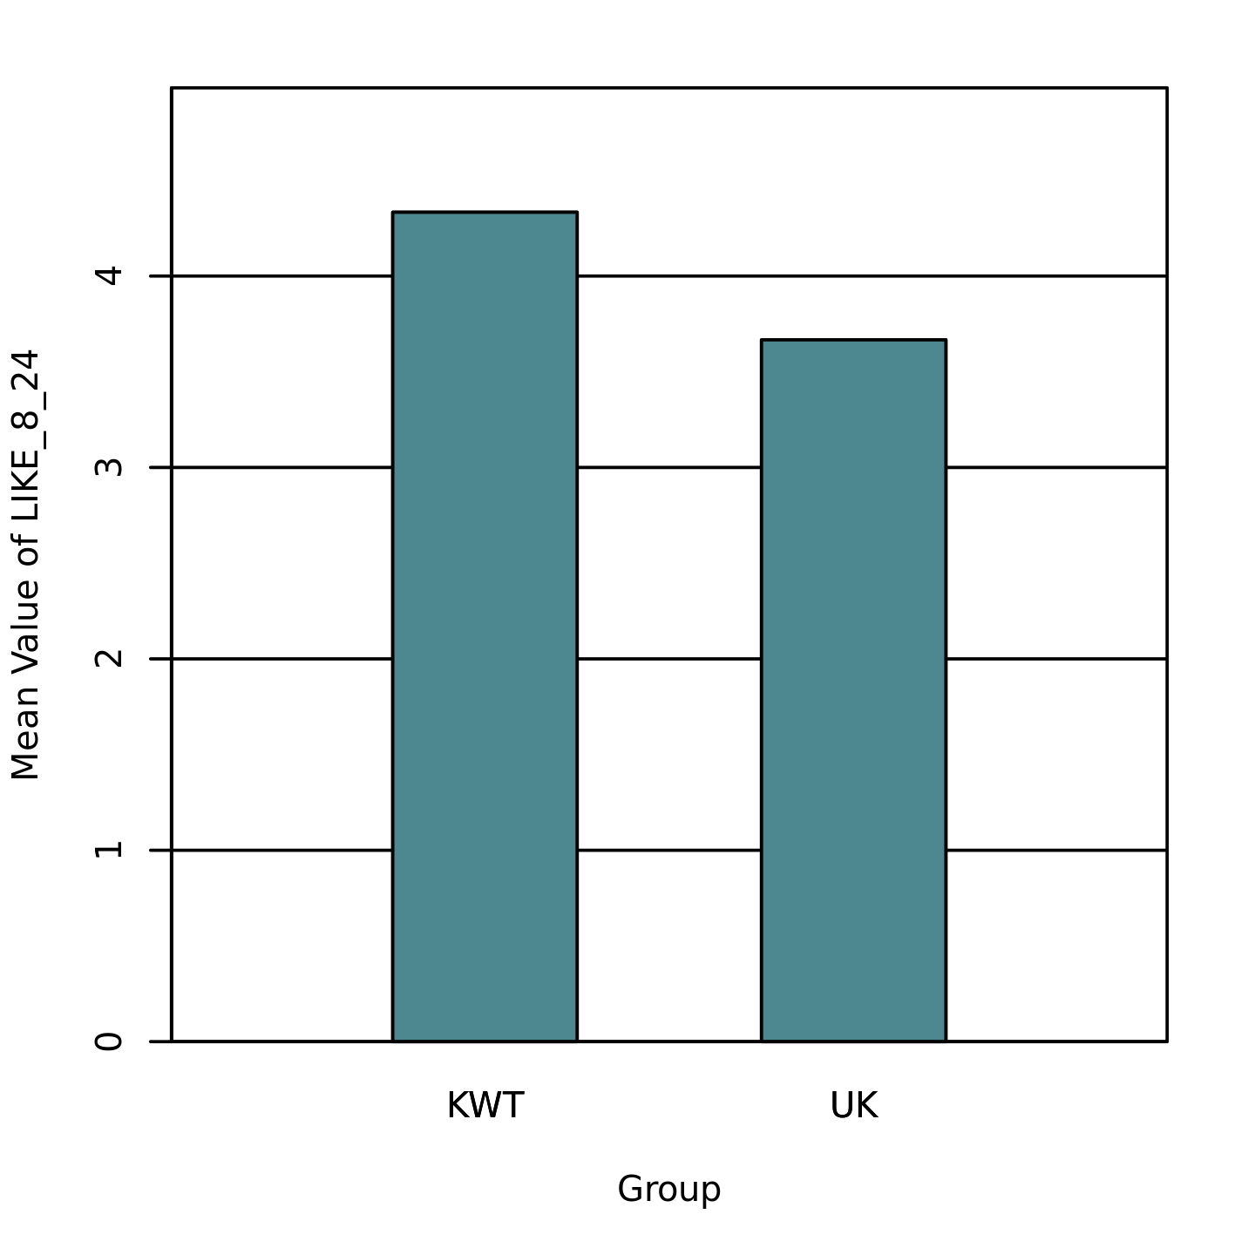

Table 10
Two-Tailed Independent Samples t-Test for LIKE_9_27 by Group
 | KWT |  | UK
Variable | M | SD | M | SD | t | p | d
LIKE_9_27 | 4.33 | 0.96 | 3.43 | 1.10 | 3.46 | < .001 | 0.87
Note. N = 63. Degrees of Freedom for the t-statistic = 61. d represents Cohen's d.

Figure 10
The mean of LIKE_9_27 by levels of Group
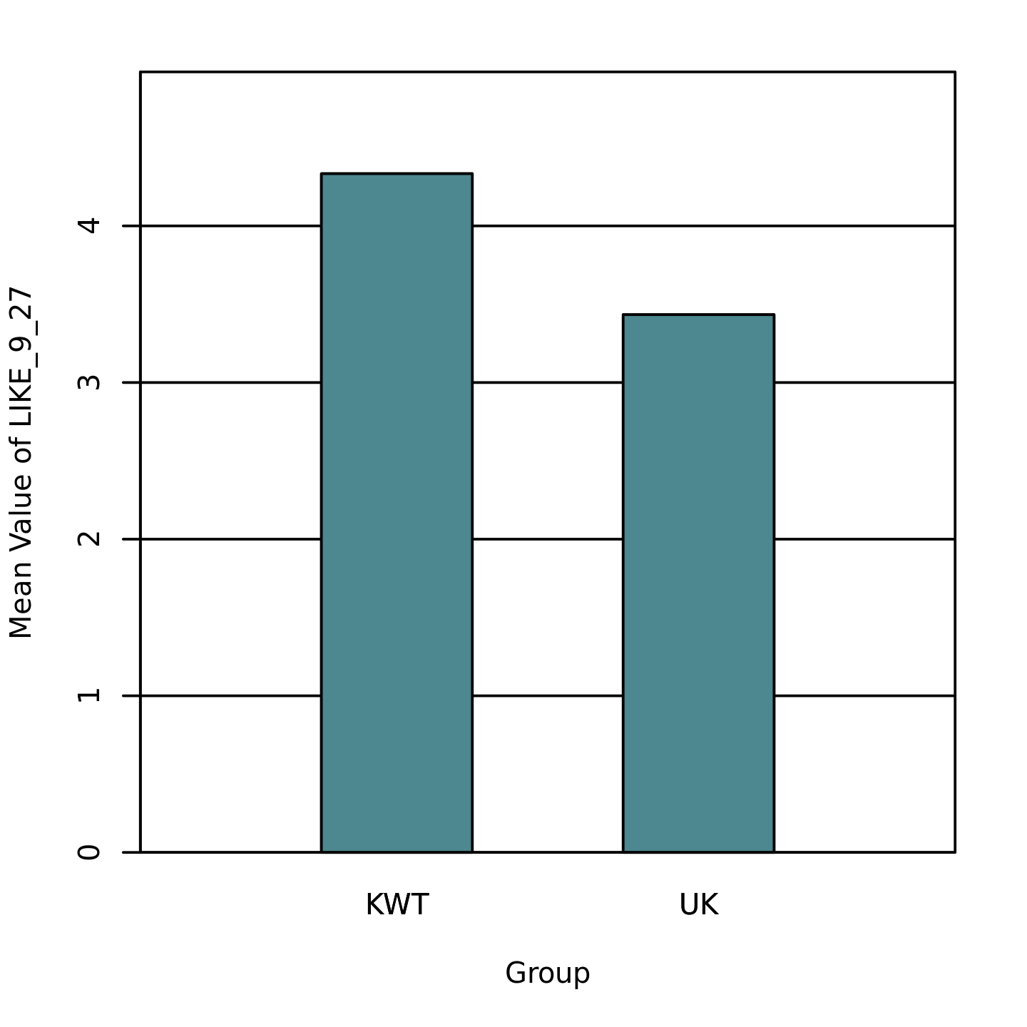

Table 11
Two-Tailed Independent Samples t-Test for LIKE_10_30 by Group
 | KWT |  | UK
Variable | M | SD | M | SD | t | p | d
LIKE_10_30 | 4.00 | 0.87 | 3.47 | 0.94 | 2.35 | .022 | 0.59
Note. N = 63. Degrees of Freedom for the t-statistic = 61. d represents Cohen's d.

Figure 11
The mean of LIKE_10_30 by levels of Group
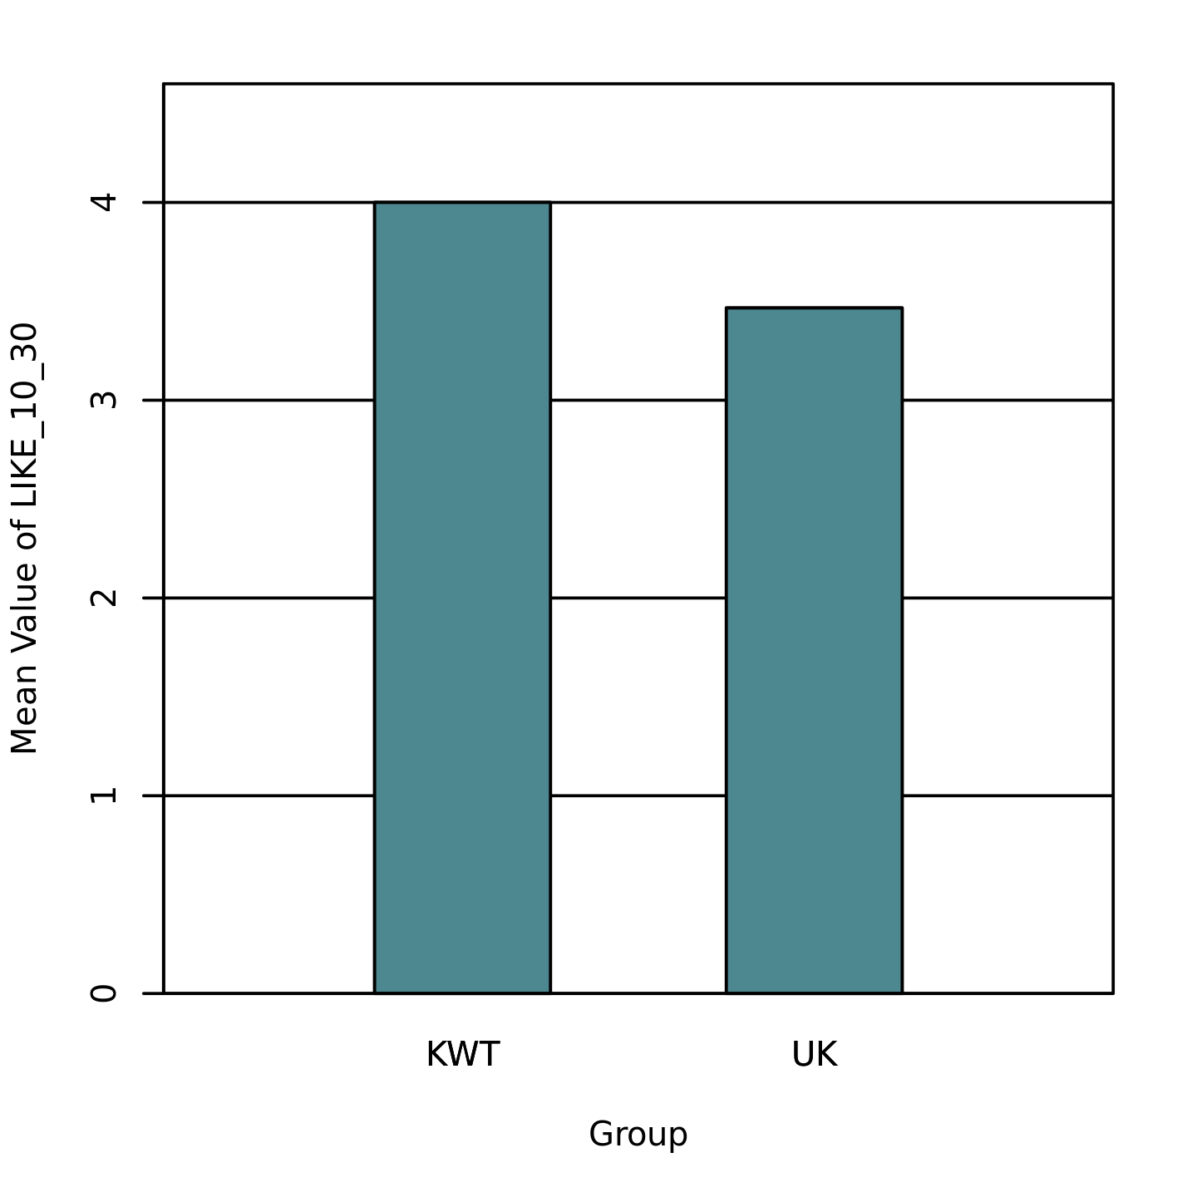

Table 12
Two-Tailed Independent Samples t-Test for II09 by Group
 | KWT |  | UK
Variable | M | SD | M | SD | t | p | d
II09 | 3.64 | 0.68 | 3.23 | 0.69 | 2.34 | .023 | 0.59
Note. N = 63. Degrees of Freedom for the t-statistic = 61. d represents Cohen's d.

Figure 12
The mean of II09 by levels of Group
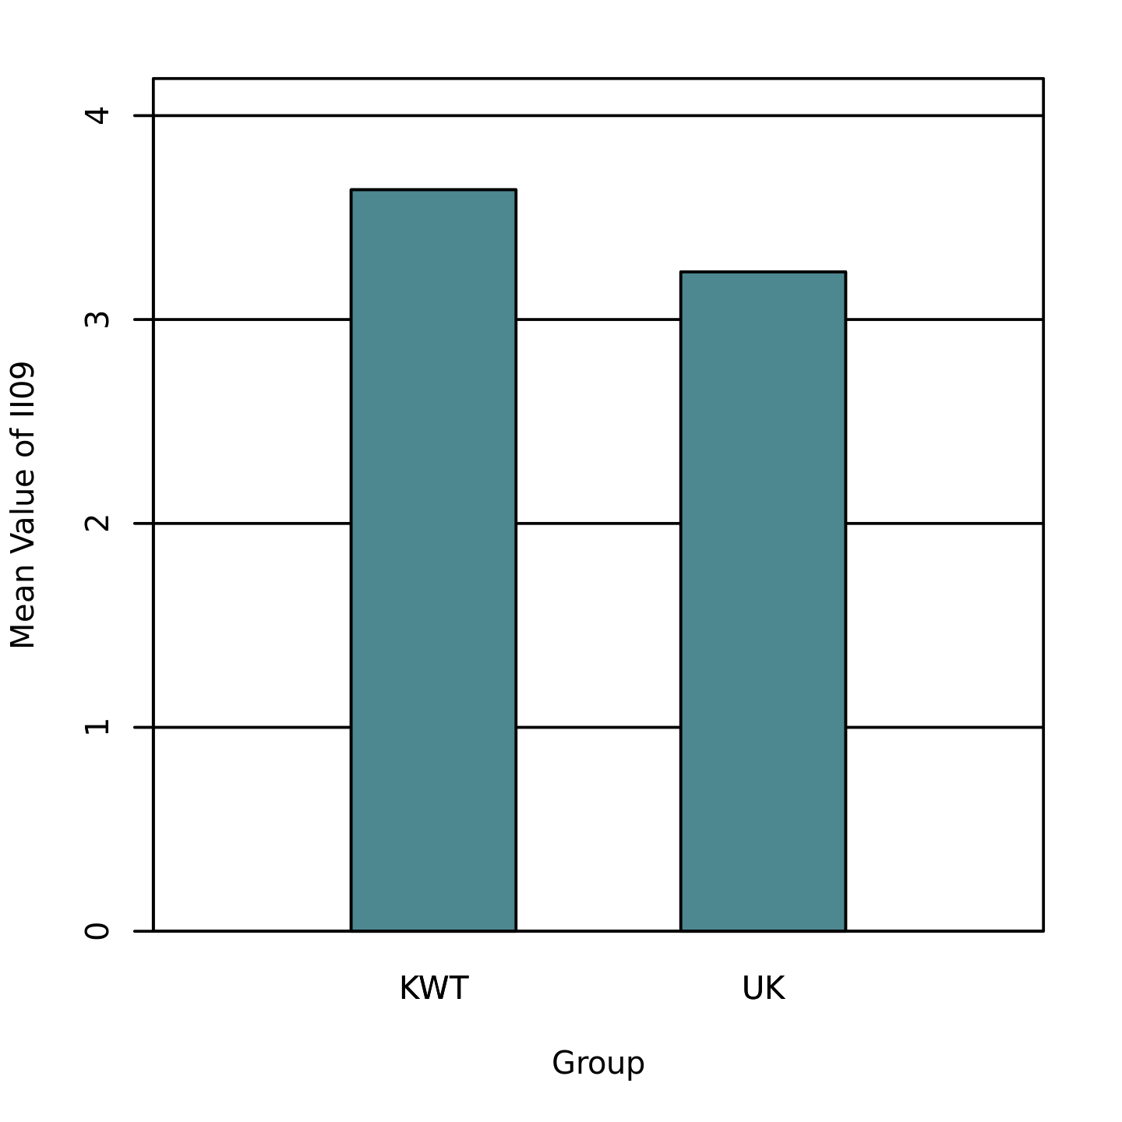

Table 13
Two-Tailed Independent Samples t-Test for II10 by Group
 | KWT |  | UK
Variable | M | SD | M | SD | t | p | d
II10 | 3.59 | 0.65 | 3.23 | 0.57 | 2.30 | .025 | 0.58
Note. N = 63. Degrees of Freedom for the t-statistic = 61. d represents Cohen's d.

Figure 13
The mean of II10 by levels of Group
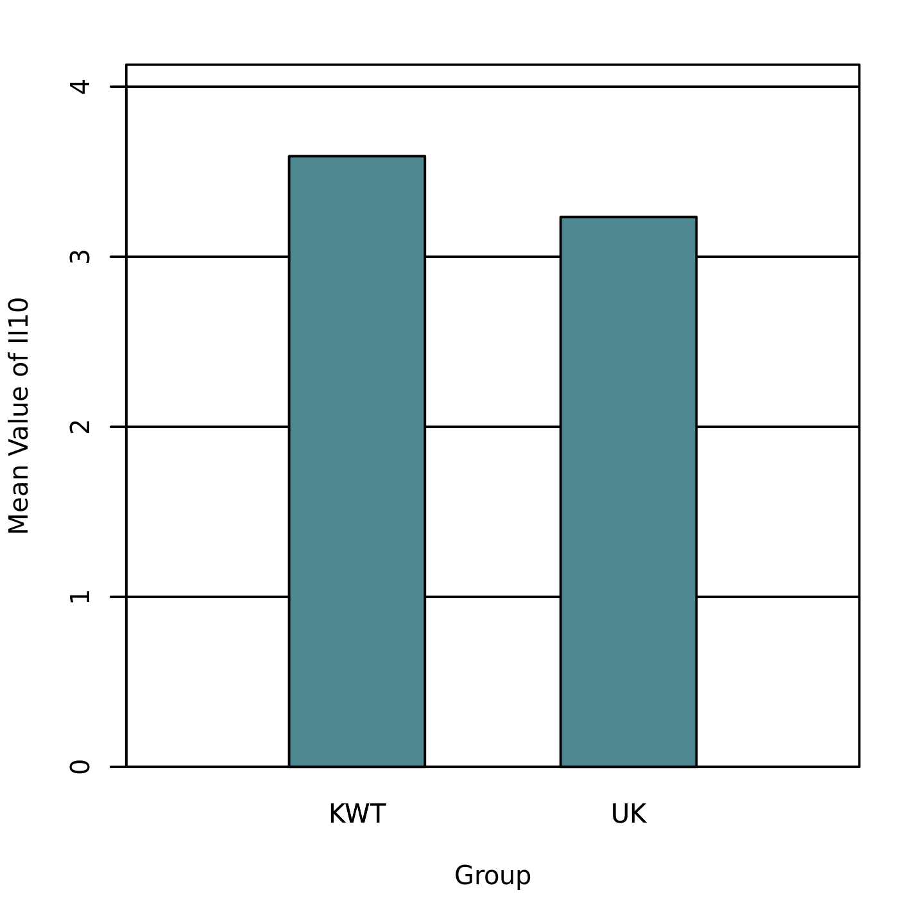

Table 14
Two-Tailed Independent Samples t-Test for II11 by Group
 | KWT |  | UK
Variable | M | SD | M | SD | t | p | d
II11 | 3.67 | 0.76 | 3.30 | 0.55 | 2.18 | .033 | 0.55
Note. N = 63. Degrees of Freedom for the t-statistic = 61. d represents Cohen's d.

Figure 14
The mean of II11 by levels of Group
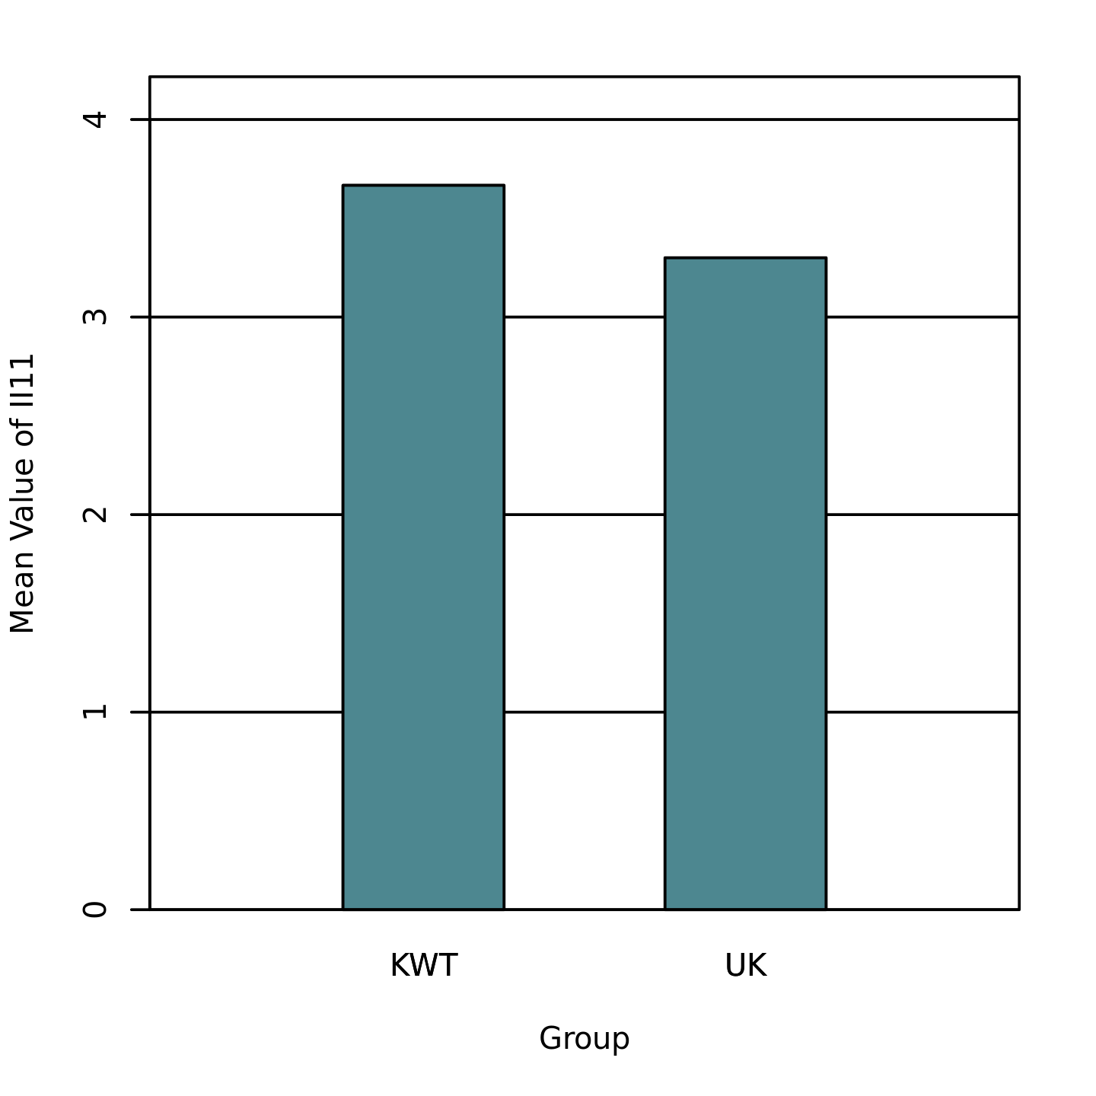

Table 15
Two-Tailed Independent Samples t-Test for DES01 by Group
 | KWT |  | UK
Variable | M | SD | M | SD | t | p | d
DES01 | 3.62 | 0.61 | 3.15 | 0.62 | 3.04 | .004 | 0.77
Note. N = 63. Degrees of Freedom for the t-statistic = 61. d represents Cohen's d.

Figure 15
The mean of DES01 by levels of Group
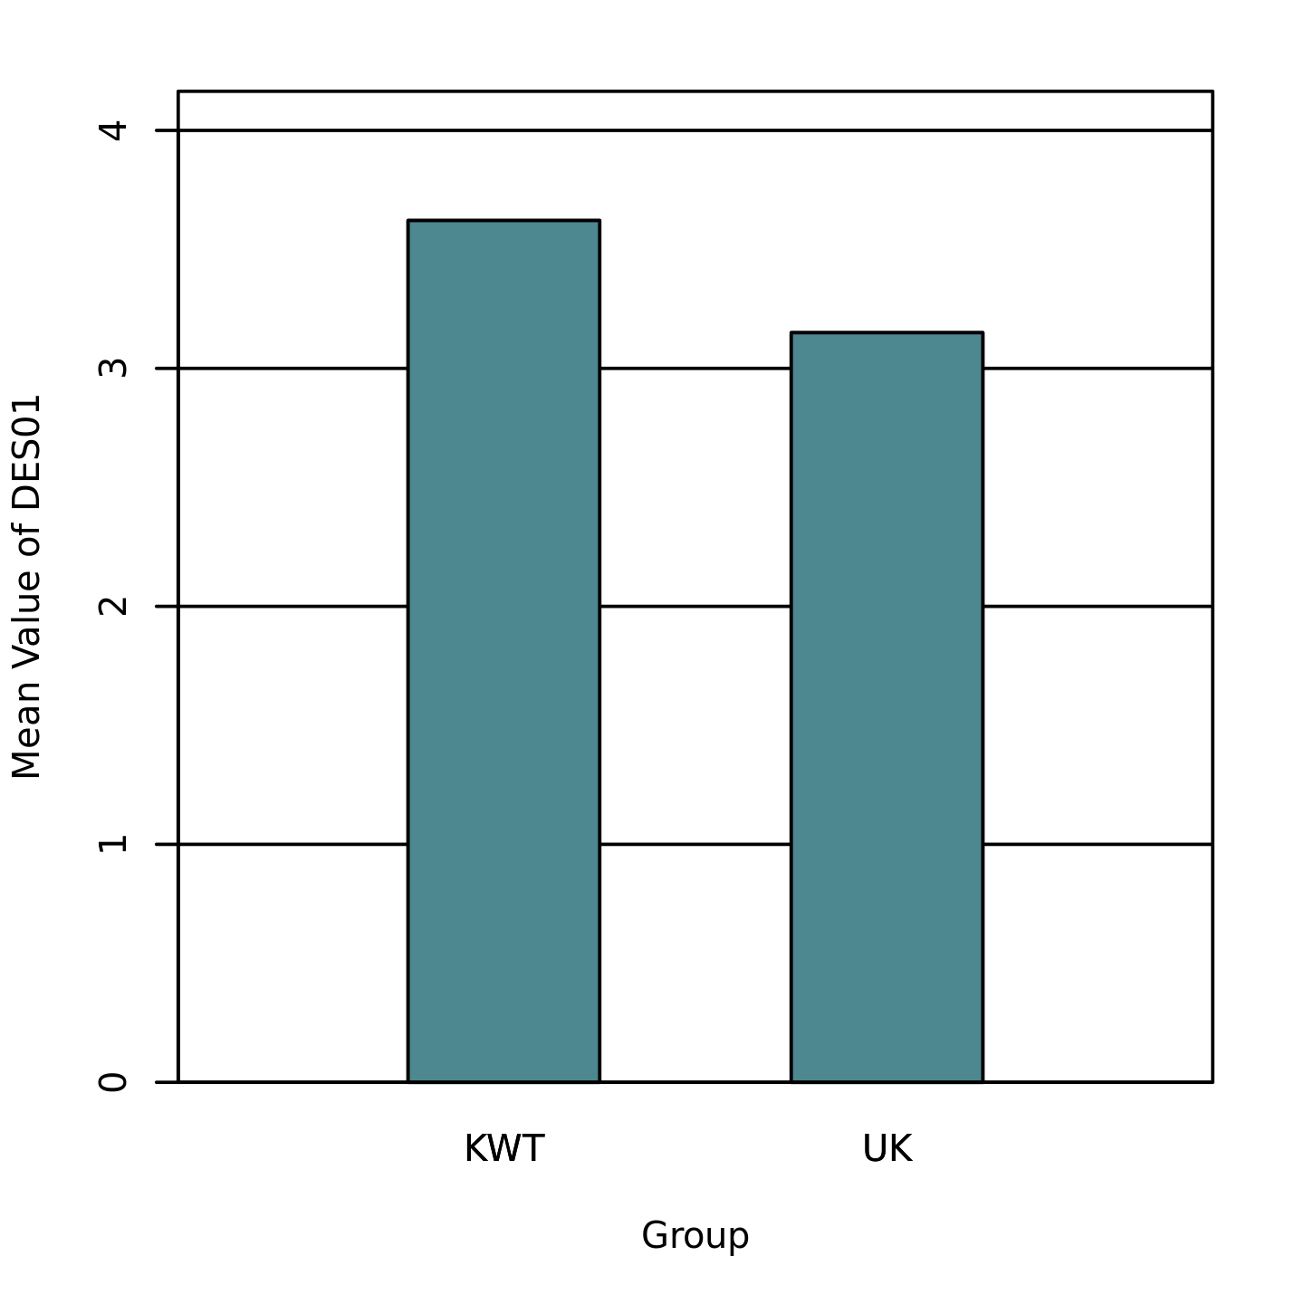

Table 16
Two-Tailed Independent Samples t-Test for DES03 by Group
 | KWT |  | UK
Variable | M | SD | M | SD | t | p | d
DES03 | 4.53 | 0.60 | 4.17 | 0.48 | 2.64 | .010 | 0.67
Note. N = 63. Degrees of Freedom for the t-statistic = 61. d represents Cohen's d.

Figure 16
The mean of DES03 by levels of Group
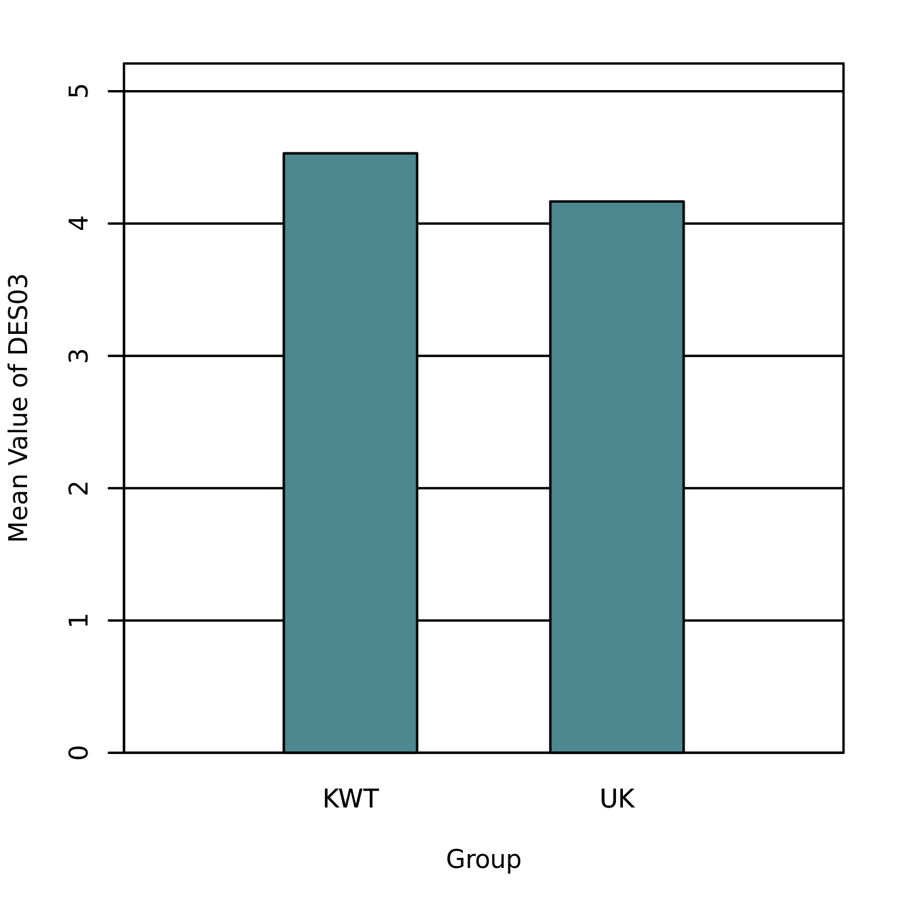

Table 17
Two-Tailed Independent Samples t-Test for DES05 by Group
 | KWT |  | UK
Variable | M | SD | M | SD | t | p | d
DES05 | 4.36 | 0.56 | 3.85 | 0.76 | 3.08 | .003 | 0.77
Note. N = 63. Degrees of Freedom for the t-statistic = 61. d represents Cohen's d.

Figure 17
The mean of DES05 by levels of Group
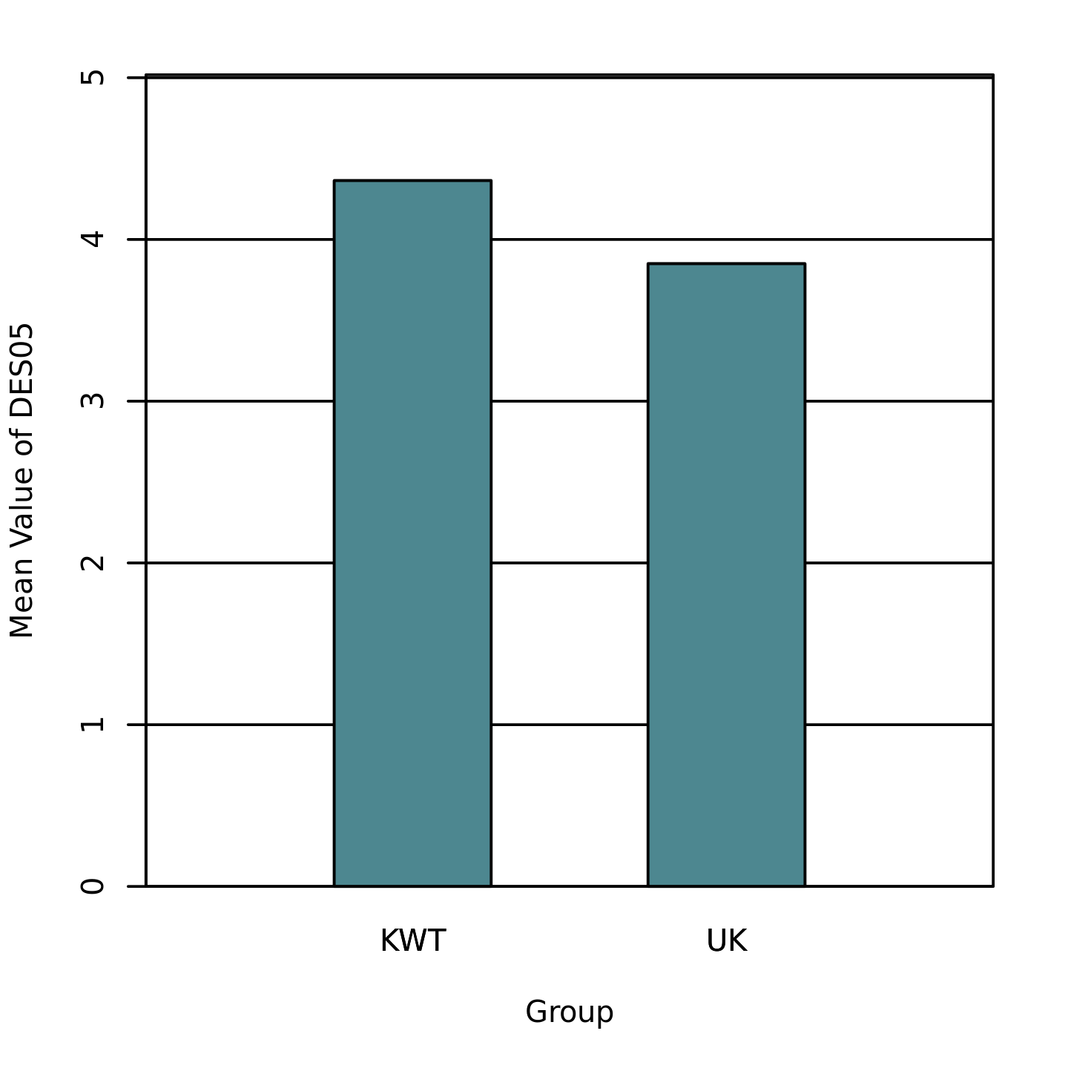

Table 18
Two-Tailed Independent Samples t-Test for DES06 by Group
 | KWT |  | UK
Variable | M | SD | M | SD | t | p | d
DES06 | 4.39 | 0.76 | 3.95 | 0.69 | 2.43 | .018 | 0.61
Note. N = 63. Degrees of Freedom for the t-statistic = 61. d represents Cohen's d.

Figure 18
The mean of DES06 by levels of Group
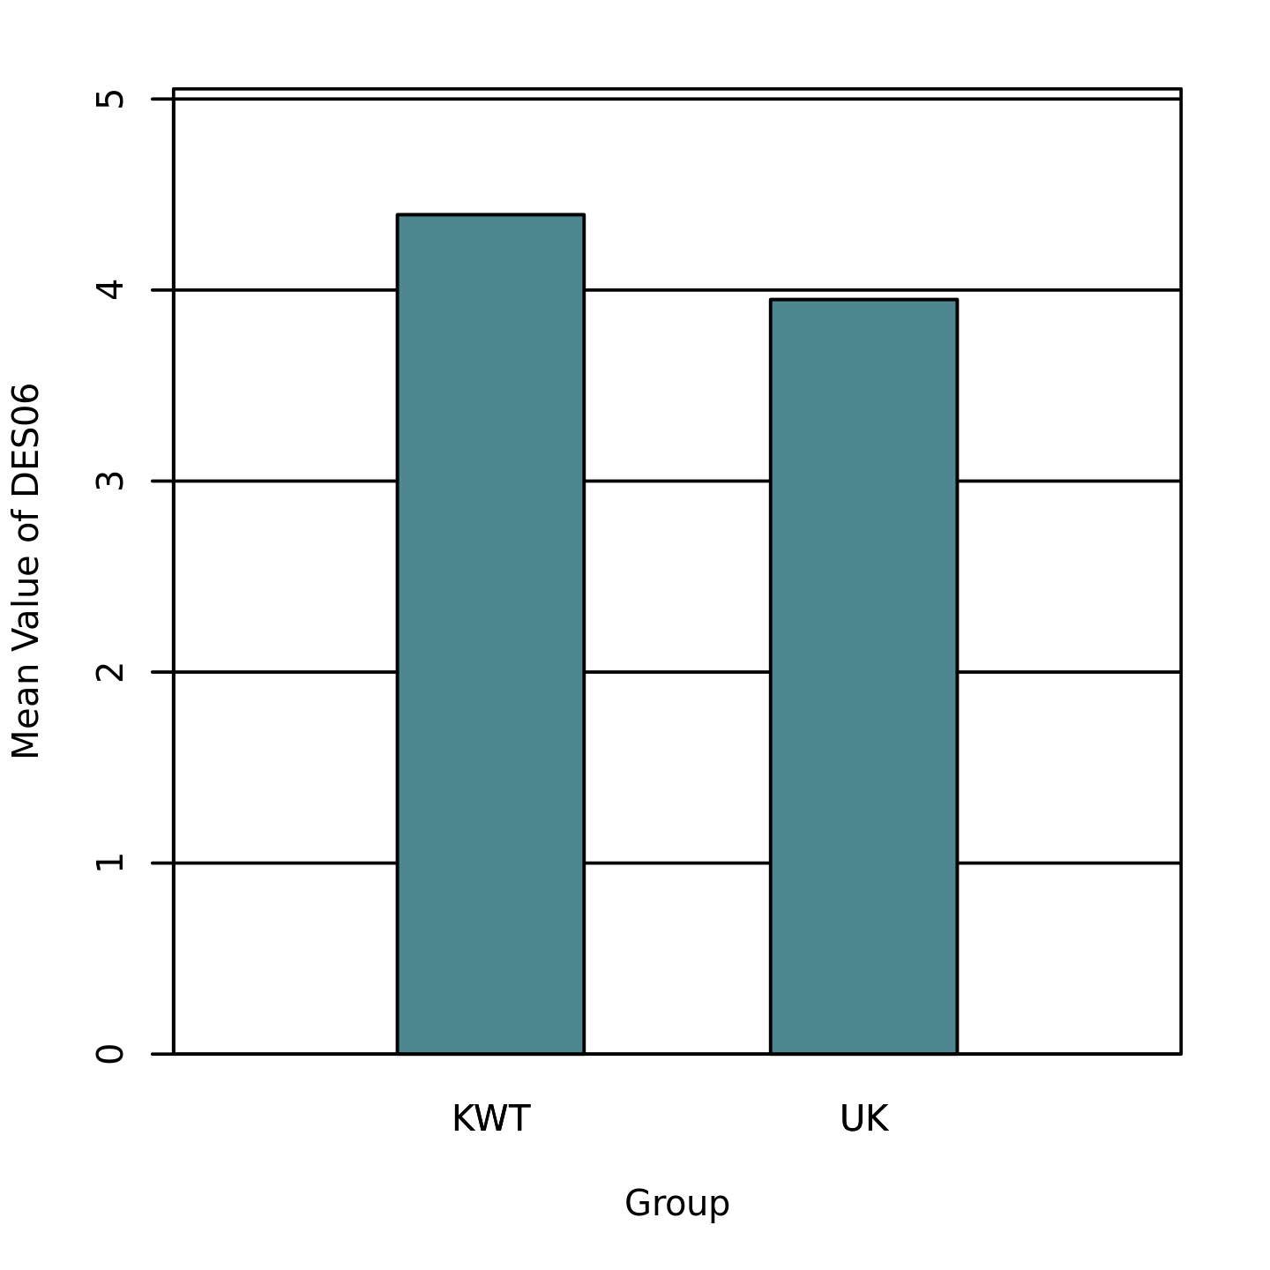

Table 19
Two-Tailed Independent Samples t-Test for DES08 by Group
 | KWT |  | UK
Variable | M | SD | M | SD | t | p | d
DES08 | 4.44 | 0.75 | 3.82 | 0.75 | 3.30 | .002 | 0.83
Note. N = 63. Degrees of Freedom for the t-statistic = 61. d represents Cohen's d.

Figure 19
The mean of DES08 by levels of Group
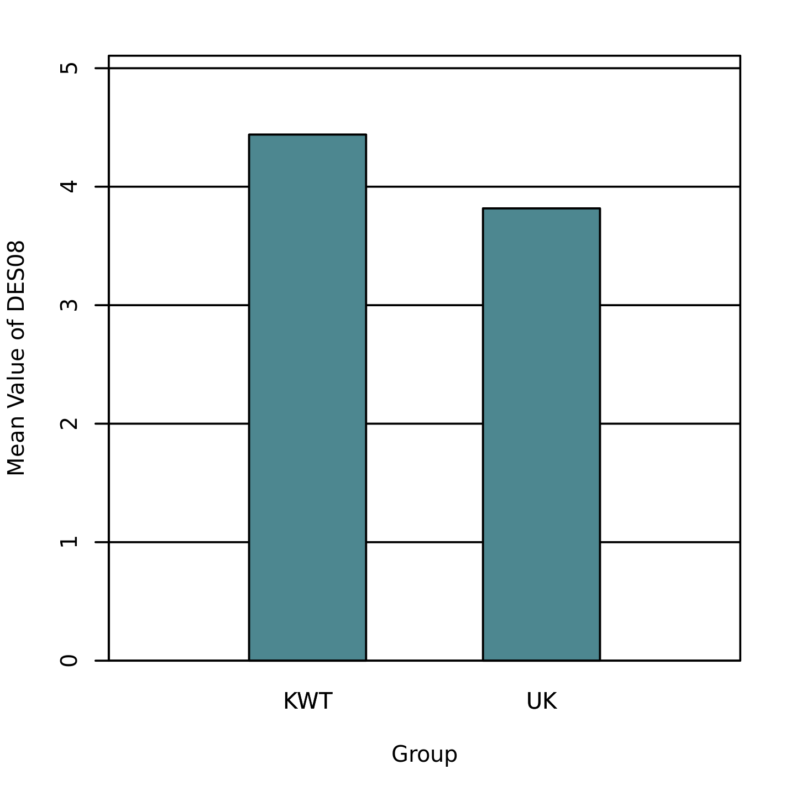

Table 20
Two-Tailed Independent Samples t-Test for DES09 by Group
 | KWT |  | UK
Variable | M | SD | M | SD | t | p | d
DES09 | 4.45 | 0.68 | 3.62 | 0.75 | 4.66 | < .001 | 1.17
Note. N = 63. Degrees of Freedom for the t-statistic = 61. d represents Cohen's d.

Figure 20
The mean of DES09 by levels of Group
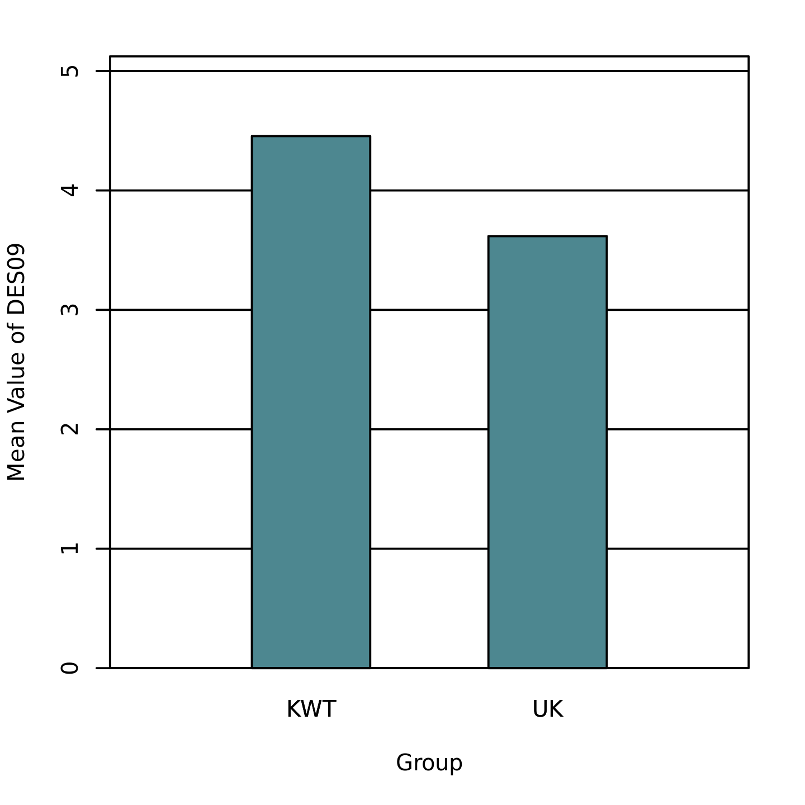

Table 21
Two-Tailed Independent Samples t-Test for DES10 by Group
 | KWT |  | UK
Variable | M | SD | M | SD | t | p | d
DES10 | 3.82 | 0.80 | 3.32 | 0.64 | 2.74 | .008 | 0.69
Note. N = 63. Degrees of Freedom for the t-statistic = 61. d represents Cohen's d.

Figure 21
The mean of DES10 by levels of Group
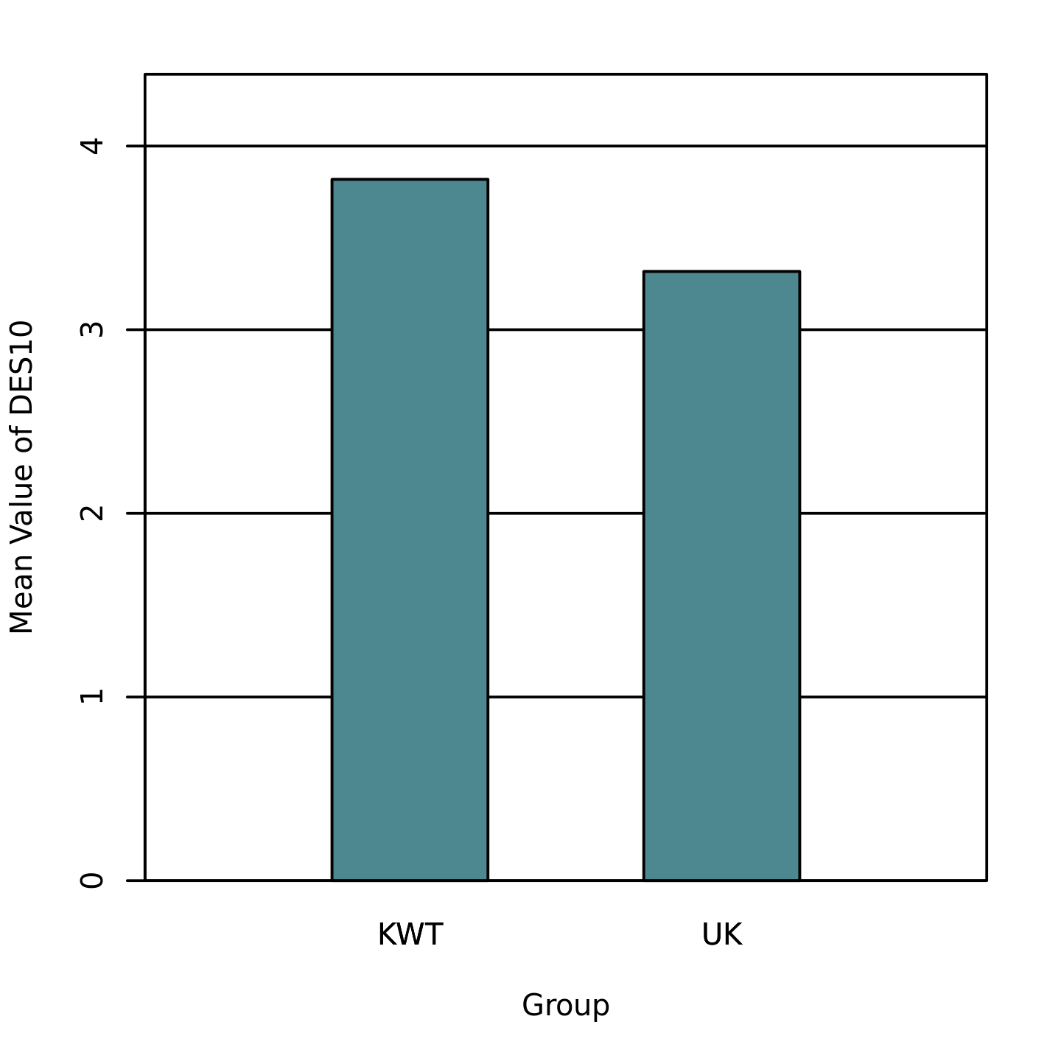

Table 22
Two-Tailed Independent Samples t-Test for See_more_IKEA_IG_80 by Group
 | KWT |  | UK
Variable | M | SD | M | SD | t | p | d
See_more_IKEA_IG_80 | 4.55 | 0.62 | 3.53 | 0.90 | 5.25 | < .001 | 1.31
Note. N = 63. Degrees of Freedom for the t-statistic = 61. d represents Cohen's d.

Figure 22
The mean of See_more_IKEA_IG_80 by levels of Group
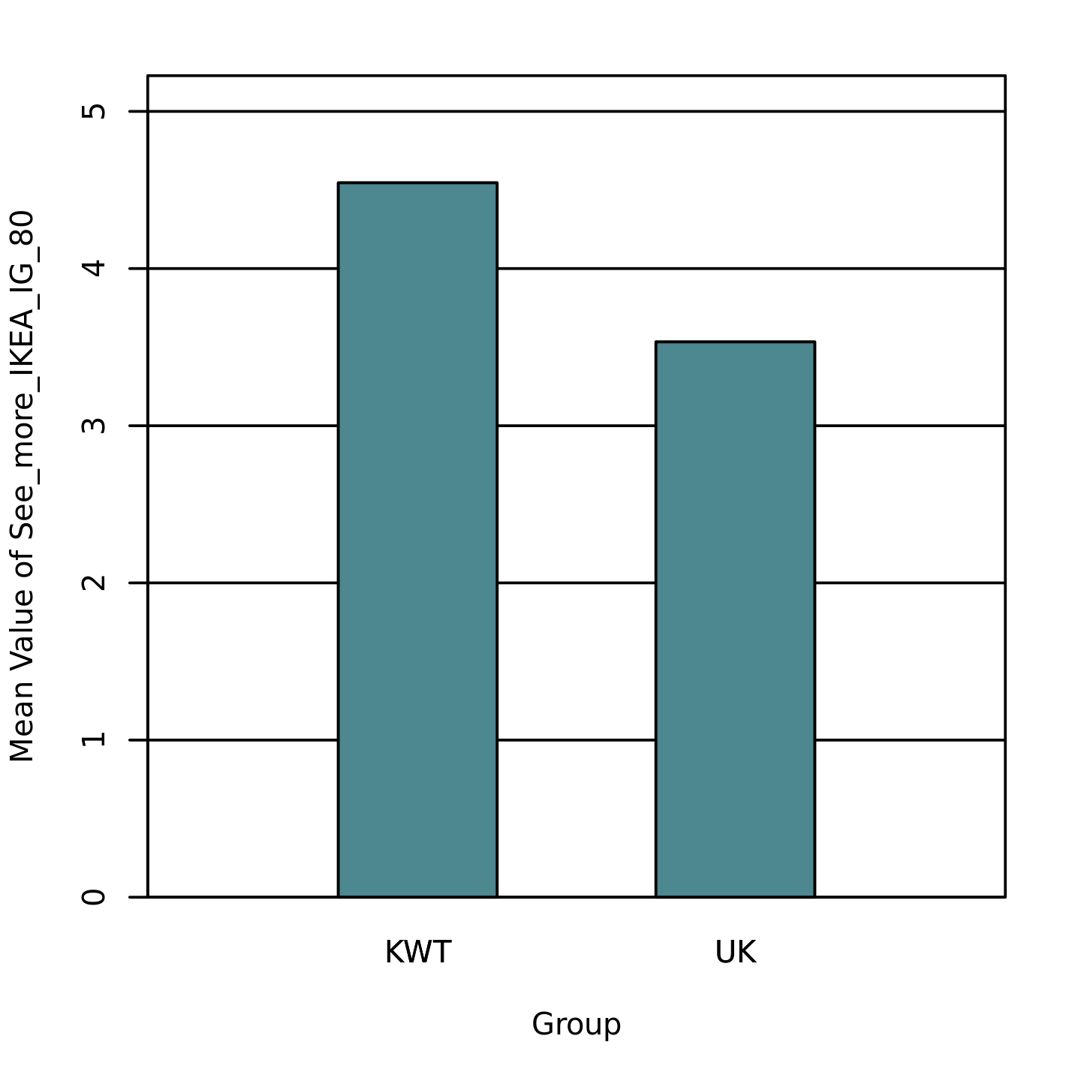

Table 23
Two-Tailed Independent Samples t-Test for I_prefer_no_additional_design by Group
 | KWT |  | UK
Variable | M | SD | M | SD | t | p | d
I_prefer_no_additional_design | 2.45 | 1.48 | 4.13 | 0.73 | -5.62 | < .001 | 1.44
Note. N = 63. Degrees of Freedom for the t-statistic = 61. d represents Cohen's d.
Figure 23
The mean of I_prefer_no_additional_design by levels of Group
