ESM 1: Electronic Supplementary Material to Environmental factors are stronger predictors of primate species’ distributions than basic biological traits

By Katherine A. Williams^{1,3}, Helen D. Slater^{2,3}, Phillipa Gillingham^{2,3}, Amanda H. Korstjens^{2,3*}
¹Bioengineering Research Group, Faculty of Engineering and Physical Sciences, University of Southampton, UK.
²Department of Life and Environmental Sciences, Bournemouth University, UK.
³Landscape Ecology and Primatology (LEAP), Bournemouth University, Poole, UK
*Corresponding author

Contact details:
Amanda H. Korstjens: Bournemouth University, Talbot Campus, Poole, BH12 5BB akorstjens@bournemouth.ac.uk

Table S1: Hypotheses and predictions with references forming the basis of an analysis on environment-trait relationships in African haplorrhines. When referring to more open habitats we consider those to be characterised by lower tree height, less rain, greater temperature and rain seasonality, and greater temperature diurnal range as opposed to areas with more dense forests.
Trait | Hypothesis | Prediction
Arboreal vs terrestrial | Both terrestriality and large body size enable primates to cover greater distances more effectively to find dispersed food sources within open habitats than arboreal and smaller primates making open habitats less suitable for arboreal and smaller primates (Fleagle 2013). | Arboreal primates are positively associated with tree height, and rainfall, and negatively with temperature and rain seasonality.  Terrestrial primates have no specific associations with environmental variables because they can fare well in both open and closed habitats.  Body size is negatively associated with tree height, and rainfall, and positively with seasonal variation.
Frugivorous, folivorous, omnivorous | Omnivorous primates have the greatest range of fallback food items, followed by folivorous primates and finally frugivorous primates, which gives omnivores the greatest flexibility, folivores intermediate and frugivores the least flexibility in switching food items in highly seasonal environments with regular periods of low productivity (Hemingway and Bynum 2005). | Frugivores have the strongest positive association with tree height and rainfall, and the strongest negative association with temperature and rainfall seasonality. Folivores are predicted to have intermediate associations in the same directions.  Omnivores are predicted to show less strong associations with specific environmental conditions.
Diet | Leaf quality (protein to fibre ratio) goes down steeply with higher temperatures, therefore, food availability for folivore specialists is reduced under such conditions (Zvereva and Kozlov 2006; Korstjens and Dunbar 2007; Rothman et al. 2014). | Folivores are negatively associated with areas with high mean temperature but we do not predict a specific association for omnivores and frugivores with mean temperatures.
Intermembral index | Species with relatively equal lengths of the forelimbs and hind limbs (i.e. IMI~100) are faster and more efficient at longer duration terrestrial quadrupedal locomotion than those with relatively short forelimbs (IMI<80; which tend to jump more when on the ground), which is more important in the most open habitats (Fleagle 2013; Jungers 1985). | We predict a negative association between IMI and characteristics typical of very open habitats (i.e. low canopy height, high temperature and rainfall seasonality, and low rainfall).  (Because none of the African apes have particularly long forelimbs, we do not predict this relationship to be quadratic in this dataset)
Body mass & Sexual size dimorphism | Both large body size and greater sexual size dimorphism reduce predation risk for diurnal primates living in relatively open environments but not so much for those living in more dense forests. (Plavcan et al. 2005, Cassini 2020) | Body size and sexual size dimorphism are positively associated with the suite of characteristics associated with more open environments (i.e. low canopy height, low rainfall, greater rain and temperature seasonality).
Body mass | Larger body size protects primates against greater diurnal temperature variation (Bergman’s rule - Plavcan et al. 2005). | Body size is positively associated with diurnal temperature variation.
Group size | Diurnal primates in open environments form relatively larger groups in order to reduce predation risk (Hill and Lee 1989). | Group size is positively associated with open environment characteristics (see above).
Age at first birth and inter-birth interval | Animals living under stable consistently intermediate conditions are hypothesized to have a slower life history than those that have to cope with greater harshness and variability in their environment if these lead to higher adult mortality (the opposite may be true if these environmental conditions lead to high juvenile mortality; Ellis et al 2009). | Age at first birth and inter-birth interval are negatively associated with daily temperature variation, seasonal temperature and rainfall variation and low tree canopy.
Home range size | More seasonal environments have less stability in year-round food availability and require larger home ranges to ensure year-round access to food (Hemingway and Bynum 2005, Kalan et al. 2020). | Home range size is positively associated with rainfall and temperature seasonality.
Daily travel distance | More open environments provide more dispersed food sources at lower abundance and require greater home ranges and daily travel distances to ensure year-round and daily access to food (Hemingway and Bynum 2005, Kalan et al. 2020). | Daily travel distances and home range sizes are positively associated with characteristics of more open environments (see above).
This study is designed to test whether genus and species-intrinsic traits enable a genus or species to survive better under particular environmental conditions, it is not designed to test whether within-genus variation is associated with particular environmental conditions.
Table S2a: Number of species in each genus used in analysis on environment-trait relationships in African haplorrhine genera for which published data were unavailable for trait variables.

Table S2b: Pearson correlation analysis, correlation coefficient R and p-values, between environmental data of sites used in analysis on environment-trait relationships in African haplorrhine genera (N=354)
 |  | Temperature diurnal range | Temperature seasonality | Annual precipitation | Precipitation seasonality | canopy height
Mean annual temperature | R | -0.19** | -0.24** | 0.19** | 0.38** | 0.02
Mean annual temperature | p | 0.00 | 0.00 | 0.00 | 0.00 | 0.67
Temperature diurnal range | R |  | .63** | -0.61** | 0.29** | -0.46**
Temperature diurnal range | p |  | 0.00 | 0.00 | 0.00 | 0.00
Temperature seasonality | R |  |  | -0.65** | 0.26** | -0.54**
Temperature seasonality | p |  |  | 0.00 | 0.00 | 0.00
Annual precipitation | R |  |  |  | -0.27** | 0.65**
Annual precipitation | p |  |  |  | 0.00 | 0.00
Precipitation seasonality | R |  |  |  |  | -0.39**
Precipitation seasonality | p |  |  |  |  | 0.00

Table S2c: Spearman’s correlations, Rho and p-values, among traits data of African haplorrhine genera (N=14)
 |  | Body mass | Group size | Age at first birth | Sexual dimorphism | IBI | home range | daily travel
IMI | Rho | 0.69** | 0.45 | 0.27 | -0.66* | 0.34 | 0.76** | 0.48
 | p | 0.01 | 0.11 | 0.35 | 0.01 | 0.24 | 0.00 | 0.08
Body mass | Rho |  | 0.26 | 0.32 | -0.40 | .560* | 0.67** | 0.31
 | p |  | 0.37 | 0.26 | 0.15 | 0.04 | 0.01 | 0.27
Group size | Rho |  |  | 0.28 | -0.24 | 0.02 | 0.52 | 0.53
 | p |  |  | 0.34 | 0.42 | 0.96 | 0.06 | 0.05
Age at first birth | Rho |  |  |  | 0.10 | 0.32 | 0.12 | -0.14
 | p |  |  |  | 0.74 | 0.27 | 0.68 | 0.63
Sexual dimorphism | Rho |  |  |  |  | 0.14 | -0.65* | -0.50
 | p |  |  |  |  | 0.63 | 0.01 | 0.07
IBI | Rho |  |  |  |  |  | 0.08 | -0.17
 | p |  |  |  |  |  | 0.79 | 0.55
home range | Rho |  |  |  |  |  |  | 0.84**
 | p |  |  |  |  |  |  | 0.00

Table S2d: Spearman’s correlations, Rho, among traits data of African haplorrhine species (N=57)
 |  | Body mass | Group size | Age at first birth | Sexual dimorphism | IBI | home range | daily travel
IMI | Rho | 0.47** | 0.53** | -0.01 | -0.52** | 0.09 | 0.52** | 0.43**
 | p | 0.00 | 0.00 | 0.94 | 0.00 | 0.51 | 0.00 | 0.001
Body mass | Rho |  | 0.27* | 0.20 | -0.32* | 0.21 | 0.62** | 0.13
 | p |  | 0.04 | 0.13 | 0.01 | 0.12 | 0.00 | 0.35
Group size | Rho |  |  | -0.004 | -0.23 | -0.19 | 0.43** | 0.45**
 | p |  |  | 0.98 | 0.08 | 0.15 | 0.001 | 0.00
Age at first birth | Rho |  |  |  | -0.03 | 0.26 | 0.16 | 0.01
 | p |  |  |  | 0.82 | 0.06 | 0.24 | 0.94
Sexual dimorphism | Rho |  |  |  |  | 0.05 | -0.46** | -0.35**
 | p |  |  |  |  | 0.74 | 0.00 | 0.01
IBI | Rho |  |  |  |  |  | 0.05 | -0.06
 | p |  |  |  |  |  | 0.72 | 0.67
home range | Rho |  |  |  |  |  |  | 0.64**
 | p |  |  |  |  |  |  | 0.00

Table S3: Results of fourth-corner tests for associations between environmental variables and biological traits for African haplorrhine genera (Pseudo F for qualitative x quantitative, and Pearson R for two quantitative variables). P_{adjust} denotes P-values following correction for multiple comparisons with the FDR method; * denotes significance with α = 0.05; ** denotes significance with α = 0.01.
Table S4: Genus functional group membership and mean trait values of functional groups of African haplorrhine genera based on hierarchical cluster analysis on genus trait scores in RLQ analysis of trait-environment relationships.
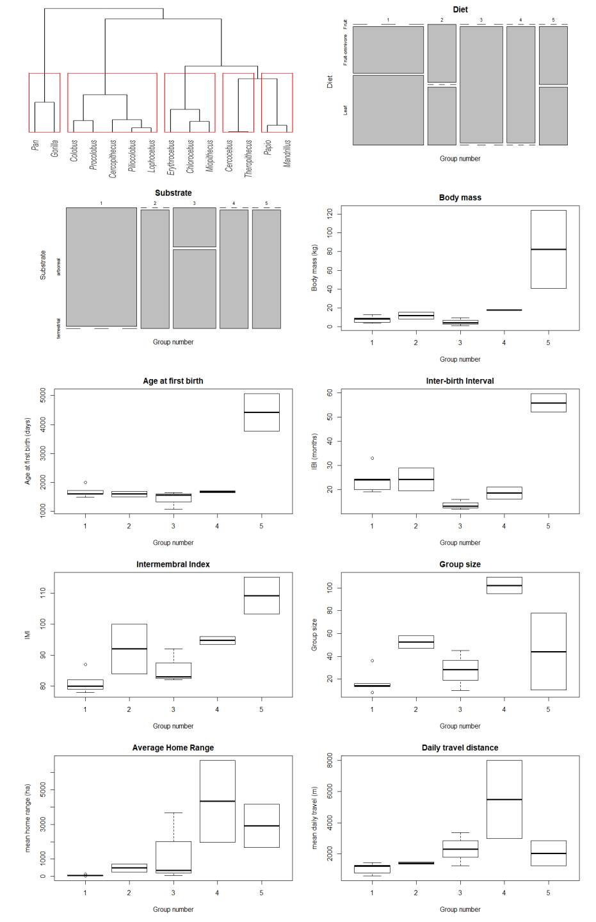
Figure S1. Cluster dendrogram showing genus clustering by RLQ trait scores and individual plots comparing biological traits for each genus’ group identified in RLQ trait-environment relationship analysis among African haplorrhines. Box plots show quartiles, median and minimum, maximum of each trait.
Table S5: Results of fourth-corner tests for associations between environmental variables and biological traits for African haplorrhine species (Pseudo F for qualitative x quantitative, and Pearson R for two quantitative variables). P_{adjust} denotes P-values following correction for multiple comparisons with the FDR method; * denotes significance with α = 0.05; ** denotes significance with α = 0.01.

Table S6: Species functional group membership and mean trait values of functional groups of African haplorrhine species based on hierarchical cluster analysis on trait scores in RLQ analysis of trait-environment relationships.

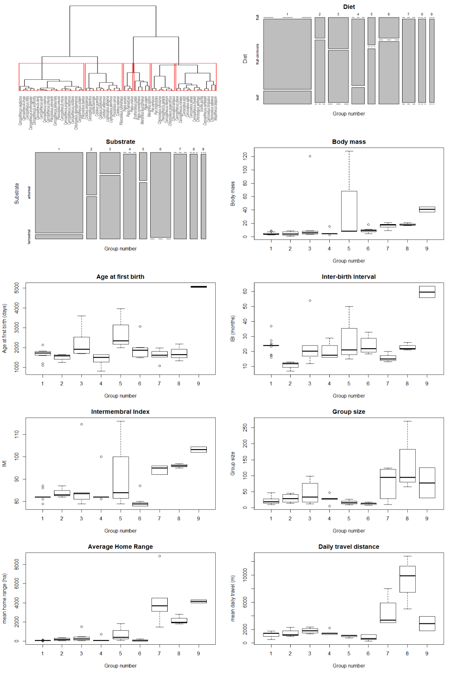
Figure S2. Cluster dendrogram showing species clustering by RLQ trait scores and individual plots comparing biological traits for each species group identified in RLQ trait-environment relationship analysis among African haplorrhines. Box plots show quartiles, median and minimum, maximum of each trait.

References
Cassini, M.H., (2020). A mixed model of the evolution of polygyny and sexual size dimorphism in mammals. Mammal Review, 50(1), pp.112-120. https://doi.org/10.1111/mam.12171
Ellis, B. J., Figueredo, A. J., Brumbach, B. H., Schlomer, G. L. (2009). Fundamental dimensions of environmental risk: The impact of harsh versus unpredictable environments on the evolution and development of life history strategies. Human Nature. 20:204–268. http://dx.doi.org/10.1007/s12110-009-9063-7.
Hemingway, C.A. and Bynum, N., (2005). The influence of seasonality on primate diet and ranging. In D. K. Brockman & C. P. van Schaik (Eds.), Seasonality in primates (pp. 57–104). Cambridge, U.K.: Cambridge University Press.
Hill, R.A. and Lee, P.C. (1998). Predation risk as an influence on group size in cercopithecoid primates: implications for social structure. Journal of Zoology, 245(4), 447-456. doi:10.1017/S0952836998008085
Jungers W.L. (1985). Body size and scaling of limb proportions in primates. In: Jungers W.L. (ed.) Size and Scaling in Primate Biology. Advances in Primatology. Springer, Boston, MA. https://doi.org/10.1007/978-1-4899-3647-9_16
Kalan, A.K., Kulik, L., Arandjelovic, M., Boesch, C., Haas, F., Dieguez, P., Barratt, C.D., Abwe, E.E., Agbor, A., Angedakin, S. and Aubert, F., 2020. Environmental variability supports chimpanzee behavioural diversity. Nature communications, 11(1), 1-10. https://doi.org/10.1038/s41467-020-18176-3
Plavcan JM, van Schaik CP, Mcgraw WS (2005) Seasonality, social organization, and sexual dimorphism in primates. In: Brockman DK, van Schaik CP (Eds), Seasonality in primates: studies of living and extinct human and non-human primates. (pp. 401–441). Cambridge, U.K.: Cambridge University Press.
Rothman, J. M., Chapman, C. A., Struhsaker, T. T., Raubenheimer, D., Twinomugisha, D., et al. (2014). Long-term declines in nutritional quality of tropical leaves. Ecology 96: 873–878. https://doi.org/10.1890/14-0391.1
Zvereva, E. L. and Kozlov, M. V. (2006). Consequences of simultaneous elevation of carbon dioxide and temperature for plant-herbivore interactions: a meta-analysis. Global Change Biology 12: 27–41. https://doi.org/10.1111/j.1365-2486.2005.01086.x

